University of Rwanda- College of Education
School of Educational Sciences
Department of Foundations of Education and Curriculum Studies
Module code/title: CE80241/Theories and practices of teaching and learning
Year 1 Semester: 2 Academic year 2025-2026
Number of credits: 10



Module general introduction

The module of “Theories and Practices of Teaching and Learning (CE80241)” serves as a foundational cornerstone for pre-service teachers, equipping them with both theoretical knowledge and practical skills essential for effective teaching and learning. At its core, this module seeks to bridge the gap between educational theory and classroom practice by fostering a deep understanding of the teaching and learning. The module covers seven units:
Unit 1: Typology of First-Year Student Teachers in Rwanda
Unit 2: Key pedagogical concepts
Unit 3: Theories of learning and their classroom applications
Unit 4: Components of effective teaching and learning
Unit 5: Planning for teaching and learning
Unit 6: Assessment in the teaching and learning process
Unit 7: Gender responsive and inclusive pedagogy

By learning this module, you will develop into reflective, competent, and inclusive teachers who can respond to the dynamic demands of modern classrooms. By integrating theory with practice, the module empowers pre-service teachers to make informed pedagogical decisions, foster meaningful learning experiences, and contribute positively to the holistic development of every learner once into the teaching profession.

Module Learning Outcomes:

By the end of this module, you will be able:
- Analyze first year student – teachers’ perceptions about the teaching profession for better reflection on their impact on future teaching roles and practices.
- Explain key pedagogical concepts, and components of effective teaching and learning for effective application in diverse teaching and learning situations.
- Differentiate theories of learning and their classroom applications in different classroom contexts.
- Design competence-based lessons and assessment using appropriate taxonomies of educational objectives for effective Teaching and Learning.
- Deliver effective lessons by implementing gender-responsive and inclusive pedagogy using Rwandan curriculum frameworks.

Unit 1: Typology of first year university student- teachers in Rwanda
Introduction

This unit introduces the diverse profiles of first-year university student-teachers in Rwanda, emphasizing how their prior experiences, beliefs, motivations, and attitudes shape their transition into teacher education. Understanding these typologies is essential for enhancing teaching, learning, and professional development within teacher training institutions. The unit focuses on four main categories of student-teachers: Traditionalists, mavericks, converts, reservationists. By examining these typologies, the unit aims to help you better understand individual differences in learning and professional identity formation.

Unit Learning Outcomes
By the end of this unit, you will be able to:
- Categorize first year student – teachers’ perceptions about the teaching profession for better reflection on their impact on future teaching roles and practices.
- Analyze the characteristics of first-year student teachers’ types in the Rwandan teacher education.
- Explain the implications of first-year student teachers’ characteristics for classroom teaching and learning practices in Rwanda

Activity
Reflect on your journey to teacher education. Write short answers to the following questions:
- Why did you choose to become a teacher?
- What challenges do you expect to face during your first year?
- What strengths do you bring to the teaching profession?

Introduction
TEACHER There is evidence that in most developing countries, teacher preparation at tertiary level combines candidates with professional preparation from high school and those without such experience. These students enter the programme with different preconceptions about and perceptions of the teaching profession (Nizeyimana, G. & Osman, R., 2013). This unit explores first year student teachers’ perceptions of the teaching profession in the context of Rwanda.
Student teachers’ beliefs about teaching and the teaching profession play a vital role in determining the way they engage in learning for the career they are trained for. Student teachers’ attitudes and beliefs affect the way they learn to teach. These beliefs are linked to:
- The students’ image of the teaching profession before entering tertiary teacher education,
- Their current image and conception of teaching during their first year at college or university,
- Their attitude towards practicing the career after graduation, and
- The socio-economic status of teachers within the socio-economic and political context of the country.
The beliefs of teacher candidates strongly affect what and how they learn and eventually how they approach teaching in the classroom. The analysis of the data shows that participants could be classified into four categories with reference to their interest in the career.
- The traditionalist students
- The Maverick Students
- The convert students and
- The reservationist students

1.1 Traditionalist students
In the study, traditionalist students are those who had a positive perception of the teaching career before entering former KIE. They enjoy the training that they are undergoing and have a positive view of their future career. According to Sears et al. (1987; 1994), they seriously consider teaching as their career and are, therefore, service oriented.
Example of how traditionalist student feel: Yes, it [being a teacher] motivates and encourages me. As I told you, it’s me who requested to be sent to KIE. I wanted to be a teacher. When I am studying, my goal is to pass and pass with good grades. Then, the knowledge I will gain from here will help me to do the work after my studies. I will do it as required because of my full commitment to study for the profession. (Interview: August 24, 2010).

1.2 Maverick students
They are those who are not really motivated or attracted by the teaching profession. These are students who entered teacher education at former KIE because of other variables, such as government sponsorship. They pointed out that they did not intend to be teachers, but because they were government-sponsored to study education and could not pay for private university education in a field of their choice. They finally ended up changing their minds and accepting teacher education. For them, this career would only be performed as a last job opportunity.

1.3 Convert students
They are those who initially did not see their career in teaching but who, once they were admitted to the teacher education programme, showed a strong commitment to the job. They initially had a negative image of the teaching profession when they were still at high school, however, after they entered a teacher education programme at former KIE, they had to change their minds (often unwillingly) and accept to do it because they did not have any other choice. They thus committed themselves to the profession.

Two out of ten students without professional preparation fall into this category. One of them said: “When you have already accepted and liked the idea of being a teacher, you are motivated. It’s a matter of being aware of the profession”. Another testimony: “Once here, you just accept it against your will, and you study as other students do. By changing your mind, you end up liking it [teaching] and understand that you can live any kind of life. From there you don’t get bored, but you study hard for your personal growth and development” (Interview: August 26, 2010).

1.4. Reservationist students
They are those who did not expect to be teachers. They were against doing the work they were training for. They have a vision different from that of the teacher education institution (Sears et al., 1987). They study the programme in order to get degrees and then run away from the teaching career to more comfortable and paying jobs. For them, the teaching profession in Rwanda is problematic. They argued that teachers are struggling with life in miserable socio-economic conditions due to their low salary.

They are absolutely against doing the work they were training for. They were not motivated to do teacher education. They were doing it because they did not have any other alternative. Calderhead (1988) argues that these students do not see themselves as being teachers.
Testimony: When I (researcher) asked her whether she would go to teach after her studies at former KIE, she ironically and laughed loudly: “Hahahahahaha!!!! […]. I cannot because, from the bottom of my heart, I don’t like to teach” (Interview: August 24, 2010). She argued that she wanted to be respected and joining the teaching career would not allow her to achieve this aim.

Activity
- Based on the typologies discussed above, identify the type of student teacher you consider yourself to be at the moment. Are you a traditionalist, a maverick, a convert, or a reservationist? Write a short explanation on a piece of paper to justify your choice and share with your classmates.
- Discuss the implications of each category’s views on their future roles and teaching practices. Explaining how being a traditionalist, maverick, convert, or reservationist may influence the way a student teacher plans lessons, interacts with learners, and performs professional responsibilities in the future (an assignment to submit).

Unit 2: Key pedagogical concepts

Introduction
This unit introduces you to key pedagogical concepts that underpin effective teaching and learning in contemporary education. It explores the meaning and branches of pedagogy, the different forms of education, and the concepts of teaching, instruction, and learning. The unit further examines major learning approaches and foundational didactic principles, including the didactic triangle, didactic contract, and didactic transposition, as essential frameworks for classroom practice. In addition, it highlights teacher professional standards in Rwanda as benchmarks for quality teaching, while emphasizing the importance of understanding pupils’ prior representations and promoting metacognition to enhance meaningful learning. Together, these concepts provide a comprehensive foundation for developing reflective, competent, and learner-centered teachers.

Unit learning outcomes
By the end of this unit, you will be able to:
- Differentiate key pedagogical concepts within formal education settings
- Explain the components and significance of the didactic triangle in classroom teaching situations
- Analyse the role of metacognition and learners’ prior representations in the teaching and learning process
- Discuss teacher professional standards in relation to pedagogical practices within the Rwandan education system.

Activity
In your own words, what does the term ‘pedagogical concepts’ mean to you? Write your response on a sticky note and share with your classmates in plenary.

Introduction
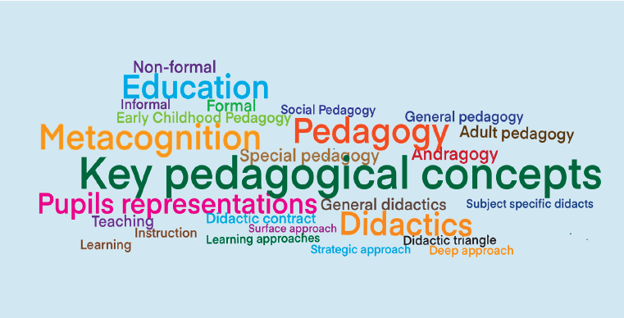Having deep knowledge of key pedagogical concepts is essential for effective teaching and learning. These foundational ideas provide the framework through which teachers design, implement, and reflect on their instructional practices. This unit will explore core concepts in pedagogy, beginning with the term pedagogy, education, teaching and learning. It will also tackle the concept of didactics; including the didactic triangle, and didactic contract. Additionally, the concept of pupils’ representations, and meta-cognition will be discussed. Together, these concepts form a vital foundation for understanding how learning occurs and how it can be effectively facilitated in diverse educational settings.

  - Concept of Pedagogy

Activity:
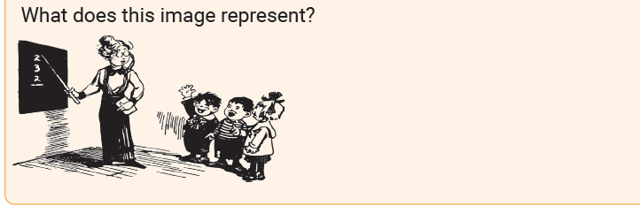

    - Meaning of Pedagogy

The word pedagogy comes from the Greek word "paidagōgia“,which is derived from two words: "pais", meaning "child" and "agōgos" meaning "leader" or "guide" (from the verb "agō", meaning "to lead" or "to bring"). Agogos is derived from the verb " ageirō ", which means "to lead “. Agogos refers to someone who leads, directs, or guides others, especially in the context of learning, teaching, or social movements. "Paidagōgia" literally means "the act of leading a child" or "the practice of guiding children.“

In ancient Greece, a paidagōgos was a slave or servant responsible for escorting and supervising the education of children. So, historically, the word pedagogy refers to a person who leads a child, but this leader was not the “teacher”. The “pedagogue” was a slave who led a male child to school in the morning and then back home again in the afternoon.

Over time, the term slave evolved to refer more broadly to the theory and practice of education, not just the supervision of children.

Today, pedagogy refers to the art, science, and practice of teaching. This means that pedagogy is not just about teaching, it is a comprehensive concept that combines creativity, knowledge, and action in the teaching process.
When we say pedagogy is an art, we are emphasizing the teacher’s creativity, intuition, and personal skill in the classroom. Teaching is not mechanical; it requires the ability to explain ideas clearly, motivate learners, adapt to different abilities, and create an engaging learning environment. For example, a teacher may use storytelling, humor, or real-life examples to make a lesson more meaningful. These are artistic elements because they depend on the teacher’s style and judgment.

When pedagogy is described as a science, it highlights that teaching is based on systematic knowledge, research, and established theories about how people learn. Educational practices are informed by fields such as Educational Psychology and learning theories like Constructivism, which explain how learners process information and develop understanding. This means effective teaching is not guesswork; it relies on evidence-based methods such as reinforcement, feedback, and cognitive development principles.

Finally, pedagogy as a practice refers to the actual implementation of teaching in real classroom situations. It involves what teachers do daily planning lessons, choosing teaching methods, interacting with learners, assessing progress, and managing the classroom. This is where theory and creativity come together and are applied in a specific context, such as a secondary school in Rwanda.
In essence, the definition shows that pedagogy integrates:
- Art → how creatively and skillfully teaching is delivered
- Science → the knowledge and theories that inform teaching
- Practice → the real-life application in the classroom
Together, these dimensions ensure that teaching is effective, informed, and responsive to learners’ needs.

Pedagogy encompasses the methods, strategies, theories and principles that teachers use to facilitate learning, considering both what is taught and how it is taught, particularly in formal educational settings, especially the teaching children or young learners. Pedagogy involves understanding learners’ needs, designing appropriate learning experiences, and creating supportive learning environments that promote meaningful engagement and development. Pedagogy implies the science of the child (psychology), the knowledge of educational techniques and the art to put them into practice (pedagogy itself).

Pedagogy often focuses on foundational knowledge, skills, and behaviors that learners need for future learning. Pedagogy has a broader scope including educational philosophy, learner psychology, and classroom management (Shah and Campus, 2021). In a more detailed sense, pedagogy includes:
- Teaching methods (e.g., lecture, discussion, cooperative learning)
- Instructional strategies tailored to learners’ needs
- Classroom management techniques
- Assessment and evaluation practices
- Understanding of how students learn (educational psychology and developmental stages).
Effective pedagogy is not just about delivering content. It is about engaging learners, fostering critical thinking, and creating inclusive and supportive learning environments.

Key branches of pedagogy
Pedagogy comprises several branches that reflect the various aspects of teaching and learning. Each branch focuses on specific dimensions of education to guide effective instructional practice. Key branches of pedagogy include (Shah & Campus, 2021):
- General pedagogy: This branch deals with the overall principles and theories of education, including teaching methods, learning processes, educational aims, and the philosophy of education.
- Special pedagogy (Special Education): Focuses on teaching learners with special educational needs or disabilities. This branch develops inclusive methods and adaptive strategies to support diverse learning requirements.
- Didactics: A central branch of pedagogy focused specifically on instruction. It explores how to teach particular content effectively, including curriculum design, teaching strategies, and the relationship between the teacher, learner, and subject matter.
- Early childhood pedagogy: Concerned with the education of young children. This branch focuses on developmental stages, play-based learning, and age-appropriate methods to support early cognitive, social, and emotional growth.
- Adult pedagogy (Andragogy): This branch addresses the education of adults, emphasizing self-directed learning, practical application, and the learners’ life experiences as central to the learning process. Andragogy is widely used in adult education programs, such as those found in community, vocational training, continuing education, or training; workplace learning and training programs to help employees improve job-related skills; many online education platforms by offering self-paced courses that allow adult learners to choose what they want to learn, when they want to learn it, and how they approach the material; and community-based learning and social movements like community workshops or groups where they can share their experiences and apply their learning in practical, socially relevant ways.
- Social pedagogy: This branch emphasizes the social aspects of education. It is concerned with how education contributes to social development, integration, and personal well-being, often working with marginalized or at-risk populations.

Each of these branches contributes uniquely to the broader field of pedagogy, allowing teachers to tailor their teaching to specific contexts, learners, and goals.

- General pedagogy: This branch deals with the overall principles and theories of education,

2.2 Concept of education
Activity:
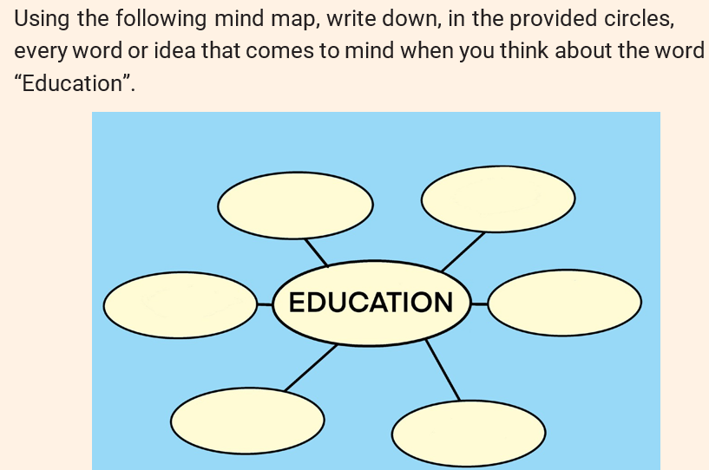

2.2.1 Meaning of education

Etymologically, the word education comes from the Latin word educatio, which is derived from the verb educare. The verb educare means to rear, to bring up, to educate, to nourish, or to feed in the sense of feeding, taking care of, and raising a child. The verb "educare” is derived from the combination of "e-": a prefix meaning "out" or "away." And "ducere": a verb that means "to lead." Thus, “Educere” means "to lead someone out of”. Therefore, "educare" literally means "to lead out" or "to bring forth." This reflects the idea of bringing out or developing one's potential, knowledge, or abilities, as is the goal of education. The noun form educatio refers to the act or process of rearing, nurturing, or training, and it later came to mean the process of educating or instruction, which is the meaning that the word education has retained in modern usage.

The word education entered the English language in the 16th century, where it was used to refer to instruction and the development of knowledge, skills, and character. Its meaning kept the original idea of “leading out” or “drawing forth” a person’s innate abilities. In this fundamental sense, education is understood as the process of guiding individuals out of ignorance and helping them develop their potential, knowledge, and capacities.

Different scholars have defined education in various ways. According to Durkheim (1968:41), education is “the action exercised by the adult generations on those who are not yet mature for social life.” In the same perspective, Morin and Brunet (1992:15) define education as “the action that consists in helping a human being to train himself, to develop himself, and to raise himself; it is also the result of his action.”

In contemporary understanding, education is viewed as a deliberate attempt to transmit and acquire accumulated worthwhile knowledge, understanding, skills, and attitudes from one generation to another. It is the process of facilitating learning or the acquisition of knowledge, skills, values, beliefs, and habits, as well as the process of teaching and learning that shapes the individual. It is the process of learning and teaching that involves the acquisition of knowledge, skills, values, attitudes, beliefs, and habits.

Through education, a person acquires competences, including knowledge, abilities, skills, attitudes, and values, which are developed in all circumstances of life. Through education, individuals are guided to develop intellectually, socially, morally, and emotionally to become productive members of society. At its core, education aims to:
- Develop human potential
- Transmit cultural heritage and values
- Promote critical thinking and problem-solving
- Prepare individuals for responsible citizenship and employment
- Foster lifelong learning and personal growth
In essence, education is both a personal and societal tool for transformation (Doharey et al., 2023).

2.2.2 Forms of education

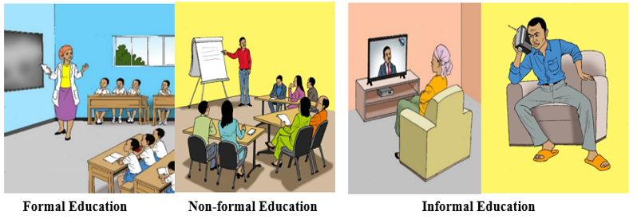

Education occurs in three main forms (Doharey et al., 2023):

- Formal education
Formal education is both structured and regular, typically provided in schools, colleges, universities, or professional training centers. It follows a well-organized curriculum designed to meet specific educational goals and is usually divided into stages such as early childhood, primary, secondary, and higher education. Normally, formal education is delivered by certified teachers who possess professional qualifications and adhere to pedagogical standards. It includes formal assessments such as exams, quizzes, and projects that are standardized and contribute to students’ academic qualifications. Regulated by governmental or accreditation bodies, formal education ensures institutions meet specific standards and usually leads to recognized certifications such as diplomas or degrees as a formal recognition of their achievements.

- Non-formal education
Non-formal education is structured but not regular, occurring outside the traditional school system in settings such as workshops, training programs, seminars, conferences. It is designed to meet specific needs such as vocational skills, personal development, or lifelong learning. Unlike formal education, non-formal education does not follow a rigid curriculum and can be customized to suit the goals of participants. It is normally voluntary; learners choose to participate based on their interests or needs. The content varies widely, focusing on practical skills or knowledge not typically covered in formal schooling.
It often focuses on specific practical skills, personal development, or knowledge that may not be covered in formal education: vocational training, adult literacy programs, life skills courses, or hobby-based workshops. It can take many forms, such as workshops, seminars, community learning circles, online courses, internships, apprenticeships, or even learning through social activities. It may offer certificates of completion or informal recognition of achievement, generally do not grant academic degrees or qualifications in the same way formal education does. The focus is often on personal or professional development rather than formal certification. Non form education is seen as essential for lifelong learning, bridging gaps left by formal education and addressing community or societal needs.
Both formal and non-formal education fall under hetero-education which means education guided by others as opposed to auto-education or self-directed education or education by oneself.

C. Informal education

Informal education is both non-structured and non-regular, lacking a fixed curriculum or standardized learning pathway. It naturally emerges from daily experiences and activities occurring outside formal classroom settings and within everyday life. This type of learning is acquired through personal reading, interpersonal relationships, life events, family interactions, community involvement, observation, and self-directed study. It is typically spontaneous and driven by the learner’s curiosity, motivation, and interests, making it highly adaptable to individual needs and circumstances rather than being guided by a predetermined educational framework.
Activity:
- Give examples of things that you can learn informally and where you can learn them.
- Discuss the advantages and challenges of each of the three forms of education (Assignment to be submitted).

  - Concepts of teaching, instruction, learning
Activity: How do you differentiate the term teaching, instruction and learning?

Introduction
Teaching, instruction, and learning are closely related concepts in the educational process. They form the foundation of classroom interaction and knowledge development. Understanding these concepts is essential because they help explain how knowledge is transmitted, facilitated, and acquired in educational settings.

2.3.1 Meaning of teaching, instruction, learning

- Teaching
The word teaching has its origins in the idea of showing or pointing out, which is closely related to the modern meaning of educating or instructing someone. The term comes from the Old English verb tǣcan, which means to show, to point out, or to instruct. This Old English word is derived from the Proto-Germanic verb taikjan, meaning to show or to make known. During the Middle English period, the word appeared as techen, and it kept the meaning of showing, instructing, or guiding, but it gradually became associated with formal and organized instruction. In Modern English, the word teaching came to refer to the act of imparting knowledge, skills, values, or wisdom, as well as the profession and role of those who do so.

Contemporary, teaching refers to the overall process by which a teacher facilitates learning. This includes planning lessons, creating a supportive learning environment, guiding students, using various methods and strategies, managing the classroom, and assessing student progress.
It defined as a set of steps, operations and conditions that are implemented by the environment (the teacher, parents, etc.) in order to facilitate learning. It is the process of imparting knowledge, skills, values, or behaviors to others, typically in an educational context.
It involves guiding, instructing, and supporting students to understand concepts, develop critical thinking, and apply learning. It is often characterized by communication, interaction, and assessment of progress.
Teaching is not limited to the delivery of content, it also involves motivating learners, adapting to their needs, fostering critical thinking, personal development and a deeper understanding that can be applied in real-life contexts.
Teaching involves planning, delivering, and assessing educational experiences to help learners achieve specific learning objectives (Rajagopalan, 2019). Teaching is both an art and a science:
- As an art, it involves creativity, empathy, communication, and adaptability.
- As a science, it draws on theories of learning, pedagogy, psychology, and educational research to make informed instructional decisions.
The key components of teaching include:
- Preparing lessons based on learners’ needs and curriculum goals
- Delivering instruction using appropriate methods and materials
- Engaging learners through questioning, interaction, and activities
- Assessing understanding and providing feedback
- Supporting learners’ development intellectually, emotionally, and socially
Effective teaching not only helps students learn facts or skills but also encourages critical thinking, curiosity, and lifelong learning.

Instruction
Instruction is a concept closely related to teaching, but it is more specific. It specifically refers to the deliberate act of delivering knowledge or skills, usually in a structured and systematic way. Instruction involves direct communication of information, such as explaining, demonstrating, or giving directions. It focuses more on the “how” of content delivery within the broader teaching process. Instruction is a component of teaching. While teaching encompasses the full educational experience, instruction deals specifically with how lessons are presented to help learners acquire knowledge, skills and values.

Learning

The word "learning" has its roots in Old English verb "leornian", meaning "to learn “, "to study or get knowledge “. It comes from the Proto-Germanic root "lizn-" or "leizn-", which also meant "to learn" or "to acquire knowledge. “
The verb "leornian" evolved into the noun "learning", which referred to the process of acquiring knowledge or understanding. By the 14th century, "learning" referred not only to the act of acquiring knowledge but also to the body of knowledge itself. The concept of "learning" as the process of acquiring and understanding knowledge has remained central to its meaning through its linguistic history.
Learning is a personal activity that consists of integrating new knowledge into the existing one. It is the process through which individuals acquire or modify knowledge, skills, attitudes, values, or behaviors through experience, study, practice, or instruction. It involves internalizing new information and applying it in meaningful ways, often leading to changes in understanding, thinking, or performance. Learning can be:
  - Cognitive (developing intellectual abilities like reasoning, problem- solving, and memory)
  - Affective (shaping attitudes, emotions, values, and motivation)
  - Psychomotor (acquiring and refining physical or motor skills)
In essence, learning is at the heart of personal development and education, it is how we grow intellectually, socially, emotionally, and physically across our lifespan.

Psychologists often define learning as a relatively permanent change in behavior as a result of experience or practice (Sequeira, 2012). This definition has three important terms:
    - Change in behavior: learning involves a change for better or worse
i.e. learning can involve both beneficial and negative behaviors. Sometimes people learn things that help them become more knowledgeable and lead better lives. In other instances, people can learn things that are detrimental to their overall health and well-being.
    - Change takes place through experience or practice; changes due to growth or maturation are not learning.
    - Before it can be called learning, the changes must be relatively permanent. What one learns is relatively permanent because it can be changed by future experience.
The ability to learn is possessed by humans, animals and machines. There is also evidence for some kind of learning in some plants. Learning is perhaps the most important human capacity. It is an ongoing process that takes place throughout all of life. Human learning begins before birth and continues until death as a consequence of ongoing interactions between person and environment.

Both concepts teaching and learning go together and we usually say: Teaching – learning process.

    - Learning approaches
Activity:
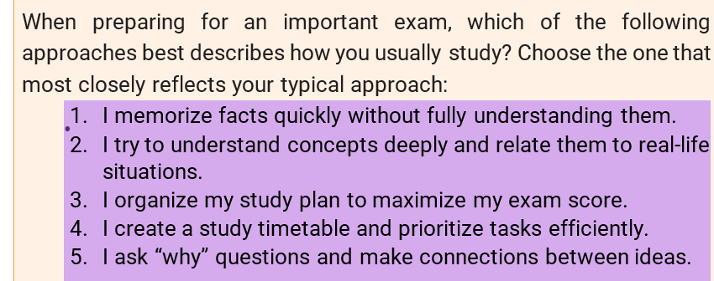

The term learning approaches refer to the strategies, methods, and mindsets that learners adopt to engage with new information and skills. These approaches describe the qualitative differences in how students go about learning and can vary widely based on individual preferences, the learning environment, intentions for learning, and cultural influences. The three main learning approaches are surface learning, strategic learning and deep learning (Beyaztaş & Senemoğlu, 2015).

- Surface Learning
Surface learning refers to a narrow approach to learning in which students focus primarily on memorizing facts, completing tasks with minimal understanding, and meeting requirements without engaging deeply with the material. Learners who adopt a surface approach often aim to reproduce information just enough to pass exams or fulfill assignments, rather than to develop meaningful comprehension or apply knowledge in different contexts.

This type of learning is typically driven by external motivations, such as fear of failure, the desire for high grades or meeting external expectations, and is often associated with teaching environments that emphasize rote learning, high workload, or assessment-centered practices over conceptual understanding and critical thinking.

For example, in mathematics, a surface learner may focus on rote memorization of formulas without grasping the underlying concepts, while in language learning, they might memorize vocabulary lists without understanding how the words function in context or real-life communication. This approach can lead to fragile learning, where knowledge is easily forgotten and difficult to apply beyond the classroom.

- Deep learning
Deep learning is an approach in which learners seek to understand ideas and concepts at a meaningful level rather than simply memorizing information. It involves actively engaging with the content, making connections between new and prior knowledge, and applying what is learned to real-life situations or new problems.
Deep learners are typically motivated by curiosity and a genuine interest in the subject matter. They analyze, evaluate, and reflect on what they learn, aiming for comprehension rather than mere performance. Deep learners are actively involved in the learning process, often extending their inquiry beyond what is taught to deepen their comprehension and apply knowledge in real-world or unfamiliar contexts.
For example, in a history class, instead of memorizing dates and events, students analyze historical events and explore the impact of those events on modern society.

- Strategic learning
Strategic learning is an approach in which learners aim to achieve the best possible academic outcomes by employing effective study techniques, time management, and goal-oriented behaviors. Strategic learners are typically highly motivated by achievement and grades, and they consciously adapt their learning methods to meet assessment requirements. They balance deep and surface learning strategies, using deep understanding when necessary but also relying on memorization or shortcuts when it serves their academic goals. Strategic learners are highly organized and efficient; they prioritize key content, practice with past exam papers, and adapt their strategies based on the nature of the task or evaluation
2.4 The concept of didactics

2.4.1 Meaning of didactics

The term "didactics" has its roots in Greek and Latin. The word "didactics" comes from the Greek word "didaktikos", which means "apt to teach" or “suitable for teaching." The root of this word is "didaskalos” meaning "teacher."
The term was then borrowed into Latin as "didacticus", maintaining its meaning related to teaching or instruction. From Latin, the word entered modern European languages, including English, in the 17th century, where it came to refer to the art or science of teaching and the methods and principles of instruction, especially those applied in formal educational contexts.
Thus, "didactics" literally means the theory or practice of teaching, specifically focusing on instructional methods and the way knowledge is imparted to others. Didactics became more formally recognized as a discipline in the 18th and 19th centuries, especially in Europe. Notable figures, such as Johann Amos Comenius (famous educator, philosopher, and writer born in Moravia, which is today part of the Czech Republic), contributed to the development of didactics as a methodical approach to teaching with his most famous book Didactica Magna (The Great Didactic).
Didactics is a branch of pedagogy that specifically focuses on the theory and practice of instruction. It deals with the content of teaching (what to teach), the methods, strategies and techniques of delivery (how to teach), educational goals and objectives (why teach it), the learner’s characteristics and needs (to whom), learning environment and cultural/social setting (in what context) and the relationship between the teacher, the learner, and the subject matter, often illustrated by the didactic triangle.
Didactics concentrates more narrowly on the instructional process itself. It focuses on how knowledge is conveyed, understood, and applied by learners. It is more concerned with the instructional process. It deals with the design and delivery of teaching. Didactics is the field that helps educators make informed decisions about how best to teach a particular subject to a particular group of learners in a specific context (Djilali & Khemmad, 2023).
2.4.3 Types of didactics
There are two types of didactics: General didactics, and subject- specific didactics.
A. General didactics
General didactics encompasses the fundamental principles, methods, and techniques of teaching that are applicable across a wide range of subjects and educational levels. It focuses on overarching aspects of the teaching and learning process, such as how to effectively engage students, structure and sequence lessons, and adapt instructional strategies to suit diverse learning needs and educational contexts. General didactics supports educators in making informed decisions about pedagogy, classroom management, and curriculum delivery, regardless of the specific subject matter.
B. Subject-specific didactics
Subject-specific didactics also called special didactics refers to the teaching strategies, methods, and instructional approaches tailored to specific subject areas, such as mathematics, language, history, or science. Unlike general didactics, which applies broadly across disciplines, special didactics focuses on the unique content structures, cognitive demands, and learning processes associated with each subject.
It provides subject-specific frameworks that guide educators in selecting the most effective ways to present content, address misconceptions, and foster deep understanding within a particular discipline. For example, the didactics of mathematics emphasize logical reasoning and problem-solving, while language didactics may focus on communication skills and grammar acquisition.

2.4.4 Didactic triangle

Activity: Write down the key elements that you consider essential for teaching and learning to take place

Every teaching and learning situation can be analysed through a triangular diagram called didactic triangle. The Didactic Triangle is a conceptual model that represents the core elements of the teaching and learning process. It highlights the relationship between three key components: Knowledge (K)/ Content (C), Learners (L) and Teacher (T):
- Knowledge (K) represents the content, disciplines, programs, subject matter, information, or material being taught and learned.
- Learners (L) refer to pupils, trainees, students. The student or individual who receives, processes, and engages with the knowledge or skills being taught.
- Teacher (T) refers to the lecturer, trainer, educator, initiator, etc. The individual responsible for imparting knowledge, guiding learning, and facilitating the overall learning experience.

A didactic triangle (Adapted from Djilali & Khemmad, 2023).

A. Relationship between elements of the didactic triangle
- Teacher ↔ Learner: This relationship is crucial for effective communication, understanding, and feedback. The teacher must be able to connect with the learner, recognize their needs, and adapt their teaching approach accordingly.
- Teacher ↔ Knowledge/Content: The teacher’s role involves selecting, structuring, and presenting content in an engaging and comprehensible way. The teacher needs to have a deep understanding of the content and how best to teach it.
- Learner ↔ Knowledge/Content: this represents how the learner interacts with the material. The learner engages with the content, makes sense of it, and internalizes or applies it. This relationship is mostly influenced by the learner’s prior knowledge, motivation, and learning strategies.

B. Significance of the didactic triangle

Didactic triangle has a huge significance:
- It emphasizes that teaching is not a one-directional act but a dynamic process involving constant interaction between the teacher, the learner, and the content. The teacher must not only deliver subject matter but also adapt it to the learners’ needs, prior knowledge, and learning styles. This requires thoughtful planning, flexibility, and awareness of pedagogical strategies.
- The triangle highlights the learner’s active role in constructing knowledge. Learning is not merely receiving information but engaging with content through exploration, questioning, and reflection. The learner’s interaction with both the teacher and the content is crucial for deep understanding.
- It indicates the dynamic and interdependent relationship between the teacher, the learner, and the content, serving as a foundational framework for understanding effective teaching and learning: It emphasizes that successful education is not only dependent on the teacher’s ability to deliver content, but equally on the learner’s active engagement and the relevance and clarity of the content itself. The model also emphasizes that effective teaching depends not only on the content itself but also on the interaction between the teacher and the student. It illustrates that the quality of interactions among these three elements significantly influences the overall effectiveness of the learning experience.
- The didactic triangle serves as a diagnostic and reflective tool for teachers. When challenges arise in the classroom, analyzing which link in the triangle is weak—teacher-learner, learner-content, or teacher-content—can guide improvements in instructional practice.
- The didactic triangle underscores that quality teaching depends on the harmonious interplay of its three elements, making it a vital model for both novice and experienced teachers.

    - Didactic contract
Activity: Read carefully these two questions and provide at least three answers for each question:
- What do you expect your teachers to do in class?
- What do teachers expect you to do as a student?
- Meaning of didactic contract
The didactic contract refers to the implicit and explicit agreement between the teacher and the student regarding expectations, roles, responsibilities, norms and behaviours. It governs the relationship between the teacher, the learner, and the content being taught during the teaching and learning process. It outlines what both the teacher and the learner are expected to contribute to ensure effective learning (Hausberger & Patras , 2019). Didactic contract has two types which are implicit contract and explicit contract.

- Types of didactic contract

i. Implicit contract: Often unspoken expectations, roles, responsibilities, and norms; this refers to the natural, expected dynamics between teacher and student. For example, it is generally assumed that students will attend class, complete assignments, and the teacher will provide instruction and assessments, students expect teachers to give hints when they are stuck, teachers expect students not to interrupt when explaining.
ii. Explicit contract: This is a formal where the roles, responsibilities, and expectations of both the teacher and the learner are clearly outlined or stated. It could be in the form of a syllabus, classroom rules, or a specific learning agreement. For instance, students raise their hand to speak, students must complete the assignment by Friday, etc.

- Key elements of a didactic contract

i. Teacher’s roles and expectations
The teacher’s role and expectations are central components of the didactic contract, shaping how teaching and learning unfold in the classroom. As part of this implicit agreement, the teacher is expected to play different roles including the following:

- Teacher’s roles

- Facilitator of learning: teachers guide students in the learning process, encouraging inquiry, critical thinking, and independence rather than just delivering content.
- Planner and organizer: teachers design lesson plans, structure learning activities, and manage classroom time effectively to meet curriculum goals.
- Assessor: teachers evaluate student progress through formal and informal assessments, providing feedback that helps learners improve.
- Mentor and role model: Teachers model ethical behavior, communication skills, and lifelong learning attitudes, influencing students both academically and morally.
- Curriculum implementer: Teachers interpret and deliver the curriculum in ways that are meaningful and accessible to all learners, adapting it to different needs and contexts.
- Classroom manager: Teachers create a positive, inclusive, and disciplined environment where all students feel respected, supported, and safe.
- Counselor and supporter: Teachers provide emotional and social support, helping students navigate academic and personal challenges.
Lifelong learner: Teachers continuously improve their professional skills through training, reflection, and collaboration with colleagues.

- Expectations from teachers
The following are also part of expectations of what the teacher is supposed to have:
- Professionalism: Teachers are expected to be punctual, prepared, respectful, and uphold high ethical and professional standards.
- Inclusivity and equity: Teachers should accommodate diverse learning styles, backgrounds, and abilities, ensuring every learner has equal opportunities to succeed.
- Effective communication: Teachers must communicate clearly with students, parents, and colleagues, fostering collaboration and understanding.
- Adaptability: Teachers are expected to adjust their strategies in response to student needs, classroom dynamics, and changes in the education system.
- Commitment to student success: Teachers are expected to be committed to helping all students reach their potential academically, socially, and emotionally.
- Confidentiality and integrity: Teachers must respect students’ privacy and act with honesty and transparency in their professional conduct.
ii. Learner’s roles and expectations

- Learner’s roles
Active participant: learners are expected to take an active role in their education by engaging with learning activities, asking questions, and contributing to discussions.
Self-directed learner: learners should take responsibility for their own learning by managing time effectively, setting goals, and seeking help when needed.
Collaborator: learning often involves working with peers. Learners are expected to cooperate respectfully in group tasks, share ideas, and support one another’s understanding.
Critical thinker: learners should analyze, evaluate, and synthesize information rather than memorize facts. They are encouraged to form opinions and justify their reasoning.
Problem solver: learners are expected to apply knowledge in practical situations, reflect on challenges, and find creative solutions to academic and real-life problems.
Respectful community member: learners must contribute to a positive and inclusive classroom environment by showing respect for teachers, peers, and differing opinions.
Reflective individual: learners are encouraged to assess their progress, reflect on their learning experiences, and adjust improve.

- Expectations from learners
Active engagement: Learners are expected to participate in class activities, complete assignments, and maintain focus during lessons.
Respect for rules and authority: Learners must follow classroom rules, respect school policies, and show courtesy to teachers and classmates.
Punctuality and attendance: Regular and timely attendance is crucial for continuous learning and classroom involvement.
Preparedness: Learners should come to class with the necessary materials, having completed required readings or assignments in advance.
Academic integrity: Learners are expected to be honest in their work—avoiding plagiarism, cheating, or any dishonest behavior.
Willingness to learn: Learners must demonstrate a positive attitude toward learning, be open to feedback, and show perseverance even when tasks are challenging.

iii. Content and context
The subject matter to be taught and learnt and the methods used to teach and learn it are part of the didactic contract. Learners need to understand what they will learn and how the content will be delivered while the teacher needs to master the content, plan it and effectively teach in relation to their roles and responsibilities in the teaching and learning process.

  - 6 Teachers’ professional standards in Rwanda
Activity: Write down at least three key characteristics that define a professional teacher.
- Meaning of teachers’ professional standards
Teachers’ professional standards are a set of guidelines or benchmarks that define the knowledge, skills, attitudes, and behaviors expected of teachers. Teachers’ professional standards in Rwanda serve as a framework to guide and assess the knowledge, skills, values, and conduct expected of teachers at all levels of education.
These standards aim to promote high-quality teaching, professional accountability, and continuous development among educators. They provide clear benchmarks for effective teaching practices, ethical behavior, and professional growth, ensuring that teachers contribute meaningfully to learner achievement and national education goals. By adhering to these standards, teachers uphold the integrity of the profession and play a vital role in improving the overall quality of education in Rwanda.

- Domains of professional teacher standards in Rwanda
Professional teacher standards in Rwanda are grouped under three domains: (1) Professional knowledge and understanding, (2) Professional skills, and (3) Professional attitudes and values (REB, 2020).
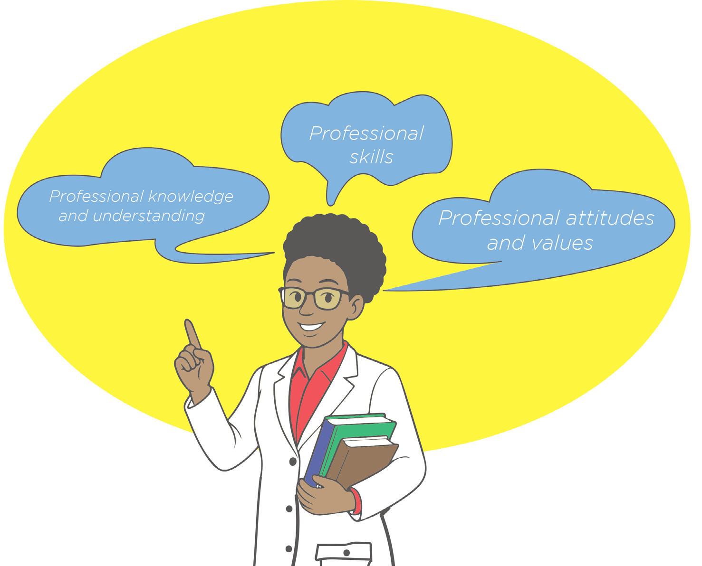
Each domain has descriptors in the form of standards indicators. The standards indicators are detailed descriptions of the knowledge, skills, attitudes and values associated with each domain. In the context of competence, knowledge defines what teachers must know in his/her teaching career. Attitudes and values represent beliefs that play a critical role in teachers’ practice and influence on the teaching and learning process.
Skills describe the application of teachers’ knowledge, attitudes and values in their practices. They are therefore observable and measurable behaviors that represent what teachers know, can do, believe and value teaching and learning.

B.1 Domain of professional knowledge and understanding
The standards for teachers’ professional knowledge and understanding include:

Knowledge and understanding of the learner
A professional teacher must demonstrate awareness of the physical, social, intellectual and emotional development of children, and know how to adapt teaching to support students’ education at different stages of child development. Such teachers should be able to examine the factors that constrain students’ ability to learn and propose adequate measures of how best to overcome them.

Knowledge and understanding of the curriculum
A professional teacher has:
    - Adequate knowledge of the curriculum content relevant to her/his teaching subject.
    - Sufficient knowledge and understanding of the subject matter for teaching at the appropriate level;
    - Good understanding of how new knowledge in his/her subject area is acquired.
    - Good understanding of how subject knowledge is linked to other subjects and applied to life experiences.
    - Good knowledge of new developments in the subject area.
    - Good knowledge of the language of instruction.

Knowledge and understanding of teaching and learning process
A professional teacher:
- Has up-to-date knowledge and understanding of when to use which teaching and learning methods;
- Has broad knowledge and understanding of how to use and adapt a variety of teaching and learning methods to provide opportunities for all learners to learn;
- Knows and understands how learners build knowledge, acquire skills and develop habits of mind.
- Knows and understands how learning is influenced by individual experiences, talents and prior learning, language as well as family and community values and socio- economic status.
- Has good knowledge and understanding of a variety of teaching and learning materials including ICT tools.
- Knows how to motivate learners and provide constructive feedback.
- Has adequate knowledge of managing time for teaching and learning.

Knowledge and understanding of instructional planning
A professional teacher must:
- Understand the importance of instructional planning.
- Know how to write appropriate schemes of work and lesson plans.
- Know how to write lesson plans with clear learning objectives and relevant measurable outcomes.

Knowledge and understanding of learning assessment and evaluation strategies:
A professional teacher:
- Knows and understands the nature and use of different learning assessment strategies.
- Knows and understands how to use different assessment tools to
- identify learning difficulties, potentials, and talents of learners.
- Knows a variety of ways of assessing learning holistically including the cognitive, psycho-motor and affective domains.
- Knows and understands how information acquired through assessment processes is used to improve teaching and learning.

Knowledge and understanding of parents’ involvement in education
A professional teacher:
- Knows and understands the family background of learners.
- Has knowledge and understanding of how the family background of learners influences learning.
- Knows the importance of parents’ involvement in their children’s learning.
- Knows how to get parents involved and engaged in the education of their children.
- Understands and empathizes with parents who have difficulties in involved with their children’s schoolwork.

Knowledge and understanding of professional development
A professional teacher:
- Knows and appreciates that learning to teach well is a process.
- Has knowledge of research as a tool for professional development.
- Knows what is required to develop professionally.
- Knows and understands the professional standards for teachers in Rwanda and what is required to meet them.
- Knows and understands the importance of Continuous Professional Development Courses in his/her teaching career.

Knowledge and understanding of career guidance and counselling
A professional teacher:
- Knows and understands the concept of career guidance and counselling.
- Knows and understands the principles of career guidance and counselling.
- Understands the importance of career guidance and counselling in education.

B.2 Domain of professional skills
The standards for teachers’ professional skills are the following:

Using learners’ data to inform teaching and learning:
A professional teacher:
- Has sufficient data concerning learner’s overall development, socio-economic status, past experiences, readiness for learning and preferred learning styles.
- Analyses learner’s data accurately and designs appropriate teaching strategies to improve learning.
- Demonstrates ability to manage the learning of individual students, groups of students and whole classes and adjust teaching plans to suit the stage of learner physical, social and cognitive development, such teacher is aware of socio-economic background, experiences and learning styles of the students.
- Responds to learner’s learning differences and special learning needs with appropriate teaching strategies.
- Identifies and anticipates a range of factors that hamper learners’ ability to learn, and devises teaching strategies to overcome them.
- Collaborates with professional colleagues and parents to know and understand the learners in order to better support their learning.

Implementing the curriculum:
A professional teacher:
- Demonstrates ability to teach the subject content and justify the chosen teaching strategy.
- Selects and logically sequence content for teaching in a series of learning experiences [lessons] in ways that facilitate learning.
- Structures lessons and teaching activities in a logical sequence to fit all learners’ needs.
- Links teaching content knowledge and skills to everyday life experiences.
- Facilitates students’ access to learning materials and environment.
- Critically analyze and use information effectively; integrates a variety of strategies, activities, and resources in the process of teaching and learning.
- Facilitates students access critically analyze and use information effectively.

Instructional planning:
A professional teacher:
- Uses learners’ data to guide instructional planning.
- Plans what to teach annually, termly, monthly, weekly and daily.
- Plans for whom they intend to teach.
- Plans how to teach.
- Outlines clearly the intended learning outcomes of each lesson,
- Plans time realistically for pacing, content mastery and transitions.
- Plans for differentiated instruction.
- Aligns lesson objectives to the subject content and learners’ needs.
- Aligns teaching activities to school vision, mission and values.
- Translates their instructional plans into teaching and learning actions.
- Describes the expected actions that students should be able to perform as they participate in the learning activities; plans assessment for/of learning.
- Plans, sets and assesses learner’s portfolio.

Applying acquired skills to teaching:
A professional teacher:
- Sets clear, challenging and achievable learning goals that describe what students will learn.
- Demonstrates focus on teaching with appropriate learning objectives.
- Plans and implements well-structured and paced lessons as well as teaching activities that engage students and promote learning.
- Demonstrates ability to manage the learning of individuals, groups and whole class.
- Modifies teaching to suit the stage of the lesson.
- Builds on previous knowledge to support learners acquire and apply new knowledge, understanding and skills to meet learning objectives.
- Selects and uses appropriate teaching strategies supported by research and good practice to develop problem solving, critical and creative thinking, communication and collaboration skills.
- Selects, creates and uses a range of resources to engage students in learning.

Assessing, providing feedback reporting on learner’s performance:
A professional teacher:
- Develops, selects and uses formative and summative assessment strategies to assess learners learning.
- Aligns the assessment tasks to Learning Outcomes and content.
- Develops and clarifies assessment criteria.
- Participates in assessment moderation activities to support consistent and comparable judgment of learners learning.
- Provides timely, effective and appropriate feedback to learners about their achievement relative to their learning goals.

Engaging professionally with colleagues, parents and the community:
A professional teacher:
  - Establishes and maintains constructive collaborative relationships with parents regarding their children’s learning and well-being.
  - Participates in professional and community networks and forums to broaden knowledge and improve practice.
  - Provides relevant opportunities for parents to be involved in their children’s learning.
  - Participates actively in community socioeconomic development.

Engaging in continuous professional development:
A professional teacher:
- Uses the National Professional Standards for Teachers and pieces of advice from colleagues to identify and plan professional learning needs.
- Participates in continuous professional development to update knowledge and practice aligned to professional needs and school priorities.
- Contributes to collegial discussions and applies constructive feedback to improve professional knowledge and practice.
- Undertakes professional learning programs designed to address identified learners’ learning needs.

Providing career guidance and counselling services:
A professional teacher:
- Gives total attention to learners and values each of them as an individual.
- Demonstrates the ability to effectively listen to learners and provides feedback.
- Has the ability to ask relevant, open and closed questions and how to make questioning more effective to gain a deeper understanding of learner’s concern.
- Reflects on the learner’s experiences.
- Demonstrates the ability to put him/ herself in learner’s situation in order to build trust.
- Guides the learners to make the right choice in their future career.
- Identifies the areas in which learners can be provided with career guidance and counseling.

B.3 Domain of professional attitudes and values
Standards for teachers’ professional attitudes and values are the following:
Care for the learners: showing genuine concern for their academic, emotional, and social well-being by creating a safe, supportive, and inclusive learning environment. It involves building positive relationships, listening to their needs, and responding with empathy to help them feel valued and motivated to learn.
Respect for learners and colleagues: recognizing and valuing everyone’s dignity, opinions, and contributions within the learning environment. It involves treating others with fairness, kindness, and professionalism, regardless of differences in background, beliefs, or roles.
Trustworthy: being honest, reliable, and dependable so that others can have confidence in your words and actions. A trustworthy person keeps their promises, follows through on commitments, and earns the respect of those around them.
Integrity: consistently doing what is right and ethical, even when no one is watching. It involves being honest, fair, and having strong moral principles that guide your actions and decisions.
Dialogue with learners and colleagues: engaging in open, respectful, and meaningful conversations to share ideas, solve problems, and build mutual understanding. It promotes collaboration, active listening, and the exchange of perspectives to enhance learning and professional relationships.
Non-discriminatory: treating all individuals fairly and equally, without bias or prejudice based on characteristics such as race, gender, age, disability, or background. It ensures that everyone has the same opportunities and respect regardless of their differences.
Responsible: being accountable for your actions and duties, reliably
fulfilling your commitments and making thoughtful decisions. It involves taking ownership of the consequences of your behavior and acting with care and professionalism.
Tolerant: showing acceptance and open-mindedness toward different opinions, behaviors, or cultures, even if they differ from your own. It includes respecting diversity and being patient with others’ beliefs and ways of life.
Polite: showing good manners, respect, and consideration toward others in speech and behavior. It involves being courteous, kind, and thoughtful in interactions to create positive and respectful communication.
Patriotic: having a strong love, loyalty, and devotion to one’s country. It is about showing pride in the nation’s values, culture, and heritage, and actively supporting its well-being and progress.

Activity: Teacher Uwase, a secondary school Geography teacher, is conducting a lesson on the effects of climate change on agriculture in Rwanda. She begins by showing a short video clip that illustrates recent climate challenges faced by Rwandan farmers. To deepen understanding, she organizes learners into small groups and assigns each group a specific region of Rwanda to analyze how climate change negatively affects local agriculture. Before the group activity begins, she clearly explains the task, expected behavior, and the importance of every student contributing. While monitoring the groups, she notices that one learner, Eric, is sitting quietly and not participating. Instead of scolding him, she kneels beside the group, gently encourages Eric, and reminds him that his ideas are valuable. She offers him a guiding question to help him get started and assigns him a manageable role within the group. After the group presentations, the teacher praises each group’s effort and provides feedback on how they could strengthen their arguments with more evidence. To conclude, she links the topic to Rwanda’s environmental protection strategies and asks learners to reflect on how climate change may affect their own communities.
Questions
1. Identify the elements of a didactic triangle found in the scenario
2. Highlight how the teacher in the scenario meets the teachers’ professional standards in Rwanda.
3. Based on the teachers’ professional standards in Rwanda, which aspects teacher Uwase needs to improve. Give suggestions on how she would improve.

2.5 Didactic transposition

Activity
Read the following sentence carefully and answer the questions that follows:
“Water evaporates due to the effect of heat energy which transforms liquid into vapor.”
- Rewrite the sentence so that a secondary school learner can understand it.
- Which sentence is easier to understand?
- What did you change?
- Why is it necessary to change the sentence before teaching?

2.5.1 Meaning of didactic transposition
Changing difficult knowledge into simple knowledge for learners is called didactic transposition. It means transforming original scientific knowledge into knowledge that can be taught and learned in the classroom. This transformation occurs because the knowledge created in universities or research centers is often too complex, too detailed, or not directly useful for learners. Therefore, curriculum developers, textbook writers, and teachers modify this knowledge so that it becomes understandable and teachable in the classroom.
The concept of didactic transposition was developed in the field of didactics, and introduced by Yves Chevallard, a French mathematician and didactician, who explained that the knowledge produced by scientists or specialists cannot be taught to learners in its original form. It must first be selected, simplified, organized, and adapted to the level of students and to the objectives of education. This transformation process is called didactic transposition.
In didactic transposition, knowledge is adjusted for different:
- Age groups: Knowledge is simplified for younger audiences, such as secondary vs. university students, primary vs. secondary students
- Educational system levels: Adjustments are made depending on the level of schooling, such as primary school vs. high school or higher education.
- Cultural contexts: Information might be altered to be more relevant or relatable to the cultural or geographical context of the learners.
- Learning environments: How knowledge is structured for in-person classes, online learning, or practical, hands-on environments.

2.5.2 Stages of didactic transposition
Didactic transposition usually involves two main stages: External didactic transposition and internal didactic transposition.

- External didactic transposition:
Educational authorities and curriculum designers transform scientific knowledge into programs, syllabuses, and textbooks. External didactic transposition refers to the transformation of knowledge that takes place outside the classroom, before the content reaches the teacher and the learners.

In this stage, scientific or scholarly knowledge (produced by researchers and specialists) is selected, simplified, and organized by curriculum designers, education authorities, and textbook writers so that it can be taught in schools. In other words, external didactic transposition is the process through which scholarly knowledge becomes knowledge to be taught. For example, historical knowledge produced by historians is transformed into school history programs and textbooks prepared by the Ministry of Education.

- Internal didactic transposition

The teacher adapts the content during lesson preparation and teaching so that learners can understand it. Internal didactic transposition refers to the transformation of knowledge that takes place inside the classroom, when the teacher prepares and delivers the lesson. At this stage, the teacher interprets the curriculum, selects teaching methods, gives explanations, uses examples, and adapts the content according to the learners’ level and context. Internal didactic transposition therefore transforms knowledge to be taught into knowledge actually taught and learned. For example, a teacher may simplify a concept, use local examples, or change the order of explanation to help students understand better.

In short, external didactic transposition occurs at the level of curriculum development and educational authorities, while internal didactic transposition occurs at the level of the teacher and the classroom practice.

2.5.3 The process of didactic transposition
The process of didactic transposition refers to the transformation that knowledge undergoes before it becomes teachable and learnable in the classroom.
The process begins with scholarly knowledge (savoir savant), which is the knowledge created by researchers, scientists, historians, mathematicians, and other specialists. This knowledge is usually complex, detailed, and intended for experts, so it is not directly suitable for learners in schools.
The next stage is knowledge to be taught (savoir à enseigner). At this level, the knowledge is selected, simplified, and organized by curriculum developers, education authorities, and textbook writers. They decide what content is important for learners, what should be removed, and how the content should be structured according to the level of education. This stage corresponds to external didactic transposition, because the transformation happens outside the classroom.
The final stage is taught knowledge (savoir enseigné), which is the knowledge actually presented to learners by the teacher in the classroom. The teacher interprets the curriculum, chooses teaching methods, gives examples, and adapts the lesson to the learners’ abilities and context. This stage corresponds to internal didactic transposition, because the transformation takes place during teaching and learning activities.
Therefore, the process of didactic transposition can be summarized as a progression from scholarly knowledge → knowledge to be taught → taught knowledge, showing how academic knowledge is gradually adapted until it becomes understandable and meaningful for learners.
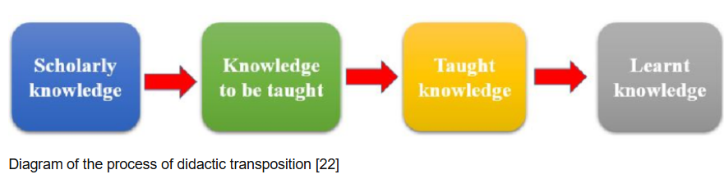

In summary, didactic transposition is the process through which scholarly knowledge is transformed into teachable and learnable knowledge, first by curriculum designers (external transposition) and then by the teacher in the classroom (internal transposition).

  - Pupil’s representations

Activity
- Write down what you believe or know about the following topics by answering corresponding questions:
  - Biology: Photosynthesis – “How do plants get their food?”
  - Geography: Rivers – “Where does river water come from?”
  - History: The 1994 Genocide against the Tutsi in Rwanda – “What caused it?”
- Which ideas/answers are scientifically or historically accurate and which are misconceptions, without correcting them yet.

2.6.1 Meaning of pupils’ representations
Pupils’ representations refer to the ideas, beliefs, opinions, mental models or prior knowledge that learners already have about a topic, subject, concept, or phenomenon before they are taught it at school or during instruction. These representations come from daily life, previous learning, culture, family, media, language or personal experience, and they influence how pupils understand new knowledge (Gurung, 2021; Fyttas, et al., 2023; Susac, et al., 2023).
In teaching and didactics, pupils’ representations are important because learners do not come to class with empty minds. They already have their own way of explaining things, which may be correct, incomplete, or wrong. The teacher must first identify these representations and then help learners improve or change them through teaching.
For example, in science, some pupils may think that the sun moves around the Earth because they see the sun moving in the sky. This is a pupil’s representation. In history, a pupil may believe that all kings were good leaders, which is also a representation based on limited knowledge. In mathematics, a learner may think that multiplication always makes numbers bigger, which is not always true.
In didactics, taking into account pupils’ representations helps the teacher to adapt the lesson, correct misunderstandings, and guide learners toward correct scientific knowledge. Therefore, pupils’ representations are the starting point of teaching and learning, and they play an important role in the process of didactic transposition and effective instruction.

2.6.2 Key aspects of pupils’ representations
Understanding the key aspects of pupils’ representations is essential for designing effective instruction that builds on learners’ prior knowledge, experiences, and perspectives. Such aspects include the following:
- Pre-existing conceptions: Pupils come to the classroom with ideas about how the world works. These ideas may be scientifically accurate, partially correct, or completely incorrect (misconceptions).
- Constructed knowledge: Representations are not fixed; pupils continuously modify their understanding based on new experiences and learning. This is a constructivist view of learning.
- Multiple modalities: Representations can be expressed in various ways:
  - Verbal (what students say or write)
  - Visual (drawings, mind maps,)
  - Gestural or physical (body language or physical models)
  - Symbolic (mathematical or scientific symbols and notations)
  - Actions (physical actions or hands-on activities)
- Personal and subjective: Each pupil constructs meaning in unique ways. Even when students use the same words, the underlying understanding may differ significantly.
2.6.3 Examples of pupils’ representations
- A child may believe that plants get their food from the soil, rather than understanding photosynthesis.
- In geography, a pupil may think that the Earth is flat or that the sun moves around the Earth.
- In mathematics, some pupils think multiplication always makes numbers bigger, which is not true when multiplying by fractions or decimals.
- A student may create a mental image of the water cycle to better understand how precipitation, evaporation, and condensation work (Conceptual representation: help learners make sense of new information by connecting it to what they already know).
- A student may use a graph to represent the relationship between variables in a scientific experiment (visual representation: helpful in clarifying abstract or complex ideas, making them easier to understand and remember).
- A student may describe a process or explain a solution to a problem using words (Verbal representations: help students clarify their thoughts and communicate their understanding to others).
- A student uses equations, formulas, or algebraic expressions as symbolic representations of relationships or phenomena (Symbolic representation: essential for working with mathematical concepts and abstract scientific ideas).
- A student builds a model or conducts an experiment in Physics (action-based representation): helps kinesthetic learners or those who learn better through movement and physical interaction. Used especially in subjects that require practical skills.

2.6.4 Working with pupils’ representations

Recognizing pupils’ representations is key to effective teaching in secondary schools, because it allows teachers to correct misconceptions, connect new knowledge to prior ideas, and design meaningful learning activities. Teachers can work with pupils’ representations by:
Elicit prior knowledge through brainstorming, questioning, or diagnostic assessments.
Visualize thinking using concept maps, drawings, or diagrams.
Challenge misconceptions through guided inquiry, experiments, or real-life applications.
Encourage metacognition by asking pupils to reflect on how their thinking has changed.
Use formative assessment to track shifts in pupil understanding.

2.6.5 Importance of pupils’ representations in the teaching and learning process
Pupils’ representations matter in teaching because they provide insight into how learners perceive, interpret, and understand concepts. In education, a “representation” refers to the ways in which students mentally organize knowledge, express ideas, and construct meaning through words, drawings, models, diagrams, or actions.
These representations are important for several reasons:
Reveal prior knowledge and misconceptions: Pupils’ representations show what students already know and how they think about a topic. Misconceptions, incomplete understanding, or alternative conceptions become visible, allowing teachers to address them directly rather than assuming uniform understanding.
Guide instructional decisions: By analyzing pupils’ representations, teachers can tailor their teaching strategies to meet learners’ needs. For example, if students depict a scientific process incorrectly in a diagram, the teacher can focus on clarifying the steps and underlying principles.
Promote active engagement: Encouraging students to create representations requires them to actively process information. This engagement helps deepen understanding, strengthens memory, and develops higher-order thinking skills such as analysis, synthesis, and evaluation.
Support differentiation: Pupils represent knowledge in diverse ways depending on their learning styles, abilities, and backgrounds. Recognizing these differences enables teachers to differentiate instruction, provide multiple modes of explanation, and support all learners effectively.
Facilitate assessment and feedback: Representations provide concrete evidence of learning. Teachers can assess comprehension, monitor progress, and give targeted feedback based on how students express their understanding.
Encourage reflection and metacognition: When students create representations, they reflect on their own thinking and learning processes. This helps them become more aware of their understanding, identify gaps, and develop strategies for improvement.
Effective teaching does not simply replace misconceptions it builds on existing representations to guide students toward more accurate and deeper understanding.

Activity:
- Given the following examples of secondary school pupils’ representations:
  - Biology: “Plants eat soil to get food.”
  - Physics: “Heavier objects fall faster than lighter objects.”
  - History: “The 1994 genocide against happened because one group wanted to harm the other group.”
- Identify the misconception in each statement.
- Suggest a teaching strategy to address it
- Explain how understanding pupils’ representations helps plan lessons that build correct knowledge.

  - The concept of Metacognition
Activity: Think of three different ways you could remember a shopping list of 10 items without writing them down.
- What strategies did you use to remember the items?
- Why did you choose that strategy?
- Did you change your strategy when one didn’t work?

Meaning of metacognition

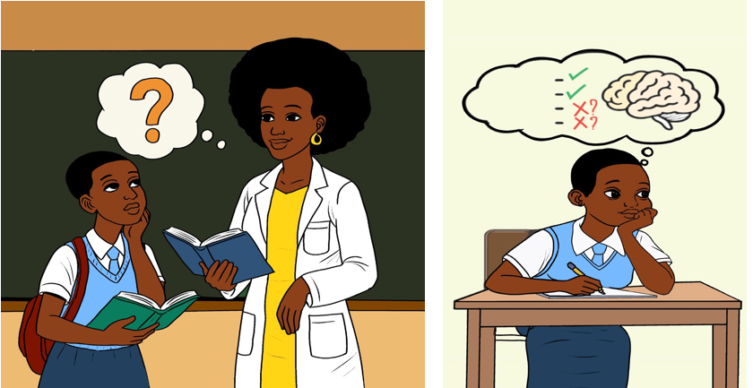

Metacognition refers to the awareness and understanding of one’s own thinking processes. It involves the ability to monitor, control, and regulate one’s cognitive activities in learning situations. Metacognition is “thinking about thinking”: the ability to think about and regulate one’s own thinking processes. It encompasses a variety of skills and strategies that help individuals reflect on their learning, plan how to approach a task, monitor their progress, and evaluate the effectiveness of their strategies. It involves being aware of how you learn, solve problems and make decisions, as well as how to recognize when a strategy is working or when adjustments are needed (Cambridge Assessment International Education, 2019; NSW Department of Education, 2017).
Example: A student knows that they are good at memorizing definitions but struggle with understanding complex concepts, so they use diagrams to help with conceptual understanding.

Key components of metacognition

Activity: Reflect on your learning of unit 2 of this module and respond to the
following questions:
- What have I learnt about the key pedagogical concepts in Unit 2?
- Do I fully understand each concept? If not, which ones are unclear?
- Which learning strategies am I using to understand these concepts?
- Are the strategies I am using effective in helping me understand Unit 2?
- What changes or new strategies can I adopt to improve my understanding?

There are four main components of metacognition (Cambridge Assessment International Education, 2019)

Metacognitive knowledge
This involves knowing about oneself as a learner, knowing your strengths and weaknesses as a learner. It involves knowing about the strategies that work best for understanding and remembering information, and the nature of the task at hand. For example, if you can explain what your strengths are in academic writing, or exam taking, or other types of academic tasks, then you are metacognitively aware. Metacognitive knowledge can be broken down into three main types:
- Declarative knowledge: Knowing hat you know (e.g. facts, concepts), or understanding the information and concepts you are learning and what strategies are available for learning.
- Procedural knowledge: Knowing how to perform certain tasks or how to use strategies effectively to process information, such as how to summarize, organize, or self-test.
- Conditional knowledge: Understanding hen and hy to use specific strategies, depending on the task or context; why a procedure or strategy succeeds in solving a problem, under what conditions and why a strategy is better than the other.

Metacognitive monitoring
Metacognitive monitoring refers to the ongoing process of checking and evaluating one’s own understanding, performance, or progress during a learning task. This involves self-assessment to identify when something is not working and needs to be changed. Metacognitive monitoring involves:
- Self-questioning: Asking questions like “Do I understand this?” or “Am I making progress?” while learning.
- Tracking progress: Continuously assessing whether current strategies are effective or whether a different approach is needed.
- Recognizing gaps: Realizing when knowledge or skills are missing or unclear and identifying when more effort is needed to understand something fully.
Example: While reading a chapter in a textbook, a student checks whether they can recall the main ideas from the previous section, deciding to review the material if they can’t.

Metacognitive control or regulation
The ability to control or adjust one’s cognitive processes to optimize learning. This includes deciding when and how to use strategies, when to switch strategies, and how to overcome obstacles. This is the active process of monitoring, controlling, and adjusting one’s cognitive processes during learning.

Examples:
- If a student realizes that highlighting the text is not helping them understand the material, they might switch to summarizing key points or discussing the material with a peer.
- A student might decide to take a short break after completing a set of practice problems in order to recharge and maintain focus for the next set.

D.Metacognitive reflection
Reflecting on one’s cognitive processes after completing a task. It involves evaluating what worked well, what didn’t, and how future performance can be improved. It involves:
- Self-reflection: Looking back on the strategies used and their effectiveness in solving a problem or completing a task.
- Analyzing successes and failures: Reviewing whether the chosen strategies led to success or failure and considering why.
- Adjusting for future tasks: Using reflection to guide future decisions about strategies, time management, and learning approaches.
Example: After finishing a test, a student reflects on the questions they found most challenging, evaluating which strategies helped them succeed and which ones need improvement for next time.

Other examples of metacognitive processes
- Writing an essay:
- Planning: A student decides on a topic, outlines their argument, and plans when to write different sections of the essay.
- Monitoring: While writing, they periodically check to see if their arguments are clear and relevant to the topic.
- Control: If they find that their argument isn’t strong enough, they might
  - change their thesis or gather more evidence.
- Reflection: After finishing, they reflect on what worked well in the writing process, such as organization or clarity, and what could be improved in the future.

Problem solving in Math:
- Planning: A student reads through the problem, breaks it down into smaller steps, and decides whether to use a formula or draw a diagram.
- Monitoring: As they work through the problem, they periodically check if their steps make sense or if they are stuck on a specific part.
- Control: If they get stuck, they decide to try another approach or seek help from a classmate.
- Reflection: After solving the problem, the student reflects on which strategies were most effective and how to approach similar problems next time.

Metacognitive strategies
Metacognitive strategies help students plan, monitor, and evaluate their learning processes, leading to improved comprehension, problem-solving, and academic performance. These strategies include the following:
- Self-questioning: Asking questions before, during, and after learning tasks (e.g., “What do I already know about this topic?” “How can I apply this information?” “Did I understand this correctly?”).
- Think-aloud: Verbalizing thoughts while solving problems or reading to make the thinking process explicit and help students identify errors or areas of confusion.
- Summarizing and paraphrasing: Writing or speaking summaries of what has been learned to ensure understanding and reinforce key concepts.
- Mind mapping: Using diagrams to organize and represent knowledge, helping learners visualize connections between concepts.
- Self-testing: Regularly testing oneself on the material to monitor understanding and retention, which helps reinforce learning and identify gaps in knowledge.
By applying these strategies, learners can take an active role in their learning journey, leading to deeper comprehension and long-term success.

Activity:
In a secondary school classroom, Ms. Uwase noticed that many students were struggling to understand complex science concepts despite reviewing their notes regularly. She introduced a new routine: before every topic, students were asked to write down what they already knew; during the lesson, they paused to ask themselves questions about the content; and after the lesson, they reflected on what worked well and what did not. One student, Mutesi, realized she was only memorizing facts without understanding them. She began using mind maps and summarizing information in her own words. Over time, her performance improved significantly.
Questions:
- Based on the scenario, how did Mutesi demonstrate an understanding of metacognitive knowledge in her learning process?
- What examples of metacognitive monitoring and control can you identify in Ms. Uwase’s teaching approach?
- How does self-reflection, as shown in the scenario, contribute to improved learning outcomes?
- If you were Mutesi, what additional metacognitive strategy would you apply to further enhance your understanding of complex topics?

Unit 3: Theories of Learning and their classroom applications

Activity: Can you recall a moment when a teacher’s teaching method really helped you understand something? What did the teacher do?

Introduction

Learning occurs in diverse ways and is shaped by many factors, leading to the development of psychological theories that explain how individuals acquire, process, and retain knowledge. This unit focuses on key theories, behaviorism, cognitivism, constructivism, social constructivism, social learning, sociocultural theory, and connectivism, each offering a unique perspective on learning. Understanding these theories helps to make informed decisions about instructional strategies, classroom management, and the creation of inclusive learning environments that address diverse learner needs.
Unit learning outcomes
By the end of this unit, you will be able to:
Describe major learning theories to build a foundational understanding of how learners acquire knowledge and how teaching approaches are shaped.
Compare learning theories in terms of their assumptions to evaluate their strengths, limitations, and relevance in different educational settings.
Discuss classroom applications of learning theories to guide the selection of effective instructional strategies that address diverse learner needs.

3.1 Behaviorism
Activity: Answer the following questions:
- What actions do you plan to take when a learner answers a question correctly?
- What measures do you intend to take when a learner arrives late at school?
- What decisions do you think the learner, and their classmates are likely to make in response to such situations described in 1 and 2 above?

Behaviorism is a learning theory that focuses on observable behaviors rather than internal mental states. It assumes that all behaviors are learned through interactions with the environment and can be measured, changed, and controlled using reinforcement and punishment. Behaviorism, as a learning theory, includes both classical conditioning or learning by association (Pavlov) and operant conditioning (Skinner) as types of learning that explain how behavior is acquired through interaction with the environment (Giannoukos, G. (2024). The key theorists of behaviourism include John Watson (1878–1958), Ivan Pavlov (1849–1936), Edward L. Thorndike (1874–1949) and B.F. Skinner (1904–1990).

Classical conditioning or learning by association

Classical conditioning is a learning process first described by Ivan Pavlov, a Russian physiologist. It involves learning through association, where a neutral stimulus becomes associated with a meaningful stimulus, eventually triggering a similar response: an association is made between two stimuli which are linked together to produce a new learned response. One stimulus is neutral and the other evokes a natural response. After learning the association, the neutral stimulus elicits the conditioned response.

- Pavlov’s experiment

In his experiments, Pavlov gave the food=meat (Unconditioned Stimulus/ US) to a dog, and the dog salivated (Unconditioned Response/UR). Pavlov paired the presentation of food with the sound of a bell (Unconditioned Stimulus/ US + Neutral Stimulus/NS) and the dog salivated (Unconditioned Response/UR). After several pairings (of the sound and the food), the dogs began to salivate as soon as they heard the sound. The sound of the bell (Conditioned Stimulus/ CS) caused the dog to salivate even in the absence of food (Conditioned Response/CR). The dog had learned to associate the sound with the food that followed, or the dog had learned to salivate to a new stimulus (the sound of the bell). This is conditioning. Even without seeing the food, the dogs began to salivate at the ringing of the bell. The dog had associated the ringing of the bell with the arrival of the food and reacted accordingly (salivated).
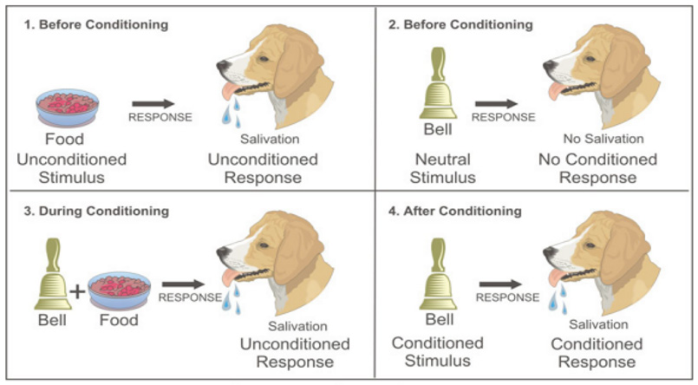
Illustration of classical conditioning (REB, 2020, p. 185)

B. Principles of classical conditioning
The principles of classical conditioning include extinction, spontaneous recovery, stimulus generalization, and stimulus discrimination.
B.1 Extinction
After the conditioning had taken place, Pavlov continued his experiment and presented the sound of the bell repeatedly but without presenting the food afterward. The behavior (salivation) rapidly decreased: the dogs salivated less and less to respond to the sound of the bell, and eventually the sound did not elicit salivation at all. The dog stopped salivating with the sound of the bell because there was no reinforcement (food). This behavior is referred to as extinction: reduction in responding that occurs when the conditioned stimulus is presented repeatedly ithout the unconditioned stimulus.
B.2 Spontaneous recovery
Pavlov found that, after a pause, ringing again the bell elicited salvation, although to a lesser extent than before extinction took place. The increase in responding to the CS folloing a pause after extinction is known as spontaneous recovery, that is, the reminiscence of earlier learning. Although at the end of the first extinction period the CS was no longer producing salivation, the effects of conditioning had not entirely disappeared.
B.3 Stimulus generalization
Pavlov also experimented with presenting new stimuli that were similar, but not identical to, the original conditioned stimulus. He found that dogs also salivated upon experiencing similar stimulus, a process known as stimulus generalization: the tendency to respond to stimuli that resembles the original conditioned stimulus.
The ability to generalize has important significance: If we eat some red berries and they make us sick, it would be a good idea to think twice before we eat some purple berries. Although the berries are not exactly the same, yet they are similar and may have the same negative properties.
B.4 Stimulus discrimination
The opposite of generalization is stimulus discrimination: the tendency to respond differently to stimuli that are similar but not identical. Pavlov’s dogs quickly learned, for example, to salivate when they heard the specific tone that had preceded food, but not upon hearing similar tones that had never been associated with food.
Discrimination is also useful: if we do try purple berries, and if they do not make us sick, we will be able to make the distinction in the future. And we can learn that although the two people in our class, Moses and Peter, may look alike, they are, however, different people with different personalities

C. Application of classical conditioning in classroom settings
The teachers can apply classical conditioning in the classroom by doing the following (Qi et al, 2021):
Avoid presenting painful experiences (stimuli) to learners as they may learn (become conditioned) to fear or hate school. For example, a teacher who frequently humiliates a learner for giving a wrong answer may cause that learner to fear participation or even dislike attending school. Instead, correcting mistakes in a supportive and respectful manner helps maintain a positive learning environment.
Identify the most important aspects of the lesson and emphasize them so that learners can discriminate or differentiate them. For instance, during a science lesson, a teacher may highlight and repeatedly stress the formula and key terms, while using diagrams or bold writing on the board to help learners focus on what matters most.
Give learners more opportunities to use and repeat the knowledge they have acquired. For example, after teaching a new mathematical concept, a teacher can provide multiple practice exercises, group work activities, or short quizzes, allowing learners to apply the concept several times in different contexts until it becomes familiar.
Reinforce desired behaviors and punish undesired ones. For instance, praise students after they answer questions correctly. Over time, students may begin to associate the teacher’s specific praise with positive reinforcement, making them feel more engaged and eager to participate. This helps create an atmosphere where students are conditioned to feel positive emotions toward classroom activities.
Encourage desirable behaviors by associating those behaviors with positive stimuli: For example, a teacher can offer verbal praise (UCS) when a student raises their hand before speaking (NS). Over time, the student will begin to associate raising their hand (CS) with praise (CR), leading to more frequent hand-raising during class discussions.
Reduce negative behaviors through extinction: If a student feels anxious when called on to speak in class (due to negative past experiences), the teacher can work to reduce this fear by consistently praising or encouraging the student when they participate, eventually removing the negative association with speaking in front of the class.
Help students develop positive emotional responses toward learning activities: Examples, a teacher who consistently provides positive feedback when a student participates in discussions can condition the student to feel a sense of pride and confidence when engaging in those activities. A student who initially feels nervous about presenting in front of the class might begin to associate the act of speaking in front of others with praise and recognition from the teacher. Over time, the student may experience positive emotions toward public speaking, due to the conditioned emotional response.
Using music to enhance focus: Teachers can use background music or specific sounds as neutral stimuli (NS) and pair them with productive learning experiences, turning the sound or music into a conditioned stimulus (CS). Over time, students may become conditioned to focus or feel more relaxed when they hear the music or sound. For instance, a teacher may play soft classical music while students are doing independent work. Over time, the students will associate the music with concentration and productivity, leading them to feel more focused whenever they hear it.

Operant conditioning: Changing behavior through reinforcement and punishment

Activity: Have you ever been rewarded for good behavior or performance in class? What was the implication in terms of your behavior and learning?

Operant conditioning, sometimes referred to as instrumental conditioning, is a type of learning first developed by Edward L. Thorndike and later expanded by B.F. Skinner. Operant conditioning emphasizes how behavior is shaped and maintained by its consequences. It is learning that occurs based on the consequences of behavior and can involve the learning of new actions. In operant conditioning, the organism learns from the consequences of its own actions. Unlike classical conditioning (which is based on association), operant conditioning involves voluntary behaviors and how they are influenced by rewards or punishments.

- Operant conditioning: The research of Thorndike

An American Psychologist Edward L. Thorndike (1874–1949) was the first scientist to systematically study operant conditioning. In his research, Thorndike (1898) observed cat who had been placed in a “puzzle box” from which they tried to escape. After many attempts, the cat accidentally pressed the lever that opened the door and went to their prize: a small piece of fish.
The next time, the cat was constrained within the box, it attempted fewer of the ineffective responses before carrying out the successful escape, and after several trials the cat learned to almost immediately make the correct response.
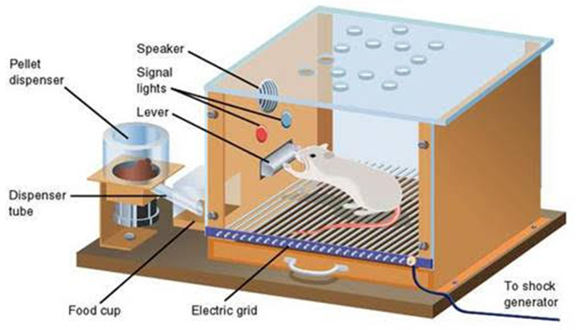

The research of Thorndike: The law of effect

Observing these changes in the cats’ behavior led Thorndike to develop his law of effect, the principle that responses that create a typically pleasant outcome in a particular situation are more likely to occur again in a similar situation, whereas responses that produce a typically unpleasant outcome are less likely to occur again in the situation. The key idea of the law of effect is that successful responses, because they are pleasurable, are “stamped in” by experience and thus occur more frequently. Unsuccessful responses, which produce unpleasant experiences, are “stamped out” and subsequently occur less frequently.

Operant conditioning: Skinner’s experiment

The most famous behaviorist was Burrhus Frederick (B. F.) Skinner (1904–1990). B. F. Skinner expanded on the Thorndike’s ideas to develop a more complete set of principles to explain operant conditioning. His experiments were quite similar to the Thorndike’s research with cats. He used a Skinner box to study operant learning. The box contains a bar or key that the organism can press to receive food and water, and a device that records the organism’s responses.
Skinner placed a hungry rat in a box (Skinner box). The box had a lever or button the animal could press, a dispenser for food (as a reward) and sometimes, an electrified floor to deliver mild punishment. The installation of the box ensures that when the bar is pressed, the food will be released into the cup. The rat started to explore after smelling the food and accidentally pressed the bar, causing food to fall into the cup and the rat ate the food. The next time, the rat took a little less time to press the lever, and on successive trials, the time it took to press the lever became shorter. Soon, the rat pressed the lever as fast as to eat the food that appeared (the reinforcer of the response). The rat had learned to repeat the action that brought about the food and cease the actions that did not.

Key concepts in skinner’s operant conditioning

Skinner studied, in detail, how animals changed their behavior through reinforcement and punishment, and he developed terms that explained the processes of operant learning:
    - Reinforcer refers to any event that strengthens or increases the likelihood of a behavior.
    - Punisher refers to any event that weakens or decreases the likelihood of a behavior.
    - Positive and negative reinforcement or punishment to refer to whether a reinforcement or punishment was added/presented or removed, respectively.
    - Reinforcement: a consequence that increases the likelihood of a response/ behaviour to occur. Reinforcement, either positive or negative, works by increasing the likelihood of behavior
    - Positive reinforcement: adding a good/pleasant stimulus after a response in order to encourage the response to continue. Examples: A teacher might praise a student for completing their work on time or for showing kindness to a classmate. Compliments like Great job! I’m really impressed by your effort, or You’re really focusing well today! Encourage the student to repeat the behavior. At the end of the week or month, students who have shown consistent effort, good behavior, or academic improvement might receive awards: “Student of the Month” awards, or other forms of recognition.
    - Negative reinforcement: removal of an undesirable stimulus after a response so that the response will occur more often. Examples: If a student consistently turns in assignments on time, the teacher might reduce the amount of homework assigned to that student, thereby reinforcing the behavior of punctuality and responsibility. If a student is in a timeout for misbehaving but then demonstrates improved behavior, the teacher may choose to end the timeout earlier than expected, thus reinforcing the positive behavior.
    - Punishment: a consequence that decreases the likelihood of a response/behaviour to occur. If you are using punishment, you are trying to decrease the behaviour. Punishment refers to any event that weakens or reduces the likelihood of a behavior.
    - Positive punishment: Adding a negative consequence after undesired behavior is exhibited, the behavior is less likely to happen in the future, will occur less or stop. Examples: Giving extra work to a student for misbehaving; a child who is beaten after fighting with a sibling is less likely to repeat these behaviors. A student receives a call phone in classroom, and he/she picks up the call and starts talking in class, the teacher then reprimands him in front of the whole class and adds his homework to be twice as much as the rest of the students. The consequence or the punishment of receiving a phone call discourages him from repeating the action again. Positive punishment weakens a response by presenting something unpleasant after the response. It involves adding something unpleasant to discourage behavior.
    - Negative punishment. Removing a certain desired or pleasing stimulus after a particular undesired behavior is exhibited, resulting in the behavior happening less often in the future, will occur less or stop Taking away television or video games from a child for misbehaving so that he or she will stop misbehaving. A child who loses the opportunity to go to recess after getting a poor grade) is less likely to repeat these behaviors. A student who really enjoys a specific class, such as gym or music classes at school, negative punishment can happen if he/she is removed from that class and sent to the principal’s office because he/she is misbehaving. Taking the cell phone of a student after receiving a call in class. If a student misbehaves, the teacher might take away a portion of their recess, which is something they enjoy. Negative punishment weakens a response by reducing or removing something pleasant. It involves removing something desirable to decrease behavior.

Although the distinction between reinforcement (which increases behavior) and punishment (which decreases it) is usually clear, in some cases, it is difficult to determine whether a reinforcer is positive or negative. For example, on a hot day, a cool breeze (gentle wind) could be seen as a positive reinforcer (because it brings in cool air) or a negative reinforcer (because it removes hot air). In other cases, reinforcement can be both positive and negative. One may smoke a cigarette both because it brings pleasure (positive reinforcement) and because it eliminates the craving (strong desire) for nicotine (negative reinforcement).

- Continuous and partial reinforcement

One way to expand the use of operant learning is to modify the schedule on which the reinforcement is applied. There are two main types of reinforcement schedules: continuous reinforcement and partial reinforcement.

In continuous reinforcement, the desired behavior is reinforced every time it occurs. For instance, whenever the child gets good marks, he/she gets a biscuit. A student receives praise every time they turn in their homework on time. Continuous reinforcement results in relatively fast learning but also rapid extinction of the desired behavior once the reinforcer disappears. The problem is that because the organism is used to receiving reinforcement after every behavior, the responder may give up quickly when it doesn’t appear.

In partial reinforcement, the desired behavior is reinforced only some of the time, not every time it occurs. Partial reinforcement occurs at irregular intervals: the responses are sometimes reinforced, and sometimes not. A student may receive praise for their behavior occasionally, but not every single time they act appropriately. A student might be given a reward (like extra recess time or a privilege) on an unpredictable schedule, making it less predictable when they will earn it. This encourages the behavior to continue because the student is unsure when the next reward will come.

The four types of partial reinforcement schedules
Partial reinforcement schedules are determined by whether the reinforcement is presented on the basis of the time that elapses between reinforcements (interval) or on the basis of the number of responses that the organism engages in (ratio). These are:
- Fixed-ratio schedule
- Variable-ratio schedule
- Fixed-interval schedule
- Variable-interval schedule

In a fixed-ratio schedule, a behavior is reinforced after a specific number of responses or reinforcement is provided after a set number of responses or behaviors. For instance,
- A student gets a small prize of a pen for example after completing 5 math problems correctly.
- A student receives a notebook after every 10 books they read or after every 10 assignments they complete.
This type of reinforcement leads to a high rate of response, as students know exactly what they need to do to get the reward. However, once the student earns the reward, they might take a short break before resuming work, as the reinforcement is predictable.

A variable-ratio schedule provides reinforcers after a specific but average number of responses or Reinforcement is provided after an unpredictable number of responses or behaviors. The number of responses needed to get reinforced varies around average. A teacher randomly praises a student after an unpredictable number of correct answers or positive behaviors. For instance, they might praise a student after 3, 5, or 8 correct answers in class, but the praise is not given on a set schedule.

This type of reinforcement tends to create a high, stable rate of responding because students never know when the reinforcement will come, keeping them motivated to engage continuously. Ratio schedules tend to produce high rates of response because reinforcement increases as the number of responses increases.

In a fixed-interval schedule, reinforcement occurs for the first response made after a specific amount of time has passed or reinforcement is provided after a fixed amount of time has passed, regardless of the number of responses or behaviors. Examples:
- Weekly quiz: Every Friday, the teacher gives a quiz on the material studied during the week. Students are reinforced (either through a grade or verbal praise) for their performance on the quiz, regardless of how many answers they get correct.
- Time-based rewards: After a specific time interval (e.g., every 30 minutes), the teacher gives a short break to students who have been working steadily during that period.
Students may exhibit bursts of activity as the time for reinforcement approaches, but there may be a decrease in activity right after the reinforcement. For example, there might be a burst of study efforts just before the quiz. Most students study for exams in the same way.

In a variable-interval schedule: the reinforcers appear on an interval schedule, but the timing is varied around the average interval, making the actual appearance of the reinforcer unpredictable or Reinforcement is provided after a variable amount of time has passed, with the time interval varying around an average. A teacher might give short quizzes throughout the week, but the students don't know when these quizzes will happen. Since the reinforcement (in this case, grades or praise after each quiz) comes at random intervals, students tend to stay prepared and engaged. Quizzes are given at unpredictable intervals, so students don't know when to expect one. The timing of the quizzes varies. A teacher might randomly check whether students are on task during independent work. The student doesn't know when the teacher will come around, so they remain focused and keep working in case the teacher checks in. A teacher might provide praise or a small reward at random times throughout the lesson. For example, a student who consistently contributes to class discussions might receive praise, but the teacher does not follow a set schedule for when to provide it.

Interval reinforcement schedules tend to produce slow and steady rates of responding. This schedule encourages consistent and steady behavior, as students know they will eventually receive reinforcement, but they are unsure of exactly when it will occur. This can lead to higher levels of sustained engagement, as students remain attentive and active in anticipation of reinforcement.

- Application of operant conditioning in classroom settings

The teachers can apply operant conditioning in the classroom by (Qi et al, 2021):
- Deciding what behavior they want from learners (clear instructional objectives) and reinforce that behavior when it occurs. Each correct response of a learner should be reinforced.
- Providing feedback on progress and linking rewards with that progress.
- Using positive reinforcement: Teachers can use rewards like praise, stickers, or tokens to reinforce desired behaviors, such as participation, completing tasks, or staying on task.
- Using negative reinforcement: The removal of an undesirable stimulus, such as reducing homework for consistently good behavior, can encourage students to behave positively.
- In classroom management, teachers can establish clear rules and routines, providing consistent consequences for actions (e.g., a time-out for disruptive behavior).
- Using repetition and drills: Through frequent practice (e.g., activities, tests), students learn through repetition and reinforcement of learned behaviors.

But the use of positive reinforcement in changing behavior is almost always more effective than using punishment. This is because positive reinforcement makes the person or animal feel better, helping create a positive relationship with the person providing the reinforcement. Although reinforcement can be effective in education, and teachers make use of it by awarding good grades, and praise, there are also substantial limitations to using reward to improve learning. To be most effective, rewards must be contingent on appropriate behavior.

In some cases, teachers may distribute rewards indiscriminately, for instance by giving praise or good grades to children whose work does not warrant it, in the hope that they will “feel good about themselves” and that this self-esteem (confidence in abilities) will lead to better performance.
Studies indicate, however, that high self-esteem alone does not improve academic performance.
When rewards are not earned, they become meaningless and no longer provide motivation for improvement. Another potential limitation of rewards is that they may teach students that the activity should be performed for the reward, rather than for one’s own interest in the task. If rewards are offered too often, the task itself becomes less appealing. Some children may engage in an activity for a reward, rather than because they simply enjoyed it.

Punishment is generally less effective than reinforcement in changing behavior. For instance, students who are punished for bad behavior are likely to change their behavior only to avoid the punishment, rather than internalizing the norms of being good for its own sake. Punishment also tends to generate anger, defiance, and a desire for revenge. Punishment is more likely to create only temporary changes in behavior because it is based on coercion and typically creates a negative and adversarial (conflict or opposition) relationship with the person providing the punishment. When the person who provides the punishment leaves the situation, the unwanted behavior is likely to return.

Activity:
- Suppose you have been appointed as a mentor at your school. One day, a colleague approaches you and shares that they are struggling to apply behaviorist theory in their teaching. How would you guide or advise them to implement behaviorist principles effectively in the classroom?
- Provide two innovative classroom-related examples for each of the following (do not provide examples given in class):
- Positive reinforcement
- Negative reinforcement
- Positive punishment
- Negative punishment
- Fixed ratio reinforcement schedule
- Variable ratio reinforcement schedule
- Fixed interval reinforcement schedule
- Variable interval reinforcement schedule
- Discuss the benefits and potential challenges of classical conditioning and operant conditioning in the teaching and learning process.

  - Cognitivism

Activity:
- When you are trying to learn something new, like a math formula or a new language, what happens in your mind?
- Think about the last time you had to remember something for a test or exam. What did you do to help yourself remember it?

- Description of cognitivism
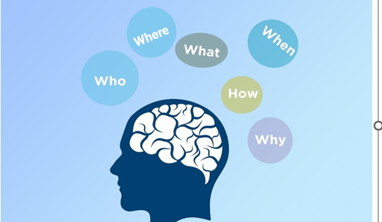
Cognitivism is a learning theory that focuses on the internal mental processes involved in learning, such as thinking, memory, perception, attention, judgement, problem-solving and metacognition. It focuses on how people think, understand, and know about the world. It put emphasis on learning how people understand and represent the outside world within themselves and how our ways of thinking about the world influence our behavior. It emerged in response to the limitations of behaviorism, which focused only on observable behavior and ignored the mental activities of the learner (Giannoukos, G. (2024).

Cognitivism was influenced by technology like other sciences. Beginning in the 1960s, growing numbers of psychologists began to think about the brain and human behavior in terms of the computer, which was being developed and becoming publicly available at that time. Cognitivism focuses on mental processes which correspond well to the processes that computers perform. Cognitivists compare human thinking to the workings of a computer, which takes in information and transforms, stores, and retrieves it. In their view, thinking is information processing. Cognitivism view learners as active participants who process, store, and retrieve information. The theory suggests that learning occurs when learners make sense of and organize new information by connecting it with their existing knowledge. According to cognitivists, mental processes and past knowledge influence behavior or response more than external stimuli do (Schunk, 2021; Ormod, 2020).

Some of the important contributors to cognitivism include:
- The German psychologist Hermann Ebbinghaus (1850–1909), who studied the ability of people to remember lists of words under different conditions;
- The English psychologist Sir Frederic Bartlett (1886–1969), who studied the cognitive and social processes of remembering;
- Jean Piaget, George Miller, and Eleanor Rosch work to understand how people learn, remember, and make judgments about the world around them. For instance, the idea that our memory is influenced by what we already know was also a major idea behind the cognitive- developmental stage model of the Swiss psychologist Jean Piaget (1896–1980) and
- Lev Vygotsky (1896–1934), a Russian psychologist who worked on cognitive development.

- Application of cognitivism in classroom settings

- Giving activities that encourage deep thinking, such as problem-solving tasks, discussions, and concept mapping (Schunk, 2021; Ormod, 2020).
- Activating prior knowledge: Teachers begin lessons by asking questions or using brainstorming to connect new content to what students already know.
- Teachers can use strategies like scaffolding to support learners as they progress through tasks, gradually reducing help as they become more proficient. Example: In teaching math problem- solving, the teacher may first demonstrate how to solve a problem, then guide the student step- by-step, and eventually encourage the student to solve problems independently.
- Use of visual aids and concept maps: Encourage students to create visual representations of the relationships between concepts, which helps organize and deepen understanding. Concept maps help learners organize their thoughts, integrate new information with prior knowledge, and visualize complex ideas, making abstract concepts more concrete. Example: After learning a unit on ecosystems, students could create a concept map that connects key concepts such as food chains, biodiversity, and the water cycle.
- Fostering active learning: Encourage students to engage in activities that require them to process information, that promote critical thinking and problem- solving rather than passive reception of information such as group discussions, problem-solving tasks, and hands-on experiments. Example: Students work on group projects or participate in debates where they are required to apply theoretical knowledge to real-world scenarios.
- Promoting metacognition: helping students become aware of how they learn, their learning strategies and reflect on their understanding of the learning materials. For example: Before a test, the teacher might ask students to review their study strategies and think about which methods helped them understand the material best.
- Use Problem-Based Learning (PBL): encourage students to work in groups to solve complex, real-world problems.
- Use cognitive apprenticeship: students learn through observation, practice, and collaboration with an expert. Learning is best achieved in authentic contexts where learners can observe and participate in real tasks. For example: In a science classroom, the teacher models how to conduct an experiment, explaining the steps and reasoning behind the process. Students then replicate the experiment, initially with guidance and eventually independently. This helps students develop both problem-solving skills and a deeper understanding of how knowledge is applied in real-life contexts.
- Paced repetition: A teacher can use this technique where information is reviewed at increasing intervals over time, aiding in long-term retention and the reinforcement of cognitive schemas. Spaced repetition helps solidify information in long-term memory and encourage deeper cognitive processing, improving retention and recall.
- Inquiry-Based Learning: involves students actively participating in their learning by posing questions, investigating answers, and engaging in exploration. This stimulates curiosity, encourages active exploration, and fosters higher order thinking skills such as analysis, synthesis, and evaluation.

Activity:
- Choose a topic in one of the subjects you teach or will teach in secondary schools and explain how you will apply cognitive learning theory to teach that topic.
- Discuss the benefits and challenges of applying cognitivism in classroom contexts

  - Constructivism
Activity: How do you know that the sun rises in the East?

Description of constructivism

Constructivism is a learning theory emphasizing that learners construct their own understanding and knowledge of the world, through experiencing things and reflecting on those experiences. It is rooted in the idea that learning is an active, contextual, and social process, rather than a passive absorption of information (Giannoukos, 2024). It emphasizes the active role of learners in constructing their own understanding of the world. According to this theory, knowledge is actively built by learners as they interact with their environment. Learning is seen as an active process where students build on prior knowledge. Learning is seen as a process of discovery and personal meaning-making. It is learner-centered, focusing on the idea that learners create their own meanings through experiences, problem-solving, and reflection.

This theory is rooted in the work of Jean Piaget, Jerome Bruner, David Ausubel, and other psychologists, who emphasized that learning occurs best when students engage in active exploration and critical thinking, building on prior knowledge and experiences.

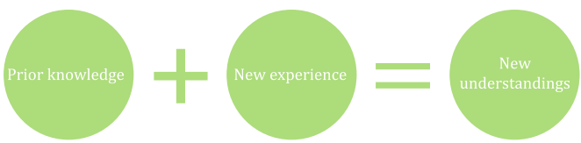
Illustration of constructivism (REB, 2020)

Core principles of constructivism

The core principles of constructivism emphasize that learners actively construct knowledge through experience, interaction, and reflection, making learning a meaningful and personalized process (Al-Qahtani & Higgins (2013).
- Knowledge is constructed, not transmitted: Learners actively build new knowledge by connecting it to their prior experiences and understanding.
- Learning is an active process: It involves exploration, questioning, problem-solving, and engagement with the environment.
- Social interaction supports learning: Learning often occurs through dialogue, collaboration, and interaction with others, teachers, peers, or even community members.
- Contextual and situated learning: Learning is most meaningful when it is embedded in real-life or authentic contexts, not isolated facts or drills.
- Learner-centered approach: The teacher acts as a facilitator or guide, not a transmitter of knowledge. Students are empowered to take ownership of their learning.
- Scaffolding: Teachers provide temporary support to help learners complete tasks that they cannot do independently but can accomplish with guidance. As learners gain mastery, the support is gradually reduced.
- Learning is a social activity where sharing and negotiating knowledge is the norm, and students will work in small groups.
- Prior knowledge: Learners build new knowledge upon their existing knowledge and experiences. This prior knowledge serves as the foundation for further learning.
- Problem-solving: Constructivism values real-world problem-solving and critical thinking. It encourages learners to engage in tasks that require them to make decisions, solve problems, and reflect on their learning.
- Self-directed learning: Students are encouraged to take responsibility for their own learning, promoting autonomy and self-regulation.
Key theorists of constructivism:
- Jean Piaget (1896–1980): Piaget is one of the most well-known theorists in constructivism. His work focused on how children develop cognitive structures and how these structures evolve through stages as they actively interact with their environment. Key contributions:
    - Cognitive development stages: Piaget proposed four stages of cognitive development: sensorimotor, preoperational, concrete operational, and formal operational.
    - Assimilation and accommodation: He emphasized the processes of assimilation (fitting new experiences into existing cognitive structures) and accommodation (changing cognitive structures to fit new experiences).
    - Piaget believed that children actively construct their understanding of the world by interacting with it.
2. Jerome Bruner (1915–2016):
Bruner argued that learning is an active process where learners construct new ideas based on their current and past knowledge. Key contributions:
    - Discovery learning: Bruner advocated for teaching methods that encourage learners to discover information themselves, as opposed to passively receiving knowledge.
    - Spiral curriculum: He proposed that curriculum should revisit key concepts regularly at increasing levels of complexity.
    - Scaffolding: Bruner emphasized the importance of providing learners with support structures that enable them to achieve tasks they can't accomplish alone.
3. David Ausubel (1918–2008): While not always associated with the term "constructivism," Ausubel's theory of meaningful learning fits within a broader constructivist framework. Key contributions:
    - Meaningful learning: Ausubel distinguished between meaningful learning (where learners relate new information to their existing knowledge) and rote memorization.
    - He proposed that new knowledge should be presented in a way that connects to the learner's existing cognitive structures to make it meaningful and easier to retain.

Classroom applications of constructivism

Teachers create environments where students are encouraged to explore, ask questions, and solve real-world problems, with the teacher acting as a facilitator rather than a direct instructor. The following are examples of applications of constructivism learning theories in teaching and learning (Al-Qahtani & Higgins (2013).
Inquiry-based learning: Teachers must encourage students to ask questions, explore, and discover answers independently or through collaboration. For instance, in a literature class, rather than merely summarizing a book, students might be asked to inquire into the themes, character motivations, or author’s intent. They could discuss their hypotheses with peers, research their questions, and present their findings.
Collaborative learning: Students can learn from each other, share ideas, and engage in joint problem-solving. The role of the teachers is to create opportunities for collaborative learning through group work, peer discussions, and collaborative problem-solving tasks. These help students build knowledge through social interaction. For example, in a history class, students can work in groups to research different aspects of a historical event and then present their findings to the class. This fosters deeper understanding as they learn from each other and work together to create a comprehensive picture of the topic.
Project-Based Learning (PBL): an effective way to allow students to explore real-world problems and build knowledge through hands-on experiences. In PBL, students work on a project over an extended period of time, developing solutions, conducting research, and collaborating with peers. For example, in a science class, students might work on a project to design and build a sustainable model of a city. They would use principles of physics, engineering, and environmental science to solve problems and create prototypes, integrating knowledge from various subject areas.
Use of real-world problems: Teachers can design tasks that simulate real-life challenges and require students to engage in critical thinking and problem-solving. Like in a geography class, students might be asked to design a community garden for their school, considering factors like climate, soil quality, and community needs. This requires them to apply geographic and environmental knowledge in a practical, problem-solving context.
Make real-world connections: connect lessons to real-life situations to make learning meaningful and relevant. for example, applying math skills to budgeting or discussing current events in the context of history.
Scaffolding: Teachers provide guidance, resources, and support tailored to the learner’s current level of understanding. This support can be gradually reduced as students become more capable of working independently. Example, in a math class, a teacher might start by providing step-by-step instructions for solving a complex problem. Over time, the teacher might provide fewer cues, allowing the students to solve similar problems on their own as their confidence and competence grow.
Differentiated instruction: constructivist teachers recognize that students have varying levels of prior knowledge, skills, and learning preferences. They differentiate instruction by providing multiple avenues for students to engage with content, ensuring that all learners are appropriately challenged. For example, in a classroom where students have different reading levels, the teacher might offer a range of texts on the same topic: some may be more visual, others may be more complex, allowing each student to engage with the material at their own level.
Learner-centered environment: Constructivist classrooms are student-centered, with a focus on creating an environment that encourages exploration, curiosity, and self-directed learning. Teachers act as facilitators rather than lecturers, guiding and supporting students as they engage with the content. Example: In a literature class, students may have the freedom to choose a book that interests them and then share their insights or analyze the themes with their classmates. This approach allows students to take ownership of their learning and develop intrinsic motivation.
Reflective thinking/reflection: encouraging students to reflect on their learning (through journals or discussions) is an important aspect of constructivism. Normally, reflection helps learners make sense of new information, identify gaps in understanding, and consolidate their knowledge. Example here is, after completing a research project, students could be asked to reflect on what they learned, the challenges they encountered, and how they overcame them. This reflection helps them internalize their learning and apply it to future tasks.
    - What teachers do in constructivist classrooms

In constructivist classrooms, teachers:
seek and value their learners’ points of view;
pose problems and structure classroom experiences that foster the creation of personal meaning;
don’t provide everything, they incite learners to build knowledge;
assess continually learning
continually adjust the level of facilitation in response to the learners’ level of performance (Scaffolding).

Activity: Mr. Muneza, a geography teacher, presents a real-life problem with farmers facing soil erosion. He takes learners outside to observe the school environment and nearby land for signs of erosion, such as gullies or rills. In groups, students identify causes and suggest solutions. Returning to class, they use resources like atlases and tablets to compare their findings with global practices. Each group then prepares and presents a report. Throughout the process, Muneza promotes critical thinking by asking guiding questions and encouraging discussion.
Question: To what extent did the teacher apply constructivism?

  - Social constructivism

Constructivism and social constructivism are both theories of learning that emphasize the active role of the learner in constructing their understanding of the world. Social constructivism builds on the ideas of constructivism but emphasizes the social aspects of learning.
    - Description of social constructivism

According to social constructivists, learning occurs not only through individual exploration but also through social interactions with others. The process of knowledge construction is seen as a collaborative activity, where social and cultural contexts play a significant role.
Social constructivism is a learning theory largely associated with Lev Vygotsky, which holds that knowledge is constructed through social interaction and collaboration with others. Rather than viewing learning as an individual process of absorbing information, the theory emphasizes that understanding develops through dialogue, shared experiences, and participation in cultural and social contexts. Language plays a central role, as it is the primary tool through which learners communicate, negotiate meaning, and internalize knowledge.

3.4.2 Key features of social constructivism
Social interaction: Learning is viewed as a process that is deeply rooted in social interaction, where dialogue and communication with others (teachers, peers, etc.) help learners build and refine their understanding.
Cultural context: The cultural background of learners is important in shaping how they understand and interpret the world. Knowledge is viewed as co-constructed through shared experiences.
Zone of Proximal Development (ZPD): A key concept in social constructivism developed, which refers to the gap between what a learner can do independently and what they can achieve with guidance from a more knowledgeable other, such as a teacher or peer. Learning is most effective when support, often referred to as scaffolding, is provided within this zone and gradually withdrawn as the learner gains competence. Social constructivism emphasizes that learners can achieve higher levels of understanding with the help of more knowledgeable others (teachers, peers).
Scaffolding: The idea that learners are provided with temporary support from more knowledgeable individuals to help them reach higher levels of understanding, which is gradually removed as learners gain competence.

    - Key theorists of social constructivism

- Lev Vygotsky (1896–1934):
Vygotsky is often considered the father of social constructivism. He focused on the critical role of social interactions and cultural contexts in cognitive development. Key contributions:
    - Zone of Proximal Development (ZPD): Vygotsky introduced the concept of ZPD, which refers to the difference between what a learner can do independently and what they can do with assistance from more knowledgeable individuals (teachers, peers).
    - Scaffolding: This concept involves providing temporary support to learners as they work through challenges, which is gradually removed as they gain competence.
    - Cultural-historical theory: Vygotsky argued that cognitive development is deeply influenced by the social and cultural environment, including language and tools provided by society.
    - Social interaction and language: Vygotsky emphasized the role of language and social dialogue in cognitive development, arguing that learning is fundamentally a social activity.
2. Jerome Bruner (1915–2016):
Bruner's work bridges both constructivism and social constructivism. He extended Vygotsky's ideas and focused on how social interactions can support learning. Key contributions in Social Constructivism): Bruner’s ideas on scaffolding are highly influential in social constructivism, as they stress how more experienced individuals (e.g., teachers, peers) can provide temporary support to help learners reach higher levels of understanding.
3. Albert Bandura (1925–2021)
While not strictly a "social constructivist" in the same sense as Vygotsky, Bandura’s social learning theory greatly influenced social constructivist thought by emphasizing the role of observational learning, imitation, and modeling in the learning process. Key contributions:
    - Social Learning Theory: Bandura's theory posits that people learn from one another through observation, imitation, and modeling.
    - Self-Efficacy: He emphasized the role of self-efficacy, or the belief in one’s ability to succeed, in learning and motivation.
    - Application of social constructivism in the classroom contexts

The application of social constructivism in classroom contexts focuses on fostering an environment where learning is seen as a collaborative process, emphasizing social interaction, cultural context, and active engagement. Teachers who use social constructivist approaches prioritize student-centered learning, where learners build knowledge together and learn through real-world, meaningful interactions. There are several keyways in which social constructivism can be applied in the classroom:
- Engaging learners in collaborative learning such as:
Group work: Students work in small groups to solve problems, discuss ideas, or complete projects. This encourages peer-to-peer learning and allows students to articulate their understanding, clarify misconceptions, and learn from each other.
Cooperative learning: Activities like Think-Pair-Share or Jigsaw allow students to collaborate and share insights. In a Jigsaw, each group member becomes an "expert" on a part of a topic and then teaches their peers, making learning a collective effort.
Peer teaching: More knowledgeable students can assist others by explaining concepts, which reinforces their own understanding while helping others build new knowledge.
- Scaffolding through:
Teacher support: Teachers provide temporary guidance to students in their learning. This could be in the form of hints, guiding questions, or suggesting resources. The goal is to support students just beyond their current level of ability (within their Zone of Proximal Development, or ZPD), allowing them to independently solve problems over time.
Gradual release of responsibility: A common instructional method is the "I do, we do, you do" approach, where the teacher first models the task (I do), then does it together with the class (We do), and finally lets the students complete the task on their own (You do).
- Focus on cultural relevance and contextual learning: Connecting lessons to students' cultural backgrounds, experiences, and interests. Teachers can use culturally relevant examples or topics that resonate with the students lived experiences to make learning more meaningful. Teachers design real-world tasks that encourage students to apply their knowledge in ways that mirror how it would be used outside the classroom. This encourages students to understand the social relevance of what they are learning.
- Dialogic teaching: Teachers use open-ended questions to stimulate critical thinking and dialogue among students where students discuss complex ideas and explore multiple perspectives through discussion, rather than simply receiving information from the teacher. The teacher fosters a classroom environment where all students are encouraged to share ideas and build on each other's contributions. This helps learners refine their understanding through dialogue and debate. Teachers encourage students to work together to solve open-ended or complex problems. This type of activity allows students to engage in higher-order thinking and to learn from the viewpoints and expertise of others. For example, students could work on community projects, participate in debates, or conduct experiments that relate to everyday life.
- Inquiry-Based Learning: Social constructivist classrooms often emphasize inquiry-based learning, where students pose questions, investigate topics, and seek solutions through exploration. Teachers guide this process, but students take the lead in constructing knowledge through inquiry.
- Problem-Based Learning (PBL): students work on solving real-world problems. They collaborate with peers, research topics, and discuss potential solutions in groups. The teacher facilitates the process but does not directly provide answers, allowing students to build knowledge and solve problems collaboratively.
- Student-Centered Teaching: In a social constructivist classroom, students take an active role in their learning: Teachers may encourage students to set their own learning goals, self-assess their progress, and reflect on their learning experiences. Offering students some degree of autonomy over their learning process such as choosing projects, topics, or modes of assessment can help them feel more engaged and invested in their education. Instead of traditional teacher-led conferences, students can lead the discussions about their progress, demonstrating how they have constructed their knowledge over the course of the term.
- Technology integration: Use of collaborative tools. Online platforms (e.g., Google Docs, Padlet, Edmodo) allow students to collaborate in real time, providing opportunities for peer feedback, joint creation of documents, and shared learning experiences. Discussion forums and online learning communities: Social constructivism can also extend beyond the physical classroom with virtual collaboration. Discussion boards, video conferences, and collaborative online research activities allow students to engage with peers and experts from around the world, broadening their learning experiences.
- Reflection: Teachers encourage students to engage in reflective practices where they consider how they constructed knowledge, what they learned, and how they interacted with peers. After completing collaborative tasks, groups can discuss their learning process, including what strategies worked, what challenges they faced, and how they overcame them.

3.5 Social Learning Theory

Activity: Answer the following questions:
- Can you recall a time when you learned something just by watching someone else?
- What have you learned from that person?

Description of Social Learning Theory

Social Learning Theory (SLT), now called Social Cognitive Theory, was developed by the Canadian American psychologist Albert Bandura in the 1960s. The theory emphasizes the role of observation, imitation and modeling in the learning process. It explains how people learn new behaviors, skills, and attitudes by observing and imitating others.

Illustration of Social Learning Theory
People can learn new behaviors and acquire knowledge not only through direct experience but also by observing others in their environment. According to the SLT, much of human learning occurs in a social context, and individuals learn by observing the behaviors of others, retaining the observed information, and later replicating the behavior. This theory integrates cognitive, behavioral, and environmental influences, suggesting that learning is a reciprocal interaction between these three factors. According to Bandura (1986), much of human learning is more efficiently learned directly from a model. For instance, if students see their friend rewarded for a good work done, they may work hard so that they are also rewarded (Giannoukos, 2024; Bandura, 2020).

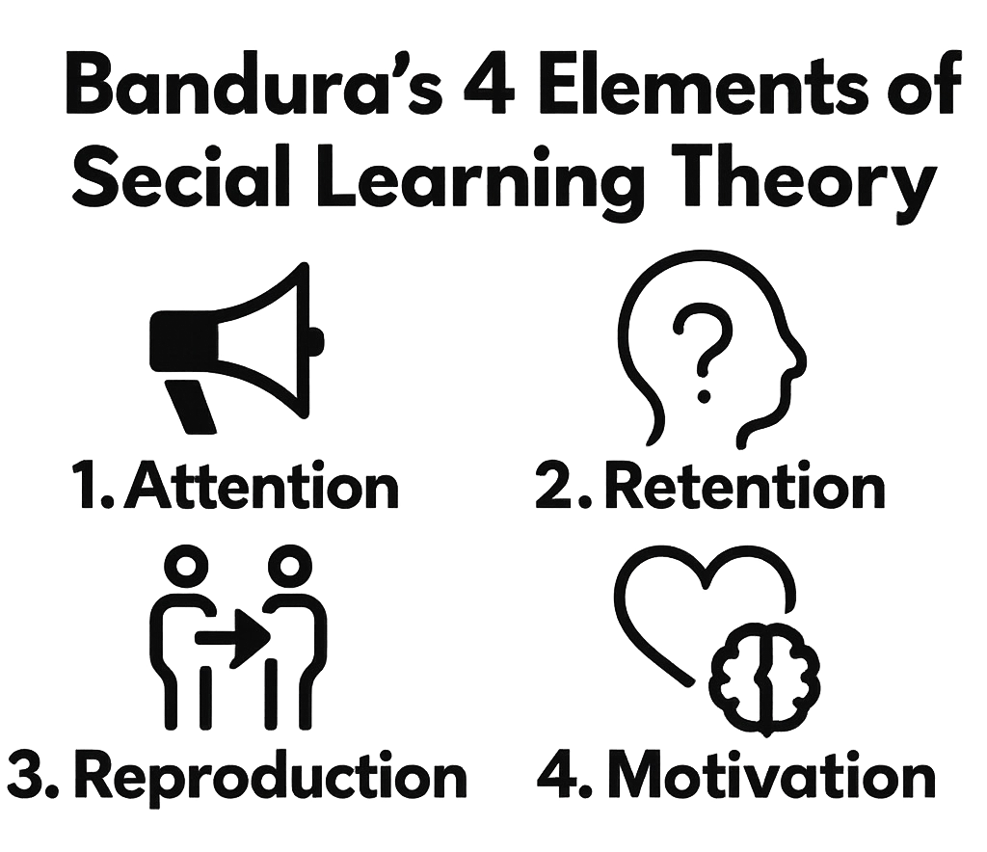
Elements of Social Learning Theory
Elements of social learning theory (Loveless, 2024)

Attention: The first process in social learning is paying attention to the model. The learner must pay attention to the model. This enables the observer to determine which aspects of the modelled information are relevant or irrelevant. Factors that enhance attention include the model’s characteristics (e.g., attractiveness, expertise), the complexity of the behavior being demonstrated, and the observer’s motivation. In the classroom situation, the teacher gains students’ attention by presenting clear information and motivating them as their model.
Retention: involves storing information in memory for later use. For observational learning to be effective, the learner must be able to remember the behavior and the conditions under which it was performed. In classroom, after gaining students’ attention, a teacher can model the behaviour he/she wants students to imitate and then give them chance to practice
Reproduction: After attending to and retaining modeled behaviour, the observer is ready to produce the behaviour or after observing and remembering the behavior, the learner must have the ability to replicate or reproduce the behavior. This requires both physical capability and mental practice.
Motivation: Motivation is critical for learning through observation. If learners perceive that the modeled behavior will lead to positive outcomes (rewards) or avoid negative outcomes (punishments), they are more likely to imitate the behavior. Students will imitate a model because they believe that doing so will increase their chance of being reinforced. This motivation is influenced by reinforcement and punishment, as well as the learner’s own goals and values. Both direct reinforcement (rewards for performing a behavior) and vicarious reinforcement (seeing others being rewarded for their behavior) play important role in observational learning. Vicarious punishment (observing others being punished for their actions) can prevent the observer from imitating the behavior.

- Vicarious reinforcement occurs when an individual observes someone else being rewarded for a behavior, and as a result, they are more likely to imitate that behavior themselves. People are more likely to repeat behaviors they see being rewarded in others. Example: If a child observes their classmate receiving praise for answering a question correctly, they are more likely to try answering questions in the future to receive similar positive reinforcement (praise or recognition). In this way, the reward that the other person (the model) receives indirectly influences the observer to behave in a similar way.
- Vicarious punishment occurs when an individual observes someone else being punished for a behavior and is then less likely to engage in that behavior themselves. People are less likely to repeat behaviors they see being punished in others. Example: If a student sees a classmate being reprimanded or losing privileges for being disruptive in class, they might be less likely to engage in disruptive behavior themselves, knowing it could lead to negative consequences. In this case, the punishment that the other person (the model) experiences serve as a deterrent for the observer.

In short, vicarious reinforcement encourages behavior by observing rewards. Vicarious Punishment discourages behavior by observing consequences or punishment. Both vicarious reinforcement and vicarious punishment show that learning doesn’t only happen through direct experience. Observation plays a crucial role in how we learn from others, whether by mimicking their rewarded behaviors or avoiding those that lead to negative consequences. This principle is particularly important in social contexts (like classrooms, homes, or social media), where people, especially children, are constantly observing others’ actions and the results those actions bring.

3.5.3 Application of social learning theory in the classroom

A teacher can apply social learning theory by doing the following (Arishaba, 2024):
Modeling desired behavior: Teachers can serve as role models for students by demonstrating the behaviors they wish students to adopt. For example, a teacher might model respectful communication during a class discussion, demonstrating how to listen attentively and respond politely. Students are likely to imitate these behaviors. Teachers may model problem-solving strategies for solving a difficult math problem on board. By demonstrating the process step- by-step, students learn how to approach similar problems.
Use of peer learning: Peer interactions play a significant role in social learning. Students can observe and learn from one another during group activities or collaborative learning tasks. Pairing stronger students with weaker ones encourages positive role modeling and provides opportunities for observational learning. For instance, during group projects, students can observe and learn from their peers as they work together on solving problems, performing experiments, or presenting findings. This interaction fosters the exchange of ideas and encourages skill development through observation.
Use of vicarious reinforcement: Teachers can use vicarious reinforcement by rewarding students who exhibit desired behaviors. By doing so, other students will be motivated to imitate those behaviors, expecting similar positive outcomes. For example, a teacher may praise or reward a student who consistently contributes thoughtful ideas during a discussion. Other students who observe this reinforcement may be motivated to participate more actively in future discussions, hoping for similar praise or recognition.
Use of vicarious punishment in classroom behavior management to discourage negative behavior by modeling appropriate behaviors and addressing misbehavior through observation. If a student sees a peer being reprimanded for inappropriate behavior, they may be less likely to engage in similar behavior themselves. Example: If a student is disruptive in class, the teacher can intervene by addressing the behavior calmly while reinforcing positive behavior in others. Seeing this can deter other students from acting out in a similar manner.
Observing models of success: Teachers can introduce students to successful models, either through real-life role models, guest speakers, or media examples. Students can observe how these individuals approach challenges and learn from their strategies and behaviors. Example: A history teacher might show video clips of famous leaders, such as Martin Luther King Jr. or Mahatma Gandhi, demonstrating their leadership and public speaking skills. Students can then reflect on the qualities that made these figures successful and try to model those qualities in their own behavior.
Encouraging self-reflection and self-evaluation: Teachers can encourage students to reflect on their behavior and the behavior of others. Self-reflection enhances self-regulation, which is a key part of social learning. Self-regulation refers to the ability to control one’s emotions, thoughts, and behaviors in the face of temptations and impulses, to achieve a goal or meet a standard. By reflecting on past actions, students can evaluate whether they want to replicate certain behaviors and make improvements. Example: after completing a collaborative project, a teacher may ask students to reflect on their individual contributions and how well they work with their peers. This encourages students to think critically about their actions and promotes self-improvement.
Use of positive reinforcement: Teachers can use praise or rewards to encourage desirable behaviors, making it more likely that students will repeat those behaviors. Example: When a student displays good behavior or achieves a goal, the teacher can offer verbal praise or tangible rewards (e.g., stickers, extra privileges). This positive reinforcement increases the likelihood of the student continuing to display the same behavior.
Utilizing technology for modeling and observation: Technology can be used in classrooms to expose students to a variety of models. Educational videos, simulations, and virtual peer interactions can provide opportunities for students to observe behaviors in diverse contexts. Students can then replicate these methods in their own experiments. Example: In a science class, the teacher can show a video of a scientist conducting an experiment, providing students with a model of how to carry out scientific investigations. Students can then replicate these methods in their own experiments.
Use of role-playing and simulation: Role-playing activities allow students to act out behaviors and observe how these behaviors are performed in different situations. Role-play exercises encourage students to practice social skills, problem-solving, and conflict resolution. Example: in a language class, students could engage in role-playing activities where they practice conversations in the target language. This allows them to observe effective communication strategies and apply them in their own dialogues.

Activity: Choose a lesson topic from the subjects you will teach, clarify how you will apply each of the four elements of social learning theory.

3.6 Sociocultural theory

Activity:
- Have you ever worked together with your peers?
- What were you doing?
- How did working together help you succeed?” or “What did you learn from your peers?

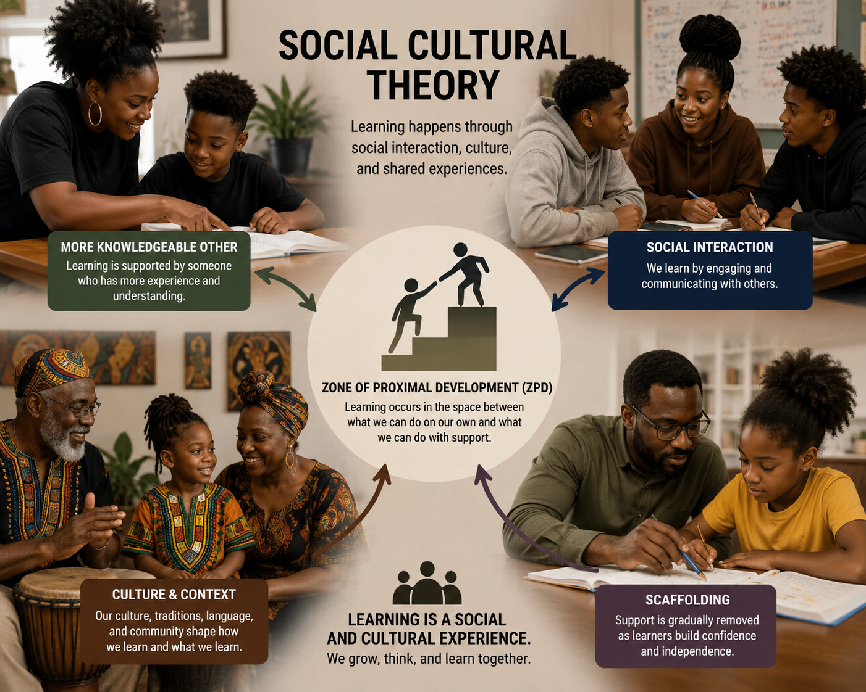

This theory is most famously associated with Lev Vygotsky (1896-1934), a Russian psychologist who believed that cognitive development is deeply embedded in the social and cultural contexts in which a person is situated. The theory emphasizes the role of social environments, cultural practices, and tools (especially language) in shaping how individuals think, learn, and construct knowledge. Sociocultural theory is a framework for understanding how social interaction, culture, and language influence learning and cognitive development.
According to sociocultural theory, learning is a social process, and cognitive functions develop through interactions with more knowledgeable others, such as teachers, peers, and family members.

    - Key concepts of sociocultural theory

- Social interaction and cognitive development:
Vygotsky believed that cognitive development is largely driven by social interactions. Learning is not an isolated process but occurs within a social context where individuals collaborate, discuss, and exchange ideas with others. Through these interactions, individuals internalize cultural knowledge and develop higher-level thinking skills. Vygotsky argued that cognitive functions (e.g., thinking, problem-solving, memory) are initially developed through social interactions with others, particularly more knowledgeable individuals such as parents, teachers, or peers. According to this theory, children learn from the guidance and support of others, which helps them internalize cultural tools and knowledge.
According to Vygotsky, learning appears twice: first on the social level and then on the individual level; i.e. between people (interpsychology) and inside the child (intrapsychology). Development cannot be separated from its social context. Vygotsky focused on a child not as an individual but as a product of social interaction, especially with adults (parents, teachers).
- Zone of Proximal Development (ZPD):
It is one of the central concepts in sociocultural theory. It refers to the range of tasks that a learner can perform with the help of more knowledgeable others, such as teachers or peers, but cannot yet perform independently. The ZPD represents the difference between what a learner can do alone (independent performance) and what they can do with assistance (assisted performance). Learning occurs most effectively within the ZPD, as learners are challenged just beyond their current abilities but still within their potential capacity to achieve with help.
Independent performance Assisted performance

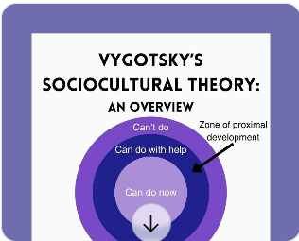

The distance between actual and potential knowledge
The concept of the distance between actual and potential knowledge is closely related to Lev Vygotsky’s concept of the Zone of Proximal Development (ZPD), which is the space between what a learner can do alone and what they can do with guidance.
- Actual knowledge refers to the information, skills, and understanding that a learner has already mastered or can do independently. It represents the learner's current cognitive abilities and what they can perform or accomplish without assistance. Example: A student who can independently add and subtract numbers or solve simple math problems has mastered basic arithmetic skills and has actual knowledge in that domain.
- Potential knowledge refers to what a learner is capable of understanding or achieving but cannot yet do independently. It represents the learner’s capacity to acquire new knowledge or skills with the assistance of a more knowledgeable person (such as a teacher or peer). Example: A student who is currently unable to solve a complex algebraic equation but has the capacity to do so with some guidance from a teacher would be seen as having potential knowledge in algebra.
The distance between actual and potential knowledge illustrates the gap between what a learner can do on their own or what a learner currently knows (actual knowledge) and what they can accomplish with guidance or what they can potentially learn with the assistance of a more knowledgeable person such as a teacher or peer (potential knowledge). That gap forms the basis for significant cognitive growth and learning. By understanding and leveraging this distance, teachers can provide effective mediation, guiding learners to new levels of understanding and ability, thus fostering growth and development.
The difference between actual knowledge (what the learner can do independently) and potential knowledge (what the learner can do with help) is the ZPD. Vygotsky emphasized that learning occurs in the ZPD, where tasks are challenging but achievable with guidance.
The process of helping learners progress from actual knowledge to potential knowledge is known as Mediated Learning. Through the interaction with a more knowledgeable person (teacher, mentor, peer), learners are given the tools, prompts, and support necessary to extend their abilities
The temporary support provided to learners to bridge the gap between their actual and potential knowledge referred to Scaffolding. The support is gradually reduced as the learner gains independence and mastery of the task.
Example of the relationship between actual and potential knowledge
Let’s consider a high school student learning calculus:
- Actual knowledge: The student knows basic algebra and trigonometry, which includes solving equations and working with functions. This knowledge is sufficient for solving simple math problems.
- Potential knowledge: The student is capable of understanding complex calculus concepts such as limits, derivatives, and integrals, but cannot do so independently yet. With targeted guidance from a teacher, the student could eventually solve calculus problems.
- Mediation in action: The teacher helps the student by explaining the concepts of calculus step by step, offering practice problems, and providing support when the student struggles with new ideas. As the student begins to grasp the concepts, the teacher reduces the level of assistance, allowing the student to work more independently.
- End result: Through mediation, the student’s actual knowledge expands to include the concepts of calculus, and the gap between their actual and potential knowledge diminishes. Eventually, the student can solve calculus problems independently, demonstrating their growth.

- Scaffolding

It refers to the support provided by a more knowledgeable other to help a learner complete a task within their ZPD. Scaffolding is temporary and is gradually removed as the learner becomes more competent and can perform the task independently. Examples of scaffolding include teachers providing hints, asking guiding questions, or breaking down tasks into manageable steps. As the learner gains mastery, the support is faded.

- Cultural tools

The theory highlights the importance of cultural tools (language, symbols, technology, etc.) in shaping how we think and learn. Vygotsky placed a strong emphasis on language as a key cultural tool for cognitive development i.e. for thinking and problem-solving. He believed that language is the primary means through which individuals interact with others and make sense of the world. Vygotsky argued that children learn to think and solve problems through the language and other tools provided by their culture. Through language, individuals internalize cultural norms, values, and knowledge. For example, a child learns the cultural meanings of words, rules of conversation, and problem-solving strategies through social interactions, which shape their cognitive development.

Vygotsky also highlighted the importance of private speech (talking to oneself), which children often use as a tool for self-regulation and problem-solving. As children develop, private speech becomes internalized and forms the basis for inner thought.

- Cultural tools and Mediated Learning

According to sociocultural theory, cultural tools (e.g., language, symbols, books, computers, and other technological or social tools) mediate cognitive development. These tools help individuals process information, communicate, and engage in problem-solving. For example, mathematical symbols, written language, and calculators are all cultural tools that enable individuals to think in ways that would not be possible without them.

- Social and cultural contexts
Sociocultural theory underscores the significance of the social and cultural environment in shaping learning. The theory posits that learning is not just an individual process but is deeply influenced by the cultural and social contexts in which a person lives. The norms, values, and practices of a particular culture impact how people think, communicate, and learn. For example, the educational practices, social interactions, and cultural expectations within a particular community or society influence the cognitive development of individuals in that community.
    - Classroom applications of Sociocultural Theory

Collaborative Learning: Sociocultural theory advocates for learning environments where students work together in groups, sharing knowledge and solving problems. This approach fosters social interaction and helps learners construct meaning through collaboration. Peer tutoring, group projects, and cooperative learning activities are examples of ways to apply sociocultural theory in the classroom. In these settings, students help each other develop skills and knowledge, learning through social interaction.
Guided participation: Teachers act as guides or facilitators, providing support for students within their ZPD. Teachers might model tasks, provide hints, or ask probing questions to help students navigate learning challenges. Apprenticeship learning or project-based learning (where students engage in real-world tasks with the guidance of more experienced mentors or peers) is another practical application of sociocultural theory.
Scaffolded instruction: Teachers can offer support through scaffolding techniques by breaking down complex tasks into smaller, manageable parts and providing the necessary resources for students to complete tasks. Over time, the support is gradually withdrawn as students gain independence.
Culturally responsive teaching: In the classroom, sociocultural theory emphasizes the importance of considering students’ cultural backgrounds in the learning process. Teachers should incorporate culturally relevant materials, strategies, and content that reflect the diverse backgrounds of their students. Teachers can recognize and build on the cultural knowledge that students bring to the classroom, such as knowledge from home or community experiences, to enhance their learning.
Use of language in learning: Teachers can encourage students to use language as a tool for thinking and problem-solving. This could include activities like think-alouds, where students verbalize their thought processes, or peer discussions, where students engage in dialogue to clarify ideas and reach understanding.
Use of technology-enhanced learning: Modern educational technologies (e.g., online learning platforms, collaborative tools like Google Docs) can support sociocultural principles by enabling students to collaborate, communicate, and learn from others beyond the classroom. Online forums, video conferences, and interactive learning tools help facilitate social interaction, where students can engage with peers and mentors in meaningful ways.

Activity: Discuss the challenges you may encounter while implementing sociocultural theory in classroom settings.

  - Connectivism as a Theory of Learning

Activity:
Think of something important you learned recently outside the classroom.
How did you learn it? Or Which sources have you used to learn that thing?
Write your answers using the following “learning network map”. In the center write: How I learned …… and in the rectangle, write the answers.
In a group of five, share, one by one, your responses and connect your answers using arrows and labels on the learning network map.

As students share their answers, a web of interconnected learning sources begins to form. This makes the concept of connectivism more concrete by showing that knowledge is distributed across many sources and grows through connections, a core idea developed by George Siemens. The “learning network map” is visualized as a growing web of interconnected nodes with the answers from different students writing what and how they learnt new things.

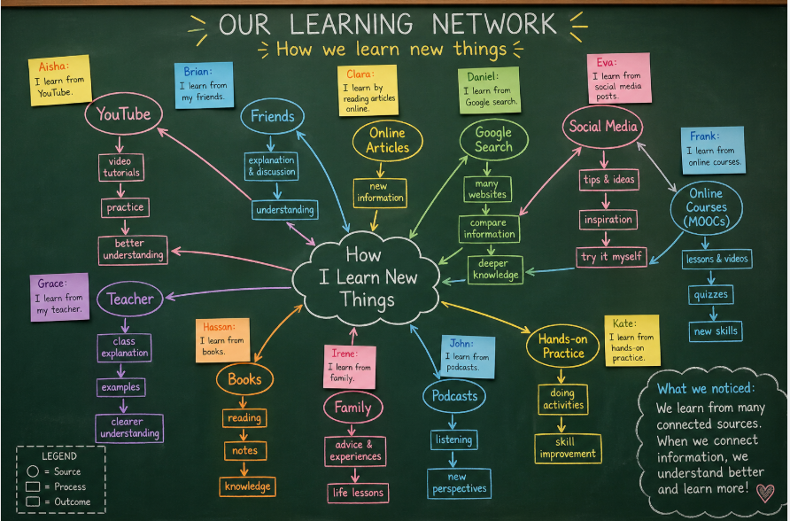

    - Description of connectivism learning theory

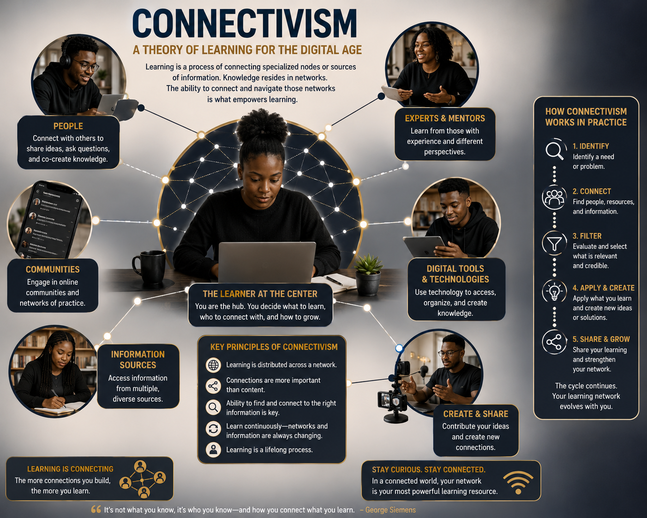
Connectivism is a contemporary learning theory developed by George Siemens (2004) and further advanced by Stephen Downes (2005) in the early 21st century. It emerged in response to the limitations of traditional theories such as behaviorism, cognitivism, and constructivism in explaining learning in a digital, networked world. Connectivism is built on the idea that digital technology brings people together and creates new learning opportunities. The theory promotes the idea that learning can successfully happen through digital channels, including social media, forums, videos, and blogs. It posits that the use of digital technology helps to solve a problem and, in turn, deepens the understanding of a topic.
According to Siemens (2008), connectivism is a learning theory comprised of different series of nodes to connect hundreds of networks to facilitate synchronous and asynchronous learning (Dunaway, 2011). These connections provide individuals with direct access to reliable information from millions of sources to duplicate, reproduce, and share within their social networks, and to delete, critique, and discard inaccurate, irrelevant, and unreliable information

Connectivism is a learning theory designed to explain how individuals acquire knowledge in the digital age, emphasizing the role of technology in shaping learning processes. Unlike previous theories that focused on individual learning experiences, connectivism recognizes the interconnectedness facilitated by digital platforms such as the Internet, social networks, and various applications. It posits that knowledge is no longer confined to personal experiences or passive absorption but is actively constructed through collaboration and interaction with others.7
George Siemens (in 2004) and Stephen Downes (in 2005) said connectivism begins when an individual turns to digital technology to solve a problem. This can include actions such as googling a question, texting a friend, or searching for topical social media content.
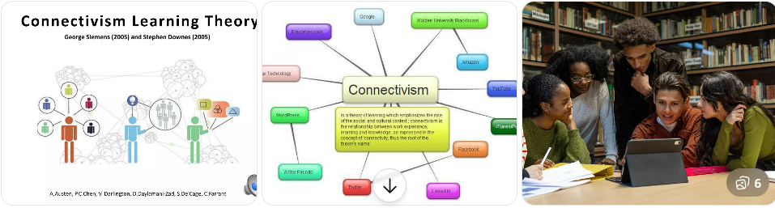

3.7.2 What are nodes and links in connectivism?
To understand connectivism, you have to think like a network engineer. The theory of connectivism relies heavily on the metaphor of a network with nodes and links.
- Nodes: A node can be anything that holds information. This could be a person, a book, a website, a database, a video, or an organization. In a classroom setting, every student is a node, as is the teacher and the textbook.
- Links: A link is the connection between these nodes. Learning happens when you create a link. For example, when a student follows an expert on social media, they create a link to a new node.
The strength of your learning depends on the diversity and quality of your network. If your nodes are all similar (e.g., you only get news from one website), your network is weak. If your nodes are diverse and interconnected, your capacity for learning and problem-solving expands significantly.

Connectivism aligns strongly with 21st-century skills, including digital literacy, critical thinking, communication, and collaboration. It is particularly relevant in contexts where technology is increasingly integrated into education systems. However, its application requires careful consideration of challenges such as unequal access to technology, varying digital competencies among learners, and the need for teacher training.

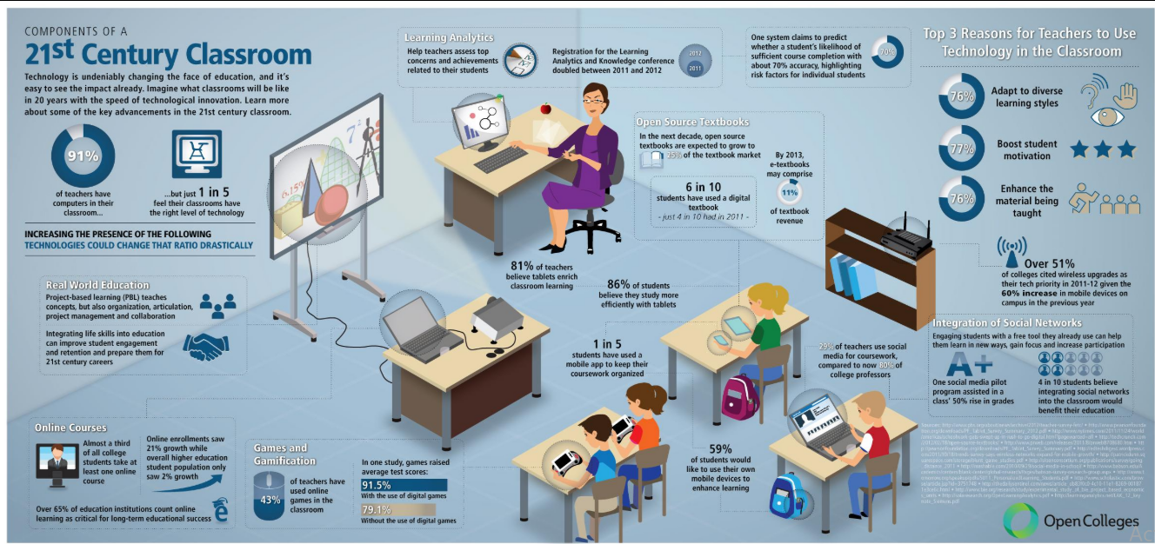
3.7.2 Key principles of connectivism

George Siemens mapped out guiding principles that redefine how learning is understood:
Learning and knowledge reside in networks. These networks consist of nodes, which may include individuals, digital platforms, databases, or organizations. Learning occurs when connections between these nodes are formed and strengthened.
Learning is a process of connecting. When we build relationships with colleagues, we open ourselves up to new skills, thoughts, and ideas we might not otherwise have access to.
Nurturing and maintaining connections are needed to facilitate continual learning. Collaborative social interaction brings people together and forms a long-term learning environment.
Ability to see connections between fields, ideas, and concepts is a core skill. We must learn how to build a bridge to connect point A to point B. That bridge itself is a new learning opportunity.
Accurate, up-to-date knowledge is the intent of all connectivist learning. When we work together, our understandings are constantly being reinforced and updated.
Diversity of opinions and sources is essential. Learning is enriched when individuals engage with multiple perspectives across networks. Perspectives from a variety of sources deepen our understanding.
The capacity to know more is more critical than what is currently known. In rapidly changing knowledge environments, the ability to access and update information becomes more valuable than what we know today. As Siemens says: “Our ability to learn what we need for tomorrow is more important than what we know today.”
Learning can reside in non-human appliances, such as computers, artificial intelligence systems, and online repositories Learners may store information in a digital way, like in an app, social media post, or video. Similarly, a community of learners may store information in a database or forum. This reflects the increasing role of technology in storing and generating knowledge.
Decision-making is itself a learning process. Learners must evaluate information, determine its relevance, and adapt to new knowledge, recognizing that what is correct today may be outdated tomorrow. What we know today may change tomorrow. We must accept that our knowledge will need to continuously evolve as new understandings present themselves.

3.7.3 Characteristics of learning in connectivism

Learning within this theory is dynamic and ongoing. It is characterized by:
- Continuous updating of knowledge
- Use of digital technologies and online platforms
- Collaboration and interaction across global networks
- Emphasis on critical thinking and information evaluation
- Informal and self-directed learning pathways
Rather than being teacher-centered, learning becomes network-centered, where the learner actively participates in knowledge creation and sharing.

3.7.4 Classroom applications of connectivism
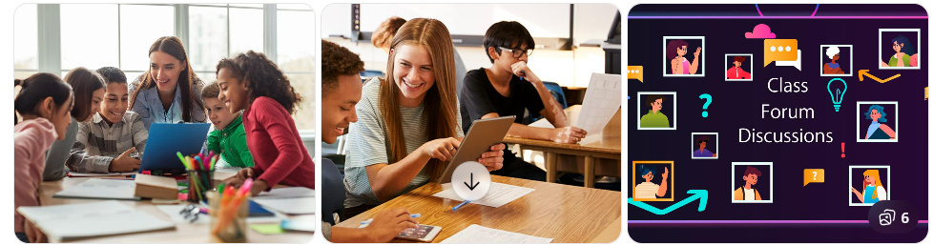

In classroom practice, connectivism shifts the role of both teachers and learners and integrates technology meaningfully into teaching and learning.

- Integration of digital learning platforms: Teachers can incorporate platforms such as Google Classroom, Moodle, or WhatsApp to extend learning beyond the physical classroom. These platforms enable learners to access resources, participate in discussions, and collaborate asynchronously. For instance, teachers can use social media platforms like X (formerly Twitter) or LinkedIn to connect students with industry experts, authors, or other classrooms around the world. Instead of writing a report that only the teacher reads, students might blog about their learning or create YouTube videos, allowing them to contribute to the global network of knowledge.
- Networked and collaborative learning: Learners must be engaged in group tasks that require interaction with peers, experts, or online communities. For instance, students may participate in online forums, co-author documents, or engage in virtual discussions, thereby building knowledge collectively.
- Emphasis on information literacy: Teachers must guide students in evaluating the credibility, relevance, and accuracy of information found online. This is critical in an era of abundant and sometimes unreliable information.
- Use of Open Educational Resources (OERs): Students are encouraged to explore diverse sources such as videos, podcasts, blogs, and academic websites. This broadens their exposure and supports self-directed learning.
- Teacher as facilitator and connector: The teacher’s role evolves from being the sole source of knowledge to a facilitator who helps learners make meaningful connections between ideas, resources, and people.
- Personalized and self-directed learning: Learners take responsibility for their own learning paths, selecting tools, resources, and networks that suit their needs and interests.
- Real-world and lifelong learning orientation: Classroom activities must be linked to real-life contexts. Students may follow current events, engage with global issues, or interact with professionals online, fostering lifelong learning habits.

In short, connectivism represents a shift from traditional, content-centered learning to network-based, technology-enhanced learning. It acknowledges that in a rapidly evolving digital world, the ability to connect, adapt, and learn continuously is more important than static knowledge. In classroom practice, this translates into collaborative, technology-supported, and learner-driven approaches that prepare students for lifelong learning.

Activity: Discuss the challenges you may encounter while implementing connectivism learning theory in classroom settings.

Unit 4: Components of effective teaching and learning

Activity: Think of a lesson that you once attended that was particularly memorable or effective. Write down three key features that made that lesson effective

Introduction
Teaching and learning are at the heart of the educational process, and their effectiveness relies heavily on the professional knowledge and competence of teachers. This unit introduces students to the foundational principles, approaches, methods, teaching styles, practical strategies, and specific techniques that underpin effective teaching and learning across educational contexts. By exploring these core components, the unit seeks to equip future teachers with the theoretical and pedagogical skills required to facilitate meaningful, learner-centered, and competence-based instruction.

Unit Learning Outcomes
By the end of this unit, you will be able to:
- Discuss the principles of teaching and learning and their classroom application in various educational contexts.
- Differentiate teaching approaches, styles, methods, strategies and techniques for effective use in the teaching and learning process.
- Analyze the criteria to consider when choosing suitable teaching methods to make effective instructional decisions in different teaching and learning situations

4.1 Principles of Teaching and Learning

Activity: Think of a lesson you plan to teach in the future. Based on your intentions as a teacher, write down four specific actions you would do to ensure that the lesson is effective and engaging for your learners.
Teaching and learning principles are foundational guidelines that influence how teachers approach their practice and how students engage with the learning process. They are interrelated and aim to create and promote effective teaching, enhance student engaging learning, create a positive educational experience and supportive educational environment. There are seven key principles of teaching and learning as summarized in the figure below and explained.
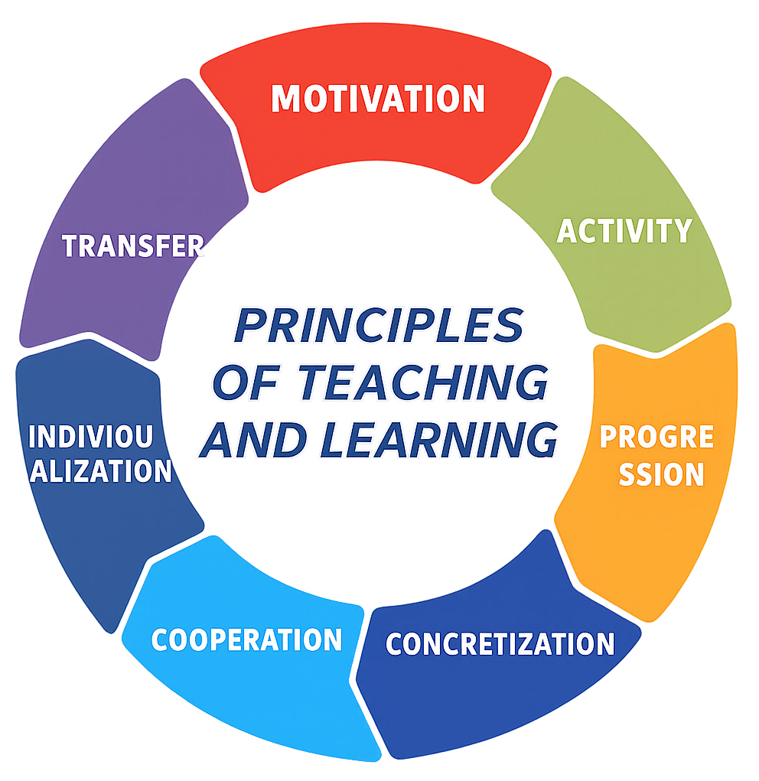
Principles of teaching and learning

Motivation
Motivation refers to the internal or external factors or forces that drive individuals to act, pursue goals, or engage in specific behaviors. It is what energizes, directs, and sustains actions, whether they are aimed at personal success, overcoming challenges, or fulfilling basic needs. Motivation can be classified into two broad types: Intrinsic and extrinsic motivation (Kumari, 2024).

Types of motivation
        - Intrinsic motivation: originates from within the individual and is driven by personal interest, satisfaction, or enjoyment derived from performing a task. Examples: A teacher who teaches because they simply enjoy the act of teaching. A student who reads a book simply because they enjoy the subject and learning, rather than earning a grade.
        - Extrinsic motivation: arises from external factors or incentives such as rewards, recognition, or the desire to avoid punishment. An individual is extrinsically motivated when they perform a task not out of personal interest, but in response to external demands or pressures. Examples: A student who studies hard to earn high grades in order to receive a scholarship or praise from parents and teachers. A student who puts effort into studying primarily to avoid failing a class or being reprimanded by their parents.
Motivation plays a critical role in how students engage with learning and influences learning outcomes. Without motivation, effective teaching and learning cannot take place. You cannot learn effectively if you are not motivated to learn. A teacher cannot teach effectively if he/she is not motivated to teach.

How can a teacher identify that his or her students are motivated during a lesson?
Motivated learners demonstrate behaviors that reflect active engagement, focus, and a positive attitude toward learning. They participate in class discussions, stay attentive, show curiosity, and persist through challenges. Such students put in consistent effort, seek feedback, set goals, and take pride in their progress. Their enthusiasm extends to both individual tasks and group activities, often encouraging and collaborating with peers. These behaviors not only support their own learning but also create a positive and effective classroom environment.

How can a teacher identify that their students are not motivated during a lesson?
When students lack motivation, they often show signs of disengagement such as minimal participation, distracted behavior, and negative body language like avoiding eye contact or appearing bored. They may put in poor effort on assignments, resist feedback, and exhibit irregular attendance. Negative attitudes, lack of curiosity, inconsistent academic performance, and verbal expressions of disinterest or defeatism further indicate low motivation. These behaviors signal a reduced interest in learning and a need for strategies to re-engage students.

How can a teacher motivate learners in the classroom?
Teachers can inspire motivation by setting clear and achievable goals, making learning relevant to students’ lives, and using varied teaching methods. Providing positive feedback, fostering a growth mindset, and building a supportive classroom environment also play a key role. Offering students autonomy, incorporating gamification, and maintaining an engaging learning atmosphere boost interest and participation. Motivation is further strengthened by appropriate challenges, recognition of progress, access to resources, enthusiastic teaching, and opportunities for peer learning. Patience and adaptability are crucial in addressing diverse student needs and sustaining motivation.

Activity
Learning is more effective when students actively participate in the process, engaging with the content through activities that require critical thinking and application. Teaching should actively engage students in the learning process, encouraging participation and collaboration rather than passive listening.
Strategies to make students active in class: engaging them physically, mentally, emotionally, and socially in the learning process. This requires moving beyond traditional lecture-based teaching to create an environment where learners participate, think critically, collaborate, and apply knowledge. To foster active and meaningful learning, teachers should use engaging strategies like group work, games, simulations, and peer teaching. Asking open-ended questions promotes deeper thinking, while hands-on activities and fieldwork make learning tangible. Creating a safe and supportive classroom where students have choices and responsibilities encourages participation and confidence. Incorporating technology and multimedia enhances engagement and caters to diverse learning styles. Finally, linking lessons to real-life context increases relevance and helps students connect learning to their personal experiences and future goals (Freeman et al, 2014; Barkley et al., 2014).

Concretization
Concretization refers to the process of making abstract concepts more understandable and relatable by linking them to real-life experiences, physical objects, or visual aids. It involves moving from theoretical or abstract ideas to practical, observable examples that students can engage with meaningfully.
Strategies to concretize a lesson: To make abstract concepts more understandable, teachers can use various concretization strategies such as visual aids (e.g., diagrams, charts, videos), hands-on activities with real objects, and real-life examples that relate to students’ daily experiences. Use of demonstrations and simulations that bring concepts to life, while analogies and metaphors help simplify complex ideas by connecting them to familiar situations. These strategies enhance comprehension by making learning more tangible and relatable (Rawson, et al., 2015; Fiorella & Mayer, 2016; Mayer, 2020; Kim & Cozart, 2021).

Progression
The principle of progression in teaching and learning refers to the idea that instruction should be organized in a logical, step-by-step sequence, moving from simple to more complex concepts based on the learner’s developmental level, prior knowledge, and learning needs. This principle emphasizes that students learn best when new information builds gradually on what they already know and can do.

Applications of progression in classroom settings: applying the principle of progression in the classroom involves structuring instruction to match students’ developmental levels and gradually increasing content complexity. Teachers begin by assessing prior knowledge and logically sequencing lessons from simple to complex. They scaffold learning, revisit topics through a spiral approach, and differentiate instruction to meet diverse needs. Regular reviews and the use of appropriate language support understanding, while goal setting and reflection encourage learner ownership. Continuous monitoring and adjustment ensure instruction remains effective and responsive to student progress (Brookhart, 2018; Tomlison, 2017; Van de Pol, 2017).

Individualization /Personalized Learning
Learning becomes more effective when it is individualized tailored to each student’s unique needs, abilities, interests, and learning styles. Individualized learning allows students to progress at their own pace, engage with content in ways that suit them, and demonstrate understanding through diverse methods. It emphasizes personal effort and independent work, acknowledging that learning is a personal journey.
Strategies for individualizing learning: Individualizing learning involves adapting instruction to meet each student’s pace, needs, and learning style. This includes offering flexible learning speeds, multiple resources and activities, and varied ways for students to show understanding. Teachers use diverse assessment methods, provide extra support when needed, and scaffold complex tasks to build independence. Lessons are structured to progress from simple to advanced concepts, with language and content tailored to the learner’s level. Differentiating task difficulty ensures all students are appropriately challenged and supported (Heacox, 2020; Tomlison, 2017)

Cooperation
Cooperation refers to the process of students working together in pairs or groups to achieve a common goal or complete a shared task. It emphasizes collaboration, communication, and teamwork, fostering an environment where students contribute to each other’s learning and support one another’s academic growth.
Strategies to foster cooperation in class: Fostering cooperation among students requires intentional strategies that create a supportive and collaborative learning environment. Teachers should begin by establishing a classroom culture rooted in mutual respect, clearly defining expectations for respectful communication and modeling cooperative behaviors such as sharing and problem-solving. Inclusive language like “we” and “our” can reinforce a sense of community. Cooperative learning strategies such as Think–Pair–Share, jigsaw, group investigations, and team-based learning, encourage students to work together toward shared goals. Additionally, teaching social skills like active listening, conflict resolution, and turn-taking equips learners with the tools necessary for effective collaboration. Tasks should be interdependent, with students taking on roles in project-based learning or engaging in peer teaching and collaborative problem-solving. Teachers must also monitor group dynamics, provide formative feedback, and encourage reflection through journals or discussions. Celebrating cooperative efforts through recognition, group rewards, or leadership roles motivates students and reinforces positive behavior. Finally, connecting classroom cooperation to broader values such as peace education and citizenship, helps students understand the importance of working together not only in school but also in society at large (Gillies, 2016; Johnson et al., 2013; Slavin, 2014).

4.1.7 Transfer of learning
Transfer refers to the process by which students apply knowledge, skills, or concepts learned in one context to new or different situations. It involves the ability to take what has been learned and use it in other settings, tasks, or problems, either within the same subject area or across different subjects (Hajian, 2019). Transfer can occur in both positive and negative forms— positive transfer is when prior learning aids new learning, while negative transfer is when previous learning interferes with new learning (Chunk, 2021; Mestre, 2020; Perkins & Salomon, 2019).
Examples of positive transfer: A student who has learned to play the piano may find it easier to learn the guitar because both instruments involve understanding music theory, rhythm, and coordination between hands and fingers. A student who learns how to organize their time effectively for school assignments might apply the same organizational skills to manage their work tasks in a job after graduation.
Examples of negative transfer: If someone learns to drive a car with a manual transmission, they may struggle to drive a car with an automatic transmission at first because the new skills conflict with their prior knowledge. A person who is used to using a smartphone may face difficulty navigating a touchscreen laptop because they might expect the same gestures (like swiping or tapping) to work in the same way, but the laptop’s interface may require different gestures.

Types of transfer of learning

There are three main types of transfer (Barnett & Ceci, 2018; Perkins & Salomon, 2017):
  - Near transfer: When skills or knowledge are applied to a very similar context. For example, after learning how to use past tense verbs in an English grammar lesson, a student correctly applies them when writing a personal narrative in class. A student learns how to solve simple addition problems (e.g., 15 + 7) and then applies the same process to slightly more complex addition problems (e.g., 234 + 56). The concept of addition remains the same; only the numbers are different. The student transfers the strategy used for smaller numbers to larger ones.
  - Far transfer: When skills or knowledge are applied to a very different or novel context. For example, applying problem-solving techniques learned in science to resolve issues in daily life or in other subjects like history. A student who has been involved in debating applies the skills of argument construction, critical thinking, and public speaking in their role as a lawyer, arguing cases in court. Both debating and law involve the ability to analyze arguments, present evidence, and speak persuasively.
  - Zero transfer refers to a situation where previously learned knowledge, skills, or experiences have no impact on or do not help with learning or performing a new task or concept. In other words, previous knowledge or skills are irrelevant to the new task. Examples: Knowing how to drive a car does not help you learn how to play the piano, as the skills and knowledge involved are unrelated. Studying French vocabulary will not assist you in solving equations in algebra; the two domains do not overlap in terms of content or cognitive processes. Being a skilled swimmer does not help you type faster or more accurately; motor skills are entirely different. Knowing how to prepare complex meals in the kitchen won’t help you fix electronic components in a phone.
Note: The negative transfer and zero transfer are not needed because they do not contribute to new learning.

Strategies to promote transfer in learning
To promote transfer in the classroom, teachers should help students connect their learning to multiple contexts by teaching for transfer and using real- world problems. Encouraging reflection allows learners to think about how their knowledge applies in future situations. Teachers should also promote generalization of concepts across different contexts, highlight connections between subjects, and provide varied practice opportunities to reinforce transferable skills.
In short, these seven principles relate to one another, they are interdependent. Here, they are presented separately just for practical and methodological reasons. Practically, one does not exist without the other; the fact of resorting to a principle automatically makes you think that the other one exists (Tse & Nicholson, 2020).

Activity: Select a lesson topic from the subject you intend to teach and answer the following questions:
- How will you motivate your learners?
- What activity will the learners do?
- What real-life objects or examples will you use?
- How will the content build from simple to complex?
- How will you address individual learning needs?
- What will learners do together?
- How will they apply what they learn to real life?

Teaching Approaches, Methods, Styles, Strategies, and Techniques

Activity: Imagine you are teaching a class of senior one students about how to plant a tree. What would you do to teach the lesson effectively? Write down two different responses on a stick note.

This section explores the diverse ways in which teaching can be effectively delivered and adapted to meet learners’ needs. It provides an overview of key pedagogical concepts, ranging from broad approaches to specific techniques, that teachers use to facilitate learning. By examining various methods, styles, strategies, and techniques, this section aims to highlight how thoughtful instructional choices can enhance student engagement, understanding, and academic success.
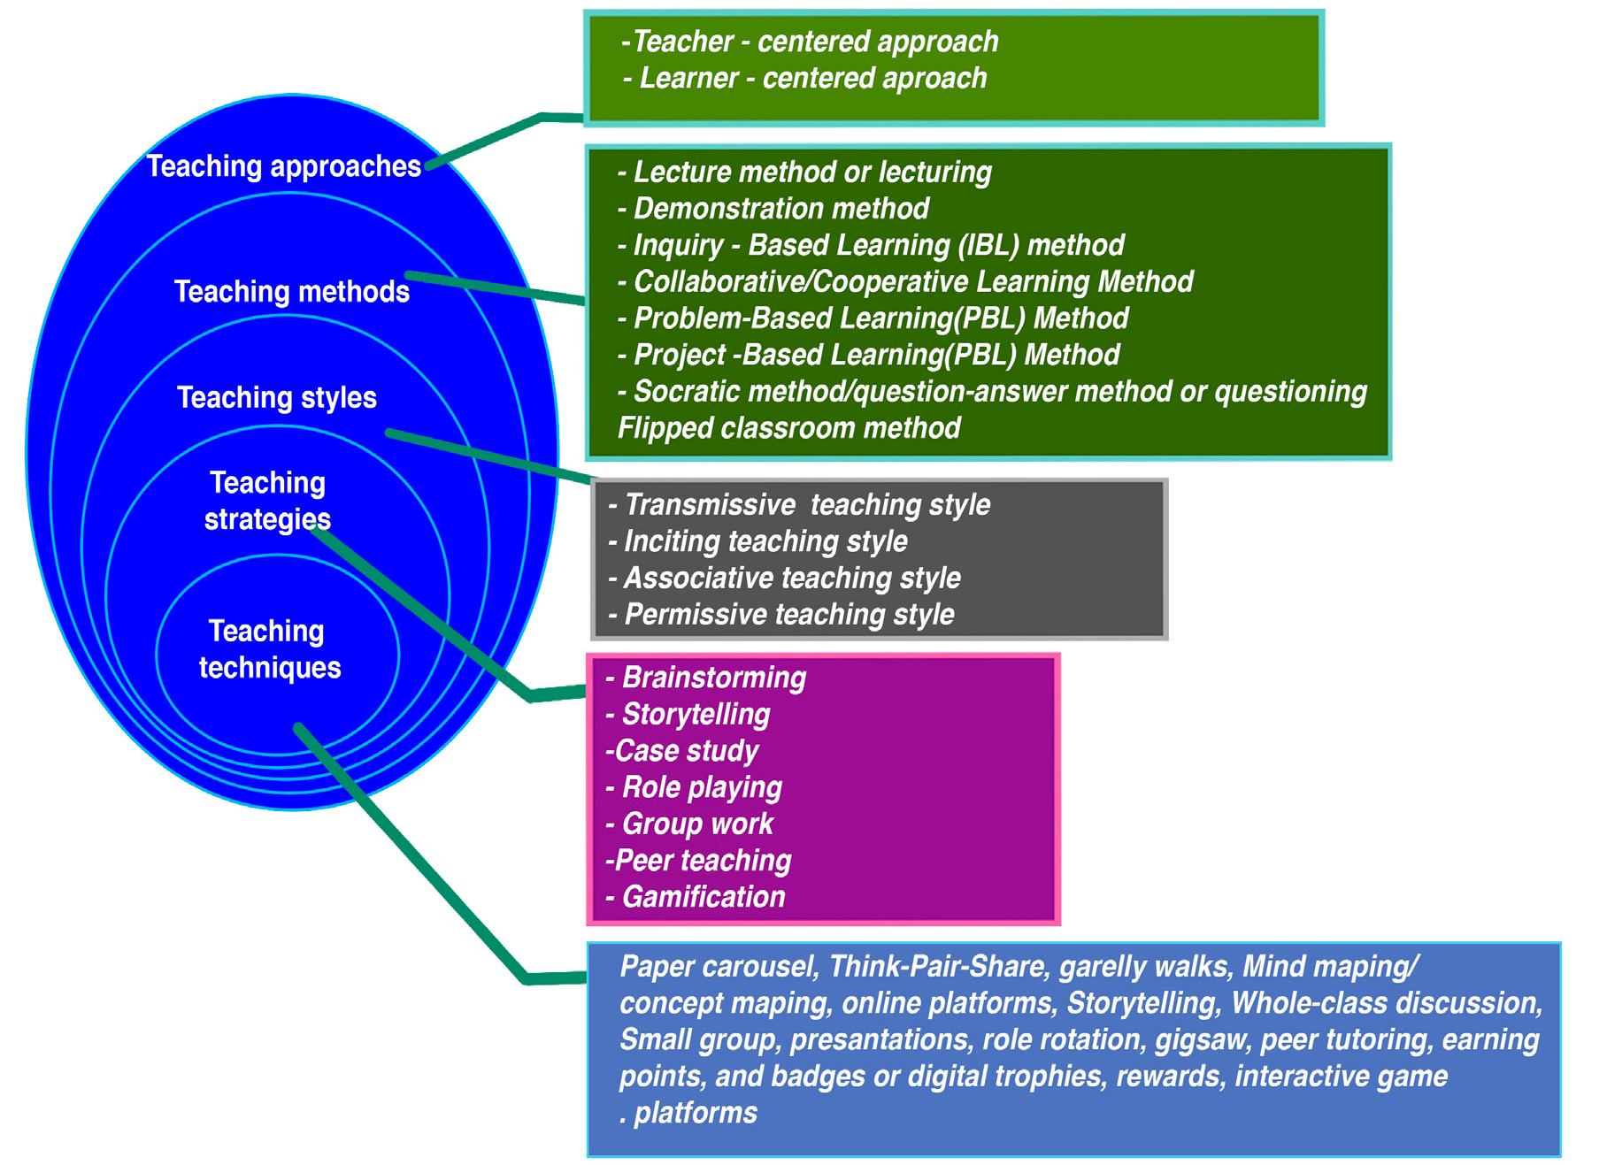
Teaching approaches, methods, styles, strategies and techniques.

4.2.1 Teaching Approaches
A teaching approach is the general philosophy, belief, or way a teacher uses to guide the teaching and learning process. It is the overall way or philosophy used by a teacher to help learners acquire knowledge, skills, values, and attitudes. It refers to the broadest and most philosophical orientation toward teaching and learning. They are grounded in educational theories and reflect beliefs about how learning occurs and what role the teacher and learner play, how students learn best, what should be taught, and the methods teachers should use in the classroom. They are two main teaching approaches:
- Teacher-centered approach: Emphasizes the teacher’s role as the primary source of knowledge (e.g., direct instruction, lecture method). Learners mainly listen and follow instructions. Example: A lecture where students take notes while the teacher explains shows a teacher centred approach.

- Learner-centered approach: Emphasizes the student’s active role in constructing knowledge (e.g., inquiry-based learning, constructivism). Teacher acts as a facilitator or guide. Examples: Group discussions, projects, and problem-solving activities reflect learner- centred approach.

Methods of Teaching
Methods are organized and systematic ways of teaching aligned with the chosen approach. They provide a general plan for conducting instruction. It comprises the ways in which the teacher delivers the content. A teaching method is a broad framework used by teachers to deliver content to students. It guides how the lesson is conducted. Teaching methods focus on how content is presented to students, and they often define the role of the teacher in the classroom. Teaching methods provide a big picture for teaching. Methods of teaching and learning are varied and cater to different educational goals, learning styles, and contexts (Akimenko, 2016; Hameed, 2024). An approach is more theoretical, while a method is more practical and detailed in application (Akimenko, 2016; Hameed, 2024).

General methods of teaching

Commonly used methods in teaching and learning process are the following (Akimenko, 2016; Hameed, 2024):

Lecture method or lecturing
Lecture method (also called lecturing) is a traditional, teacher-centered method of instruction where the teacher presents information verbally to students, usually in a structured and continuous manner. This method is often used to deliver large amounts of content to a whole class within a limited time frame. Lecturer method is often used for large groups. In the lecture method, the teacher plays the dominant role, while students listen, take notes, and absorb the information presented. The learners ask very few questions compared to the great number of questions the teachers ask. This method is more passive for learners. Example: A history teacher might give a lecture on the causes of World War I. He/she presents the material while students listen and take notes. It is particularly effective for introducing new topics, explaining complex theories, or providing background knowledge. While it may not actively engage students in critical thinking or hands-on learning, the lecture method can be enhanced by integrating visual aids, examples, questioning, and brief discussions to maintain attention and promote understanding.

Demonstration method
The demonstration method is a teacher-centered teaching method that involves showing students how to do a particular task or process while explaining each step. It combines telling and showing, making it particularly effective for teaching practical skills, procedures, experiments, or the use of tools and equipment. In this method, the teacher models the desired behavior or skill while students observe closely. After the demonstration, students are usually given the opportunity to practice the skill themselves, often under the guidance of the teacher.
This method is highly effective in subjects like science, vocational studies, mathematics, physical education, and arts, where visual understanding enhances learning. It caters especially to visual and kinesthetic learners and helps clarify abstract or complex concepts by turning them into observable actions. Students are actively involved in the learning process as they watch, observe, and sometimes even participate in the demonstration, leading to better retention. Example: A science teacher demonstrates how to measure temperature using a thermometer.

Inquiry-Based Learning (IBL) method

Inquiry-Based Learning (IBL) is a student-centered teaching method that emphasizes active learning through questioning, exploration, investigation, and critical thinking. Rather than simply receiving information from the teacher, students are encouraged to ask questions, conduct research, experiment, and draw their own conclusions. In IBL, the teacher acts as a facilitator or guide, helping learners navigate the inquiry process, rather than directly delivering content. This method often follows stages such as:
  - Asking questions
  - Gathering and analyzing information
  - Interpreting data or findings
  - Drawing conclusions
  - Reflecting and communicating results
Inquiry-Based Learning is particularly effective in subjects like science, social studies, environmental studies, and language arts, where exploration and problem-solving are central. It promotes curiosity, independent learning, develops critical thinking by encouraging students to engage deeply with the content, collaboration, and the ability to apply knowledge in real-life contexts, making learning more meaningful and enduring. However, it may be time-consuming and may not suit all learning styles. Example: In a biology class, students investigate the factors affecting plant growth.

Collaborative/Cooperative Learning Method
The collaborative or cooperative learning method is a student-centered teaching method in which learners work together in small groups to achieve shared academic goals. In this method, students are actively engaged in the learning process by interacting with their peers, discussing concepts, solving problems, or completing tasks collectively.
Cooperative learning is structured, with clearly defined roles, group norms, and shared responsibilities. Each member of the group is accountable for both their individual learning and for helping their peers learn, promoting mutual support and interdependence.
This method enhances communication skills, critical thinking, teamwork, and problem-solving abilities. It also fosters a sense of community, reduces classroom competition, and encourages respect for diverse perspectives.
The teacher’s role in cooperative learning is to organize groups, facilitate interaction, provide guidance, and assess both group and individual performance. When well implemented, collaborative learning leads to deeper understanding, improved retention, and the development of social and emotional skills alongside academic achievement. Example: In a geography class, a group of students is asked to create a presentation on different climate zones around the world. Group members must teach their topic to the class together, ensuring that each member understands and contributes. The teacher provides oversight and support, but the students lead the activity and learn through teamwork and shared learning. The teacher assesses both the group product and individual input.

Problem-Based Learning (PBL) method
Problem-Based Learning (PBL) is a student-centered teaching method in which students are presented with a real-world problem (often presented as a scenario or case study) that they must solve by applying their knowledge and skills. Students take responsibility for their learning, deciding how to approach the problem, what information they need, and how to solve it. Students work collaboratively to explore and solve the problem, and in doing so, they acquire new knowledge, skills, and understanding.
In PBL, the teacher acts as a facilitator, guiding students through the process. Example: students are given an algebra problem to solve. The teacher shows students how to break down the problem into smaller parts and apply formulas to solve it. The teacher may work through the first part of the problem as a class, then assign similar problems for students to work on individually or in pairs. The teacher circulates and offers help as needed. This enhances students’ ability to think critically, solve complex problems, collaborate effectively, and apply their learning to real-life situations, making education more relevant and impactful.

Project-Based Learning (PBL) method
Project-Based Learning (PBL) is a student-centered teaching method in which learners gain knowledge and skills by actively exploring real-world problems and challenges. Teachers assign projects that require students to apply their knowledge to real-world problems, typically over an extended period. Students engage in a long-term project that requires them to research, design, and present a solution to a real-world problem. Students take ownership of their learning, conduct research, plan, and present their findings.

PBL helps students develop critical thinking, creativity, collaboration, communication, and self-management skills. It connects classroom learning to real-life contexts, increases motivation, and prepares learners for lifelong learning and problem-solving beyond school. It promotes deeper significant planning and time management and may be difficult to implement in all subjects. Example: A science teacher asks students to design a model of school garden that is environmentally sustainable and beneficial to the community. Over several weeks, students research, plan, build, and present their projects, demonstrating how the model functions.

Socratic method/ question-answer method or questioning

The Socratic method, also known as the question–answer method or simply questioning, is a teaching method that uses guided questioning to stimulate critical thinking, promote discussion, and lead learners to discover answers on their own. This method involves the teacher posing thought-provoking questions rather than giving direct answers. The teacher asks a series of probing questions to stimulate critical thinking and draw out ideas from students. The teacher asks questions he/she prepared before and asks other questions after receiving one or more answers so that the learners can understand better. It aims to help the learner find out the answer by himself/herself and thus allows him/her to go further in his/her search for knowledge. Very often, the teacher will not answer the question of the learner. He/she will ask the learner the same question he has been asked so that he/she can find the answer by himself/herself.

In this method, learners are encouraged to analyze, evaluate, and reflect on their ideas. The teacher challenges assumptions, probes reasoning, and prompts students to justify their opinions or rethink their responses. This method fosters active engagement, deep understanding, and independent thinking. There are different types of questions used, such as:
- Factual questions (What is...?),
- Interpretive questions (Why do you think...?),
- Analytical questions (What are the implications of...?),
- Evaluative questions (Do you agree? Why or why not?).
This method is particularly effective in humanities, philosophy, literature, and social sciences, where critical inquiry and debate are essential. However, it can be adapted for all subjects to develop learners’ reasoning and communication skills. The Socratic method turns the classroom into a place of dialogue rather than passive reception, making learning more meaningful and learner driven.

Flipped classroom method
The flipped classroom is a modern learner-centered teaching method where students first study new content at home, typically through videos or reading, and then engage in interactive, hands-on activities during class time. This reversal of the traditional lecture model allows learners to learn at their own pace before class and use classroom time for deeper exploration, collaboration, and teacher-guided applications. It promotes active learning, self-discipline, and flexibility. For example, students may watch a video on the Rwandan government at home and later participate in a simulated senate debate during class.
Note: There is no good method of teaching that suits all situations. Each teaching method has its advantages and disadvantages. Its effectiveness depends upon various factors. Each method can be adapted to different subjects, levels, and learning objectives. Effective teachers often combine several methods to create a well-rounded, engaging, and effective learning experience for their students.

Criteria to choose suitable teaching methods
Choosing the right teaching method is crucial for achieving instructional objectives, catering to students’ needs, and creating an effective learning environment. Teachers should consider the following criteria when selecting the most suitable teaching method: The learning objectives, nature of content, learners’ characteristics, the classroom environment, assessment methods, teacher comfort and expertise, cultural considerations, etc.

B.1 The learning objectives: What are students expected to learn?
Teachers have to consider the purpose of the lesson: Different teaching methods are designed to achieve different types of learning outcomes. For example:
    - Conceptual understanding: Methods like lectures, or problem-based learning (PBL) may be effective.
    - Skill development: Hands-on methods such as demonstrations, or project-based learning are more appropriate.
    - Critical thinking and analysis: Discussion, or inquiry-based learning might be ideal.

B.2 The nature of content: Is it conceptual, practical, or theoretical?
Content type or subject matter plays a large role in choosing the right method.
    - Theoretical content: For abstract, theoretical, or complex subjects, lecture or direct instruction may work well.
    - Practical skills: For teaching technical or practical skills (e.g., cooking, carpentry, or laboratory experiments), demonstration, discussion are more effective.
    - Creative subjects: In areas like art, drama, or music, cooperative learning, cooperative learning, discussion may be more engaging.
    - Abstract vs. concrete: Abstract concepts may require methods like inquiry-based learning, while concrete concepts can be introduced through lecturing/direct instruction or demonstration.

B.3 Learners’ characteristics: the students’ age, learning styles, prior knowledge, and motivations
- Learning styles: Consider whether students prefer visual, auditory, reading/writing, or kinesthetic learning.Visual learners may benefit from demonstrations, visual aids, and multimedia, auditory learners may prefer discussions, lectures and kinesthetic learners may respond best to hands-on activities, role-playing, and project-based learning.
- Age and developmental stage: Younger students or beginners may require more structured, teacher-directed methods, while older students or more advanced learners may benefit from methods like inquiry-based learning or problem-based learning that promote independence.
- Student prior knowledge: If students already have some background knowledge, methods like flipped classrooms or group discussions may help deepen understanding. For new learners, methods like direct instruction or guided practice are beneficial.
- Student diversity: A diverse classroom may require a mix of methods to cater to various learning needs, such as individualization/ personalized learning or collaborative learning.
- Student motivation and engagement: teacher considers:
- Student interest: Engaging methods including gamification, case studies, or project-based learning can capture students’ attention, especially when the subject is challenging or dry.
- Active participation: Methods like collaborative learning, involving role-playing, or discussions encourage active student participation and are effective for keeping students motivated and engaged.
- Autonomy: If students are motivated to take responsibility for their learning, methods like inquiry-based learning or flipped classrooms can help them become more self-directed.

B.4 Classroom environment: What resources, time, and class size are available?
    - Size of the class: In large classes, lecture-based methods might be more practical due to time constraints. Smaller classes allow for more interactive methods like discussion.
    - Available resources: Consider what materials, technology, or tools are available. For example, projectors and interactive whiteboards may enhance lectures or demonstration, while computers or lab equipment are crucial for inquiry-based or hands-on learning.
    - Time available: The duration of the lesson affects the choice of method. Shorter lessons may be better suited to direct instruction or lecturing, while longer sessions might allow for more in-depth problem-solving activities or group projects. Some methods, like problem-based learning or project-based learning, require significant planning and may need to be spread over multiple lessons, while others, like demonstrations or direct instruction, can be done in a single class period.

B.5 Assessment: How will student learning be assessed?
    - Assessment alignment: The teaching method should align with how students will be assessed. For instance: Formative assessments (ongoing) might be well-suited to methods that allow for observation and feedback, such as group discussions or role-plays. Summative assessments (final exams or projects) might require methods that promote mastery of content, such as lectures, or independent research.
    - Feedback needs: Some methods, like project-based learning or collaborative learning method, provide opportunities for continuous feedback, while others, like traditional testing, might not.

B.6 Teacher comfort and expertise: Is the teacher familiar with the method?

        - Familiarity with the method: Choose methods the teacher is comfortable with and skilled in. If the teacher is not familiar with a particular method, it might take time to prepare and implement effectively.
        - Professional development: The method should allow teachers to continue growing in their teaching practices, such as incorporating new technology or trying out new pedagogical approaches.

B.7 Cultural considerations:
- Cultural relevance: The teaching method should be appropriate for the cultural background and values of the students. For example, methods that encourage open debate and self-expression may not be suitable in cultures where deference to authority is emphasized.
- Inclusivity: Ensure that the method is inclusive and accommodates diverse needs, including those with learning disabilities or students requiring additional support.

Teaching styles
A teaching style refers to the art of teaching for a particular teacher, a personal way a teacher teaches. It is ‘the sum of everything you do as a teacher’, i.e. your own way of facilitating learning. Examples: transmissive, inciting, associative, permissive. These styles reflect the teacher’s role, the nature of interaction, and the level of learner autonomy.

Transmissive teaching style
It focuses on the direct transmission of knowledge from the teacher to the students. The teacher is typically seen as the expert, and the primary goal is for students to absorb and understand content. Teaching methods related to transmissive teaching style: Lecturing or lecture method and demonstration method.

Inciting teaching style
This teaching style is characterized by the teacher’s role in stimulating student thought and discussion. The teacher encourages students to ask questions, reflect on the material, and critically engage with ideas. Teaching methods related to inciting teaching style: Question-Answer method, flipped classroom.

Associative teaching style
It emphasizes creating connections between ideas, facilitating student interaction, and promoting shared understanding. It aims to build on students’ existing knowledge and integrate new concepts. Teaching methods related to associative teaching style: Discussion method and cooperative learning.

Permissive teaching style
The permissive teaching style emphasizes student autonomy and discovery. The teacher acts as a facilitator who creates an environment where students are encouraged to explore, ask questions, and guide their own learning. Methods related to permissive teaching style: Inquiry-Based Learning method, Project-Based Learning (PBL) method.

Teaching Strategies and Techniques
Teaching strategies are used within a teaching method to enhance learning. They are often more practical and interactive than methods, providing the teacher with ways to engage students. A teaching strategy answers the question: “How will I teach this content to ensure students learn it effectively? It involves how the lesson is delivered in a practical, step-by-step way to help students learn more effectively. Teaching strategies focus on specific activities used in the classroom to achieve learning outcomes and engage students in the learning process.
A teaching technique is specific, detailed practical actions or tools, steps used within a strategy to deliver a lesson. Techniques are often moment-to-moment and help in executing lessons effectively. The following are examples of teaching and learning strategies (Akimenko, 2016; Hameed, 2024):

Brainstorming
Brainstorming is a creative and participatory teaching strategy used to generate a wide range of ideas, responses, or solutions to a particular question, problem, or topic. It encourages open and spontaneous thinking where all contributions are accepted without immediate criticism or judgment. The goal is to stimulate diverse thinking, promote student engagement, and tap into the collective knowledge and creativity of the group. Brainstorming is especially useful at the beginning of a lesson to assess prior knowledge, introduce a new topic, or during problem-solving activities to explore multiple solutions. Teaching techniques used in brainstorming:
  - Free writing or free speaking: Students write or say whatever comes to mind about a topic without filtering ideas.
  - Round-robin brainstorming: Students take turns contributing one idea at a time in a circular manner, ensuring equal participation.
  - Paper carousel engages students in group work by rotating them, or their written responses, around the classroom to interact with different questions, problems, or prompts posted on large sheets of paper. The teacher prepares several stations (usually flip charts or large papers) around the classroom. Each paper contains a different question, prompt, or problem related to the lesson topic. Students are divided into small groups. Each group starts at a different station and writes responses, thoughts, or answers on paper. After a few minutes, groups rotate clockwise to the next station. At the new station, they read what the previous group wrote, add new ideas, respond to existing ones, or expand on them. This process continues until all groups have contributed to each station. The class reviews the completed papers. Groups may present summaries of one station or reflect on key takeaways.
  - Think-Pair-Share: each student individually and silently thinks about a question posed by the teacher. Then, two members are paired to exchange and discuss their responses. Finally, the responses are shared with the whole class or displayed around the room and students do gallery walks: students move around the classroom to observe, analyze, and react to content/responses displayed on posters, charts, or stations, much like viewing art in a gallery. Then, plenary discussions can take place.
  - Mind mapping or concept mapping: Visual technique where ideas are connected around a central concept using branches. It consists in writing down a central theme or main idea and thinking of new and related ideas which emerge from the theme. Students create a visual diagram that represents the relationships between different concepts. This strategy helps students organize and relate ideas. is often used for organizing ideas and summarizing complex topics.
  - Use of online platforms (e.g., Padlet, Mentimeter, Jamboard) to collect and display student input in real-time.

Storytelling
Storytelling as a teaching strategy involves the use of narrative, spoken, written, or visual, to convey concepts, values, information, or experiences in a way that captures learners’ attention, emotions, and imagination. Techniques of storytelling in teaching:
  - Oral narration: The teacher tells a story aloud, using tone, pacing, facial expressions, and gestures to animate the narrative. This can be teacher or student personal stories where teachers or students share real-life experiences to illustrate a lesson concept (e.g., a story of perseverance in a life skills lesson).
  - Written story: reading the written story Visual storytelling: Use of images, illustrations, comic strips, or storyboards to convey a sequence of events or concepts.
  - Digital storytelling: Learners create or engage with stories using multimedia tools such as video, audio narration, music, and animations (e.g., PowerPoint, YouTube, or storytelling apps).

Case study
It involves presenting a detailed scenario or problem, often real-world in nature, that requires students to analyze, investigate, and propose solutions or recommendations. Techniques used in case study strategy:
- Whole-class discussion: The teacher presents a case to the entire class and facilitates a structured discussion.
- Small group: Students are divided into small groups; each assigned the same or different cases. They collaborate to analyze the case, answer guiding questions, and present findings to the class.
- Role-playing: Students assume roles of individuals or stakeholders in the case (e.g., a judge, a victim, a policymaker) to explore diverse viewpoints and simulate decision-making.
- Guided questioning: The teacher prepares a set of scaffolded questions to help students deconstruct the case step-by-step (e.g., What are the key facts? What ethical dilemmas are present?).
- Written response: Students write a structured analysis or report of the case.
- Presentations: Students or groups prepare and present their case analysis to the class.

Role play
Role play is an interactive and experiential teaching strategy where learners act out roles in a given scenario or situation to explore real-life experiences, social interactions, or professional practices related to the lesson. It helps students understand others’ perspectives, apply theoretical knowledge, develop communication and problem-solving skills, and engage emotionally with the content. Techniques of role play:
  - Structured role play: The teacher defines the scenario, provides clear instructions, assigns roles, and sets boundaries. Often includes specific goals or tasks to be accomplished by participants. Example: Students simulate a parent-teacher meeting to practice communication skills.
  - Unstructured or improvised role play: Students are given a general situation but develop their characters and dialogue spontaneously. Encourages creativity and quick thinking. Example: A group of students improvises a conversation between neighbors discussing a community issue.
  - Multiple role rotation: Students switch roles during the activity to experience different perspectives. Deepens understanding and empathy. Example: In a debate on climate change, students rotate between roles of a scientist, policymaker, and farmer.
  - Hot seating: one student takes on a role (e.g., historical figure, character in a story), and the rest of the class asks them questions. Develops deep understanding and critical thinking. Example: A student acts as Nelson Mandela and answers questions from classmates about apartheid.
  - Scripted role play: Students are given written scripts to follow, which ensures accuracy and structure, especially for beginners or language learners. Can be followed by discussions or reflection on the characters’ actions and outcomes.
  - Fishbowl role play: A small group performs the role play in the center of the room while others observe. Observers later provide feedback or join in reflection, enhancing peer learning.

Group work
Group work is a collaborative teaching strategy in which students are organized into small groups to work together solving problems, completing tasks, or engaging in. It emphasizes active participation, cooperation, communication, and peer-to-peer learning, allowing learners to collectively solve problems, complete tasks, or engage in discussions. Techniques of group work:
- Think-Pair-Share: Students first think individually about a question or problem, then discuss their ideas with a partner, and finally share with the larger group or class.
- Jigsaw: Each group member becomes an “expert” on one part of the topic, studies it individually or in expert groups, and then teaches it to their original group. The class is divided into teams or groups, with each team preparing separate but related assignments or activities to become an expert on the topic given in the activity or assignment. After completing the task given, students are grouped with members from other teams to share their knowledge/the class is re-divided into mixed groups, with one member from each team in each group (expert groups). Students in an “expert group” discuss their activity in more detail. This allows them to deepen their understanding of their assigned topic. After the expert group discussion, students return to their original “home groups,” where each student shares the knowledge they gained from their expert group. The home group members then collaborate, pooling their collective expertise to complete the overall task or solve a problem, hence the name jigsaw: putting the parts of the assignment together to form a whole picture.
- Numbered heads together: Each student in the group is assigned a number. The group discusses a problem, and then the teacher randomly calls a number to answer on behalf of the group.
- Peer teaching: One or more students take the role of the “teacher” and explain concepts to the rest of the group.
- Carousel or station work: Groups rotate around different stations (with tasks, questions, or resources), building on previous groups’ work or starting anew.

Peer teaching
Peer teaching is a learner-centered teaching strategy in which students take on the role of the teacher to teach or explain concepts, skills, or tasks to their fellow students. It is based on the idea that students can often communicate and relate to each other in ways that support deeper understanding and retention of knowledge. The teacher may guide this process, but students are in the role of the teacher. Techniques of peer teaching:
- Pairs or small groups of students take turns assuming the role of the teacher.
- Peer tutoring: A more knowledgeable or advanced student (the tutor) helps a peer (the tutee) understand a concept or complete a task. Can be one-on-one or small group, and structured or informal.
- Expert groups (jigsaw technique): Each student learns a portion of the topic independently or in an “expert group” and then teaches it to their original group members.
- Presentations: Groups of students prepare a mini-lesson or presentation to teach their peers a subtopic.
- Role play: students act out roles (e.g., teacher and student) to explain difficult concepts or simulate real-life applications in a subject (e.g., mock interviews, debates).

Gamification
It is about applying game-like elements (e.g., points/scoring, rewards, badges, levels) to the learning process. Examples of techniques:
- Points: Students earn points for completing tasks, answering questions correctly, or demonstrating certain skills. Points can accumulate over time, creating a sense of progression.
- Badges or digital trophies: digital representations of achievement or mastery in specific skills or topics. They serve as symbols of success and encourage students to reach milestones.
- Levels: represent stages or tiers of achievement in the learning process. As students accumulate points or complete tasks, they “level up” to more challenging material or gain access to new opportunities.
- Rewards: can range from virtual currency, access to bonus content, or even physical rewards. These act as incentives for students to keep engaging with the material.
- Interactive game platforms: Use of online tools like Kahoot! Quizizz, Gimkit, or Classcraft to gamify assessments.

Activity: Select a lesson topic from the subject you plan to teach in a secondary school and answer the following lessons:
- Which approach will you adopt to teach the lesson?
- What is you preferred teaching style?
- What are the teaching methods will you use?
- What teaching strategies will you apply?
- What teaching techniques will you use?
- Explain the reason for each choice.

Unit 5: Planning for effective teaching and learning

Activity: Agnes shared with her classmates that, in her favorite lesson, she learned the following:
- I learned how to solve equations.
- I learned how to use a microscope.
- I learned to respect others’ opinions.

Tasks:
- On a piece of paper, draw three columns and label them as follows:

Knowledge / Thinking | Skills / Doing | Attitudes / Feeling
- Classify each of Agnes’s learning experiences by placing them in the appropriate column.

Introduction

Preparing pedagogical documents

This unit equips you with foundational knowledge and practical skills for planning, delivering, and assessing effective lessons aligned with competency-based education. It introduces taxonomies of educational objectives, supports the development of pedagogical documents, and offers practice through lesson plans.

By the end of the unit, you will be able to:

- Differentiate taxonomies of educational objectives for recognizing the diversity of learning objectives.
- Formulate effective instructional objectives for focused teaching and successful achievement of learning outcomes
- Plan key pedagogical documents for effective lessons delivery in specific subjects and classroom contexts
- Demonstrate effective teaching practices through microteaching sessions by addressing generic competences and integrating cross-cutting issues using appropriate classroom management strategies.

5.1 Taxonomies and Domains of Educational Objectives
Activity:
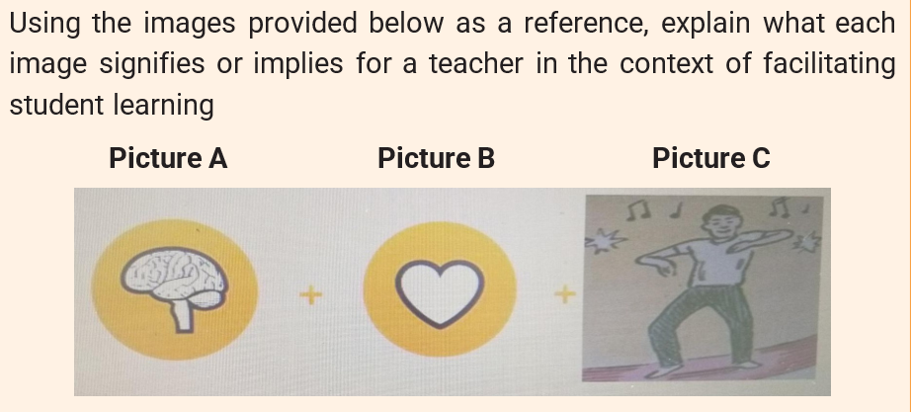

Understanding taxonomy and domains of educational objectives

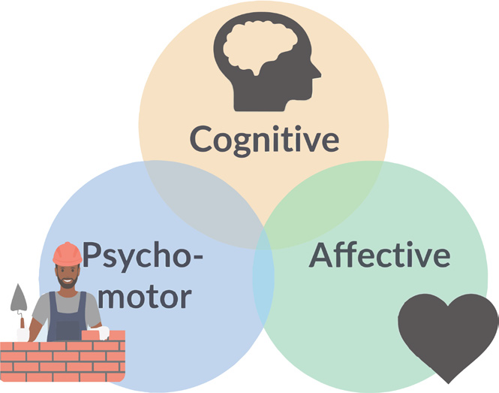

Domains of educational objectives
The word taxonomy is derived from two Greek words “taxis” which means arrangement or classification; and “nomos” which means law, science. Thus, literally, the taxonomy is the science of classification. It is the science of classification into ordered categories, the science of hierarchical classifications. To do the taxonomy is to make a list of elements that form categories concerning a particular domain, a particular science or discipline.

In educational sciences, taxonomy is defined as the science of classifying behaviours into categories or levels. Specifically, in the teaching domain, it is about the expected behaviours of the student after he/she has learnt a given content of knowledge. In teaching and learning, the teacher constantly assesses the expected students’ behaviours (objectives). Generally, these behaviours are classified into three categories or domains of manifestation of human behaviour which are cognitive, affective and psychomotor domains.

In pedagogy, taxonomy of educational objectives refers to the hierarchical classification of educational objectives. Taxonomy of educational objectives defines and distinguishes different levels of objectives. The taxonomy divides learning objectives into three broad domains: cognitive (knowledge-based), affective (emotion-based), and psychomotor (action-based), each with a hierarchy of skills and abilities.
Educational objectives are linked to any of the three domains of human behaviour, namely:
- The cognitive domain in relation to intelligence or the “brain”
- The affective domain, in relation to emotions, feelings or “heart”
- The psychomotor domain, in relation to movements or the “body”
These domains are used by educators to structure curricula, assessments, and teaching methods to foster different types of learning. Teaching aims at developing the three types of educational objectives: Cognitive objectives, psychomotor objectives, and affective objectives.

- Cognitive objectives relate to knowledge or thought. They aim essentially at the assimilation of course content. Examples: to explain the importance of educational objectives.
- Psychomotor objectives deal with movement and /or activities where gestures are used to express or interpret information or concepts. In general, these objectives are developed in Physical Education as well as other technical and vocational training courses. Examples: Draw, sing, high jump, disassemble an engine, etc.
- Affective objectives deal with feelings, values or attitudes. They occur at all levels of the teaching/learning process, but they are often neglected because they belong to the domain of attitudes. Examples: To fulfill someone’s commitments; to like mathematics, to stick to deadlines of appointments.
These objectives are also placed at various levels of complexity (from simple to complex) in their respective domains, according to their hierarchical classifications (their levels) (Hoque, 2016).

    - Three main taxonomies of educational objectives
There are three main taxonomies of educational objectives:
- Bloom’s Taxonomy of cognitive objectives and its Revised Version
- Krathwohl’s Taxonomy of Affective Objectives
- Dave’s Taxonomy of psychomotor objectives

- Bloom Taxonomy of Cognitive Objectives and its Revised Version

Activity: Suppose that the topic of the lesson you will learn is: “The importance of trees.”
Respond to the following questions:
- List the three types of trees you know.
- Explain why trees are important for people.
- Describe how you would plant and take care of a tree at school.
- Compare trees planted in the village with those planted in town, what similarities and differences do you see?
- Which tree is most useful to your community? Defend your answer.
- Design a poster encouraging people in your area to plant more trees.
What did you notice about these questions? Were they at the same level of difficulty? Did some make you think more deeply than others? Explain Which questions are easier or difficult to answer?

Old Bloom’s taxonomy of cognitive objectives (1956)

Cognitive objectives relate to knowledge acquired by learners, to the content taught. They focus on developing students’ intellectual abilities, such as thinking, reasoning, and problem-solving skills. Bloom’s taxonomy classifies learning objectives into levels of complexity and thinking skills. The taxonomy helps teachers design lessons that move learners from basic knowledge to higher-order thinking such as analysis, evaluation, and creation. This taxonomy supports effective lesson planning, assessment, and the development of critical thinking in learners. Bloom taxonomy of cognitive objectives has six levels: Knowledge, Comprehension, Application, Analysis, Synthesis, and Evaluation. The figure below shows all thinking levels of the old Bloom taxonomy and their meaning.
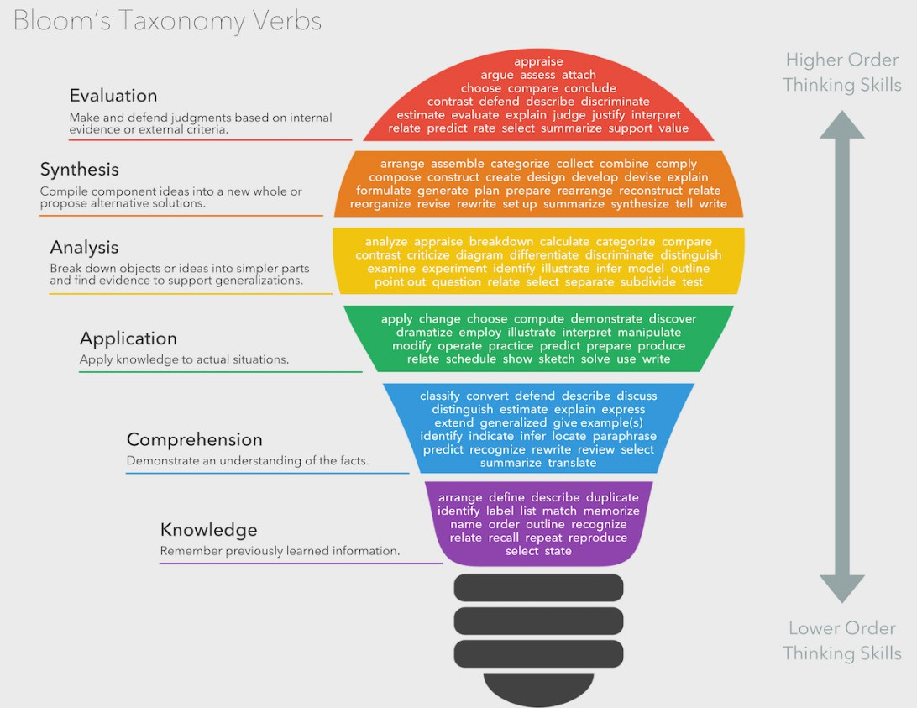

Revised Bloom taxonomy

In 2001, this taxonomy was revised, renaming and reordering the levels as Remember, Understand, Apply, Analyze, Evaluate, and Create.

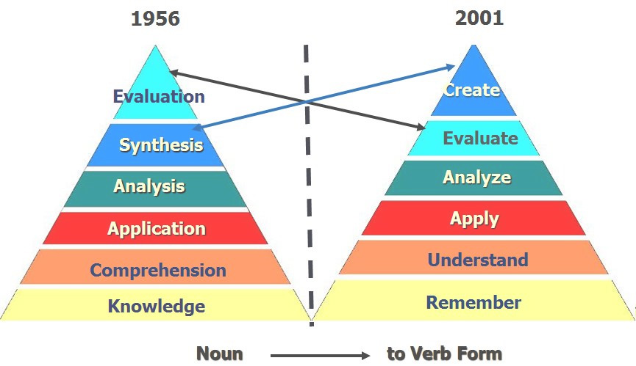

Changes in the Newly Revised Bloom’s Taxonomy
- The names of the six major categories were changed from noun forms to verb forms. Since the taxonomy represents different forms of thinking and thinking is an active process, action verbs were considered more appropriate than nouns.
- Some categories were reorganized. Synthesis was renamed Creating and moved to the highest level of thinking in the hierarchy, while Evaluation was changed to Evaluating and placed as the fifth level.
- The category Knowledge was renamed Remembering. This change was made because knowledge is viewed as a product or outcome of thinking rather than a thinking process itself. Therefore, Remembering more accurately describes the cognitive activity involved.
- Comprehension and Synthesis were also retitled as Understanding and Creating respectively, in order to better reflect the nature of the thinking processes represented in each category.
- All category names in the revised taxonomy were expressed using verbs ending in “-ing” form to emphasize active cognitive processes.

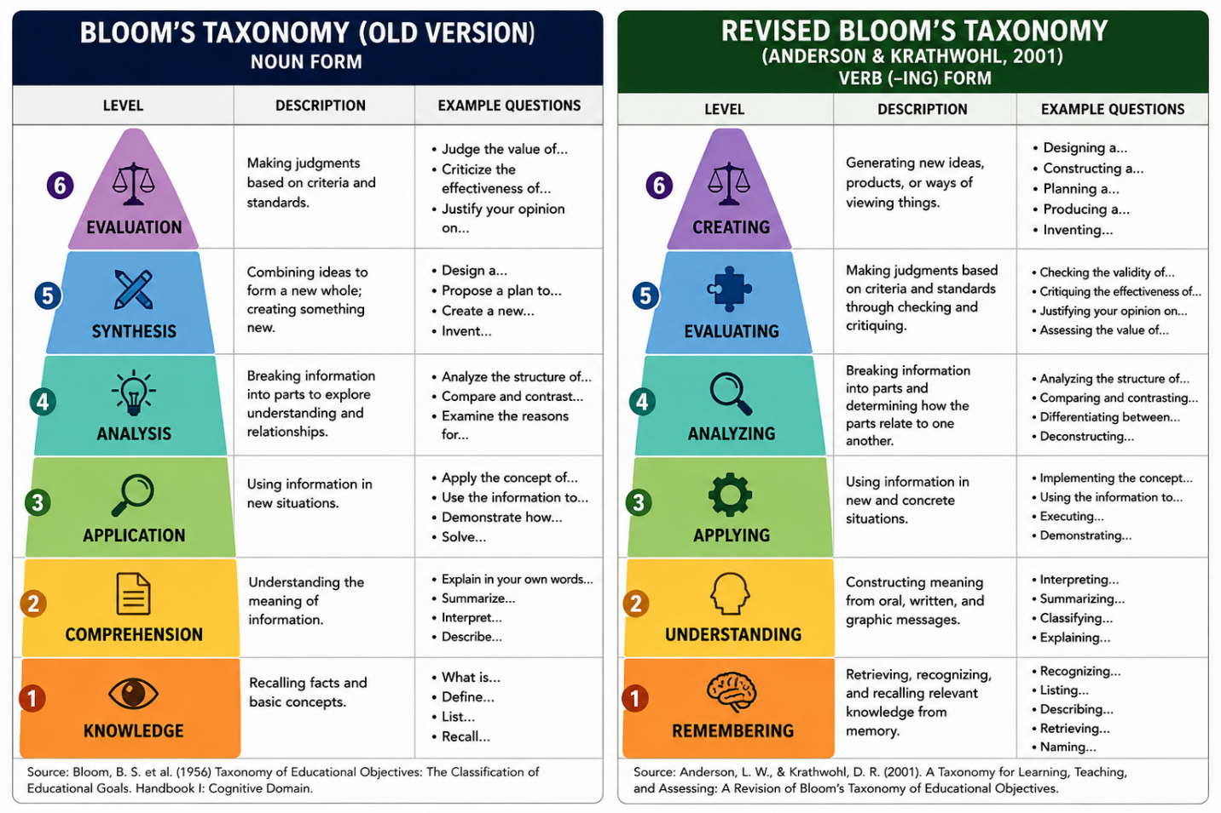Remembering, understanding and applying are considered as the Lower -Order Cognitive levels of Thinking while Analyzing, Evaluating and Creating are known as the Higher-Order Cognitive levels of Thinking.
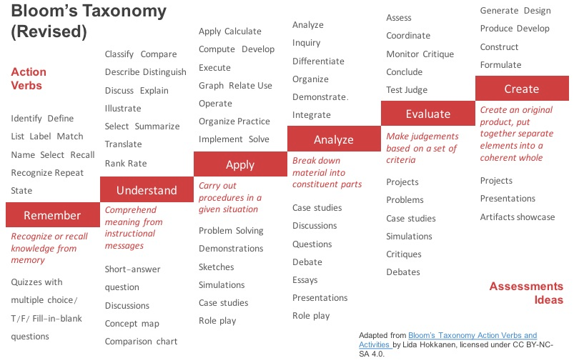
Key action verbs and assessments strategies in the revised bloom taxonomy

Krathwohl’s Taxonomy of Affective Objectives

Activity:
- Think of one song you listened to this week. Just bring it to your mind.
- Why did you play that song? Mood, lyrics, beat?
- Would you put this song on the playlist you share with your close friends? Why or why not?
Which level of Krathwohl’s taxonomy does the answer to each question represent?

The taxonomy, developed by David Krathwohl in 1964, focuses on the emotional domain of learning and emphasizes the development of attitudes, values, and feelings. The taxonomy describes how learners engage with emotional responses to stimuli, such as how they feel about a subject, their willingness to engage in specific behaviors, or the value they place on ideas and concepts. It guides teachers in fostering not just intellectual but also emotional development in students. Krathwohl’s taxonomy of affective domain has five levels listed from the simplest behavior to the most complex: Receiving, Responding, Valuing, Organizing, and Characterizing.

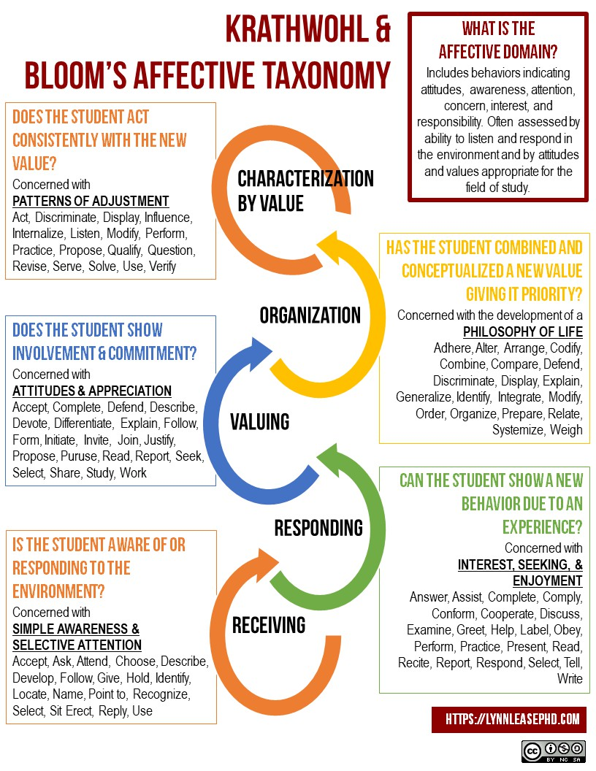

Krathohl taxonomy of affective domain (Lease, 2018)
- Receiving (Level of awareness): The lowest level; the student passively pays attention. Without this level, no learning can occur. Learners are simply aware of or willing to receive information. The learner is sensitised about the existence of certain phenomena and stimuli. He/she is incited to receive them and pay attention to them. It involves the passive process of attending to something and being open to it. Key action verbs: listen, pay attention, notice, observe, be aware. Examples: Listen attentively to a class discussion on environmental issues, observe the ethical behavior demonstrated by a role model, get knowledge of the existence of the school regulation, learners listen to the music on radio, etc.
- Responding (Level of participation): The student actively participates in the learning process. Not only does the student attend to a stimulus, but he/she also reacts in some way. This could involve following instructions, providing feedback, or engaging in a specific activity. Examples: students will give a clap after a speech; they accept that the school regulation be respected or will participate in the drama festival. Participate in a group discussion about the importance of teamwork. Complete a survey to express opinions on school policies. Key action verbs: respond, participate, discuss, answer, contribute, react.
- Valuing (Level of value development): The student attaches a value or importance to specific object, ideas, behaviours, concepts, phenomenon, or piece of information. The student associates a value or some values with the knowledge they acquired. The behaviour is motivated, not by the desire to please or to obey, but through the individual engagement to the fundamental value determining the behaviour. Examples: respect the school regulation on all occasions, sponsor one student to go for a cultural show at Serena Hotel, demonstrate a commitment to protecting the environment by recycling, respect for the opinions of others in class discussions, etc. Key action verbs: value, appreciate, prefer, demonstrate commitment to believe in, etc.
- Organizing (level of value system): This involves commitment to a set of values. The student can put together different values, information, and ideas and accommodate them within their own schema. The student is comparing, relating, and elaborating on what has been learned. Students organize values into a coherent value system, integrating different values into a broader structure. This stage often involves prioritizing and reconciling conflicts between values. Example: Students will organize themselves in study groups of four people; Organize a community service project based on personal values of social responsibility. Key action verbs: organize, integrate, compare, prioritize, formulate.
- Characterizing (level of internalizing values): It is the highest level; learners internalize values so that they consistently act in accordance with them. These values become part of the learner’s character, influencing behavior and decision-making across various situations. A student has value system to the extent that represents a philosophy of life. For example, the students will be always bound by the school rules and regulations, actively demonstrate leadership and integrity in all aspects of personal and professional life, consistently act in a manner that reflects respect for others and personal ethical standards. Key action verbs: act, demonstrate, influence, embody, internalize.

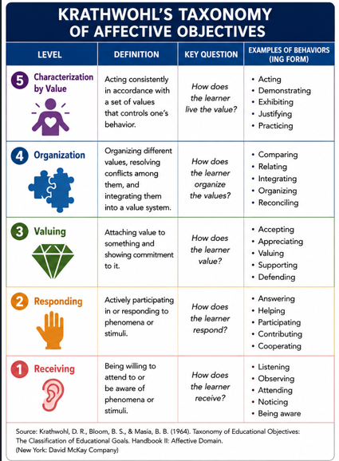

Affective objectives occur at all levels of the teaching/learning process, but they are often neglected because they belong to the domain of attitudes. It is difficult to assess these objectives, to find verbs of action.

Dave’s Taxonomy of Psychomotor Objectives

Activity: Suppose the topic of the lesson is: “Drawing a Chair.” Perform the following actions:
      - Watch the teacher draw a simple chair on the board. Did you pay attention to the shapes and lines?
      - Try to draw the chair by copying what you saw the teacher do.
      - Draw the chair independently without looking at the board.
      - Refine your drawing to improve proportions, angles, and neatness.
      - Add extra elements to your drawing, such as a desk, floor lines, or
shading.
      - Draw the chair accurately and consistently without any guidance or reference.
After responding:
Which of these steps were easiest for you? Which step challenged you the most? How did your drawing improve as you practiced at each level?

There is no taxonomy that is accepted universally for this domain. A very popular model for the psychomotor domain was established by R.H. Dave. The psychomotor domain encompasses the skills requiring the use and coordination of skeletal muscles, like physical activities of performing, manipulating, and constructing. Psychomotor skills are typically more observable, easier to describe, and measure in terms of evaluation. In general, these objectives are developed in Physical Education as well as other technical and vocational training courses. This taxonomy helps educators design and assess activities that involve physical movement, coordination, and manual skills, focusing on how learners develop proficiency in performing tasks that require fine and gross motor skills. Dave’s taxonomy has five levels: Imitation, Execution, Precision, Coordination and Naturalization.

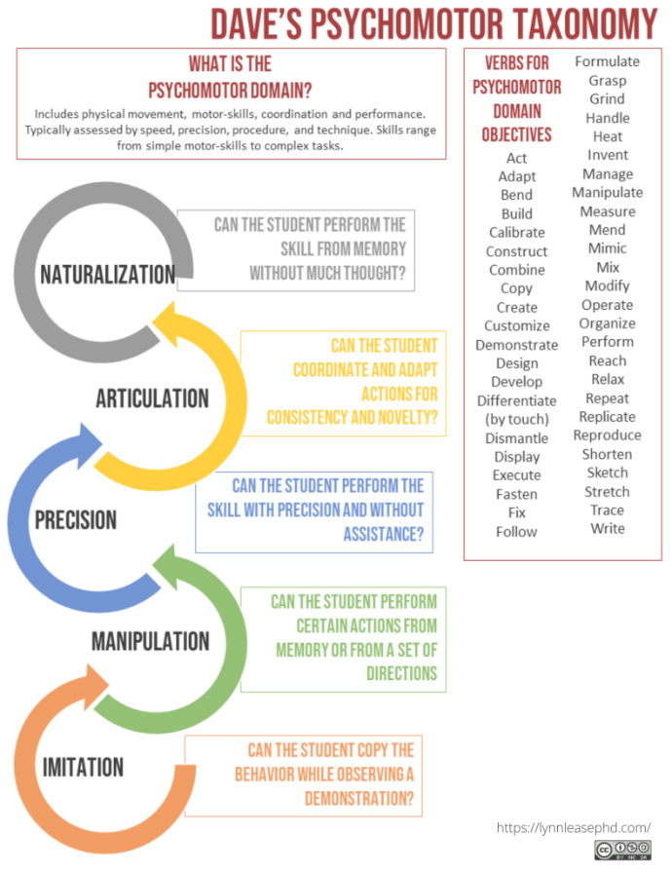

Imitation:
The learner is able to observe and replicate a motor skill, following the teacher’s demonstration. This level involves copying actions, and the skill is typically performed with some guidance. Performance may be of low quality. The learner repeats an observed action, but the neuromuscular coordination is still poor. For example, copying a work of art: the child takes a paper, rudely imitates a friend’s drawing. Key action verbs: imitate, follow, copy, repeat, duplicate.

Execution or manipulation:
Learners are able to perform the skill or task on their own, though still relying on basic procedures or instructions. The skill is performed with a greater degree of independence than in the imitation stage, but there is still some reliance on guidance. The learner becomes capable of imitating the teacher’s example. He/she starts differentiating movements and choosing the adequate behaviour. He/she reaches a certain level of ability in handling certain objects. Example: creating work on one’s own, after taking lessons or reading about it. Key action verbs: manipulate, handle, practice, use, perform.

Precision:
The learner performs the skill with increased accuracy, coordination, and control. At this level, the task is completed with greater refinement and attention to detail, often without the need for explicit guidance. The learner replicates the model with accuracy and precision. He/she reproduces the required model perfectly. He/she manages to replicate this action in the absence of the model. He/she directs the action and can modify its speed of execution about the situation. Key action verbs: perform, refine, enhance, adjust.

Coordination or articulation:
The learner coordinates and combines multiple skills to perform a complex sequence of actions smoothly and efficiently. At this stage, learners can adapt and adjust their movements based on the situation, integrating various motor actions into a cohesive whole. Coordinating a series of actions, achieving harmony and internal consistency. The learner harmonises his/ her action while at the same time being capable of adjusting the speed, the duration, and the other factors, so that actions articulate well. Examples: Producing a video that involves music, drama, color, sound, etc. The learner associates several words and knows how to write a text within a minimum time. Key action verbs: combine, integrate, coordinate, blend, synchronize.

Naturalization:
The learner performs the task with such a high level of proficiency that it becomes almost automatic or second nature. This level represents mastery of the skill, where the learner can perform the task smoothly and efficiently without thinking about the individual steps. Having high level performance become natural, without needing to think much about it. Things become automatic. Key action verbs: perform naturally, master, execute automatically, innovate, adapt. Examples: Michael Jordan playing basketball, Nancy Lopez hitting a golf ball, driving a car skilfully in varying traffic conditions, without needing to consciously focus on basic driving tasks or performing a complicated surgical procedure smoothly and efficiently, with minimal effort or conscious thought.

Note: When determining the objectives that learners should achieve at the end of their learning, the teacher must refer to the above domains of learning because, obviously, he/she must evaluate his/her educational action.

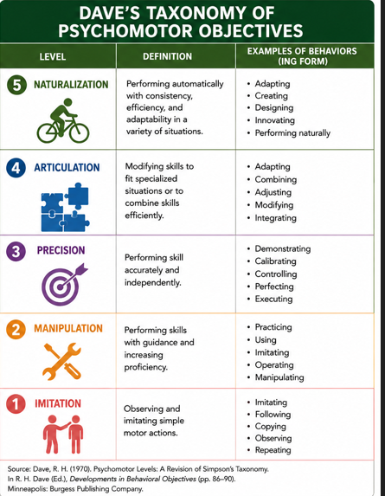

Activity:
  - Using Bloom’s revised taxonomy, design an instructional objective for a lesson of your subject that targets the “Analyze” level.
  - Give one classroom activity that can help students assess “Valuing” level in Krathwohl’s affective domain.
  - Describe how you would assess a learner’s skill at the “Precision” level in Dave’s psychomotor taxonomy during a practical art lesson.
  - For a subject of your domain, choose a topic and create one objective for each of the three domains (cognitive, affective, psychomotor) showing how they could be integrated in a single lesson.
  - Imagine you are teaching learners how to operate a microscope. Identify the psychomotor level they would be at if they can perform the task automatically without conscious thought and explain your choice.

5.2 Formulating instructional objectives
Activity: Teachers are planning a lesson for your senior two students. These are three examples of objectives formulated by them. Take a moment and read them carefully:
- Learners will understand the lesson better.
- By the end of the lesson, learners will list three causes of soil erosion
- By the end of the lesson, senior two learners will be able to explain types of vegetation in the world.
- Learners will know about good hygiene.
Which of the above objectives do you think is well formulated and why?

Meaning of instructional objective
An instructional objective is defined as a statement which describes an intended outcome of the teaching and learning process. It describes the kind of behaviour the learner is intended to display through thoughts, actions and feelings and the context in which the behaviour is to operate (REB, 2020). It describes what a learner is expected to be able to do after a lesson. In simple terms, an instructional objective answers the question: “What should students achieve by the end of instruction?”

5.2.2 Rationale of instructional objectives

The rationale of objectives is given by Mager (2001) in his book How to define educational objectives while writing:” If you don’t know where you are going, then there is a risk to be found elsewhere”. In other words, “If you do not know where you are going, how will you know when you get there”.

5.2.3 Functions of instruction objectives

- They serve as references and criteria to evaluate without any ambiguity whether the result is attained;
- They serve as headlights (a powerful light at the front of them) and help the teacher and the learner to know at any time their position/situation in regard with the result to achieve;
- They serve as means and criteria of self-assessment and improvement of action;
- They serve as criteria for choosing methods, strategies and techniques of pedagogical action.
In short, the educational objectives allow:
- To know where to go: to determine the difference between the initial situation and the final situation in order to see whether there is a change for the learner or not;
- To know how to go there: by determining the stages to follow and by choosing the most relevant techniques which will help to achieve what was determined before;
- To know where we are: it is a question of making an objective evaluation;
- Facilitate communication: between teachers and learners or among teachers themselves or even between teachers and other people in charge of the system, inspectors, supervisors, etc.

How to formulate instructional objectives?

Objectives are statements of change for students. They should specify the kind of behaviour and the content or area in which the behaviour is to operate. Instructional objectives are formulated or defined using verbs of action and specifying the content of the action which must be precise and limited. A well-written or formulated instructional objective should be SMART: Specific, Measurable, Achievable, Relevant, and Time-bound. It must also have ABCD components (Audience: Who is learning? Behaviour: What will they learn? Condition: Under what conditions? and the degree of performance: How well must they perform?) (Anderson, et al, 2001; Mager, 1975; REB, 2020).

SMART instructional objective
  - Specific: Objectives should clearly describe the attitudes, skills and knowledge or learning outcomes that the learner is expected to demonstrate after a given learning session.
  - Measurable: The outcomes should be observable and assessable through appropriate tools or activities. The achievement of the objective can be measured by an assessment strategy such as observation, test items or problem-solving exercises.
  - Achievable: The objective should be realistic, attainable, doable considering the available time, support, resources, and learner characteristics.
  - Relevant: It should align with broader course goals and curriculum standards. It should be meaningful and worth pursuing, significance, appropriate for the learner’s current stage of development or subject objectives, aligns with real-world needs, the learner’s interests, and the overall educational or developmental context.
  - Time-bound: objectives are set for a particular lesson or learning session, making them time-specific. The instructional objective should have a time limit, a specific timeframe or deadline for achieving a goal or completing a task. It means that the objective has a clear start and end time, which helps create a sense of urgency and focus. This is usually done by using the phrase “by the end of this lesson” or by the end of the week, by the end of the unit, within two months, during the semester, by the end of the semester, etc.

ABCD components of instructional objectives
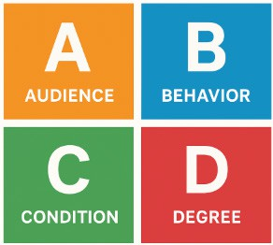
ABCD components of a good instructional objective

  - Audience (A): Instructional objectives should always specify the audience they are intended to serve. This refers to who the learning objective is aimed at - the group of learners or students. Usually, the audiences are participants in the learning session.
  - Behavior (B): observable actions that are supposed to be accomplished by the end of the lesson. This component specifies what the learner is expected to do, to perform after the learning experience. A clear instructional objective should have an action verb that demonstrates the skills, knowledge and attitudes to be acquired. Examples of action verbs: explain, identify, analyze, list, draw, write, demonstrate, calculate, describe, etc. It is important to avoid general verbs such as ‘know’ and ‘understand’ as they may not be measurable.
  - Condition (C): Instructional objectives should identify under which conditions a given task will be performed by the learner. The conditions may include time, tools, place, resources, environment and circumstances. Example: Using or without a calculator, without or referring to the notes, in a classroom setting, after reading the article, referring to a chart, or a map; while being monitored, on boat, in class, etc.
  - Degree of performance (D): It specifies how well the learner should perform the behavior/task. Example: With accuracy or accurately, without error, correctly, with confidence, etc. The teacher may want to answer: How many? How fast? How well? It is, therefore, important for a teacher to give the specifics of how a learner will be able to perform a given task in terms of quality, quantity and/or time measurements.

Example of a SMART instructional objective with ABCD components:
By the end of the lesson, every senior four student will be able to accurately create a simple personal monthly budget using a budget template and classroom examples.

- How is it SMART?

Specific: It focuses on creating a monthly personal budget.
Measurable: success is measurable through the accuracy and completeness of the student’s budget or the created personal and monthly budget.
Achievable: creating a simple budget is realistic task within a 40-minute lesson (by the end of the lesson) and appropriate for senior four learners using provided templates and examples.
Relevant: Budgeting is a practical life skill, aligns with financial literacy and
relevant to Economics curriculum.
Time-bound: The objective is set to be achieved, or the task is to be completed within one lesson (by the end of the lesson).

- What are its ABCD components?

A (Audience): Every senior four student- the learners are targeted by the objective.
B (Behavior): create a simple monthly personal budget- an observable and measurable action.
C (Condition): using a budget template and classroom examples- the resources/context given.
D (Degree): Accuracy- indicates the quality expected by the end of the lesson

Activity: Choose a topic from the subject you will teach. Then, formulate a good instructional objective that is SMART and includes all the ABCD components.

  - Planning key pedagogical documents

Activity: Imagine you have to teach a lesson tomorrow without any plan. How do you think it would go? What challenges might you face?

The teaching-learning process should never allow improvisation and randomness. The teacher must plan the teaching and learning activities on a regular basis before the real class lessons to ensure the success of the lesson.

    - Key pedagogical documents

Activity:
- What do you understand by pedagogical documents?
- List the main types of pedagogical documents you know.

Key pedagogical documents are the foundational tools and official references that guide teaching, learning, and assessment in educational systems. They ensure that instruction is aligned with national or institutional goals, curriculum standards, and learner needs. These documents vary slightly from one country or educational system to another, but the following are widely recognized and essential across most contexts (Niyibizi, 2024, REB, 2020):

- Curriculum framework: A national or institutional guide that outlines the philosophy, goals, and structure of the education system. It defines educational aims and competencies, key learning areas or subjects, learner profiles and guiding principles and cross-cutting issues.
- Subject syllabus for every subject
- Teacher’ s and learner’s subject textbooks: approved instructional materials aligned with the syllabus, used directly by students and teachers for teaching, instruction, learning and practice.
- Schemes of work for every subject
- Lesson plans for every lesson of each subject
- Class diary for every lesson to indicate daily teaching activities
- Exercise books for homework, tests and exams for each subject
- Lesson notebooks for each subject
- Marksheet for recording the marks for student’s scores (tests/quizzes, homeworks, and exams);
- Class register: to monitor student lesson attendance
- Timetable to indicate teacher’s respecting teaching time/ class

- Planning the scheme of work
Activity:
- What is a scheme of work?
- What are the key elements of a scheme of work?
- What is the importance of a scheme of work?

- 1 Meaning of the scheme of work
A scheme of work is a detailed plan that outlines how the content of a subject syllabus will be delivered by the teacher over a specific period of time, such as a term, semester, or school year. It breaks down the subject matter into manageable units or topics, specifying objectives, content, teaching methods, resources, assessment strategies, and the time allocation for each topic. The scheme of work is prepared by individual teachers or schools; a scheme of work is a long-term planning document that organizes the syllabus content into teachable units over a specific period (term or year).

A.2 Template of a scheme of work
The template has been provided in the new Rwanda curriculum framework to facilitate teachers to prepare their lessons in the same ways as much as schools should be conditioned that any change does not deviate or alienate the principles underlying the implementation of the competence – based curriculum.

REB template of the scheme of work (REB, 2020)
Format of the CBC Scheme of work
Academic year: ……….. Term: ………… School: ……………………… Subject: ………….. Class + Combination: ………… Number of period per week: ……… Teacher’s name: ……………….
Number of weeks  & Dates | Number Of  periods | Unit title | Lesson title  +  Evaluation | Learning objectives (copied or adapted from the syllabus depending on the bunch of lesson) +  Key unit competence |  | Teaching methods & techniques +  Evaluation procedures | Resources &  References | Observat ions
1  From……..  . to  ………../ 2017 | 2  (Double) | Unit 1…  … | Lesson title 1 | - Knowledge and Understanding:  -  -  - Skills:  -  -  - Attitudes and Values:  -  - | To be set this way for  each lesson
1  From……..  . to  ………../ 2017 | 1  (single)
1  From……..  . to  ………../ 2017 | 1  (single) | Unit 1…  … | Lesson title 2 | - As in lesson 1 above  -  -
1  From……..  . to  ………../ 2017 | 1  (single) | Unit 1…  … | Lesson title 3 | - “  -  -
1  From……..  . to  ………../ 2017 | 1  (single)
1  From……..  . to  ………../ 2017 | 1  (single) | Unit 1…  … | Lesson title 4 | - “  -  -
2  From……..  . to  ………../ 2017 | 2  (Double) | Unit 1…  … | Lesson title 5 | - Knowledge and Understanding:  -  -  - Skills:  -  -  c) Attitudes and Values:  -  - | To be set this way for  each lesson
2  From……..  . to  ………../ 2017 | 1  (single)
2  From……..  . to  ………../ 2017 | 1  (single)
2  From……..  . to  ………../ 2017 | 1  (single) | Unit 1…  … | Lesson title 6 | - As in lesson 1 above  -  -
2  From……..  . to  ………../ 2017 | 1  (single) | Unit 1…  … | Lesson title 7 | - “  -  -
2  From……..  . to  ………../ 2017 | 1  (single) | Unit 1…  … | Lesson title 8 | - “  -
2  From……..  . to  ………../ 2017 | 1  (single) | Unit 1…  … | Summative  Evaluation 1 | Key unit competence: …………… |  | Evaluation procedures (oral,  written, practical, …)

A.3 Common interruptions to consider in preparing the scheme of work
The scheme of work is elaborated based on the school calendar. The number of effective teaching periods varies according to both predictable and unpredictable interruptions. Effective teaching time must therefore be estimated before topics are selected. The most common interruptions that are likely to disrupt a scheme of work include: Public holidays, examinations (should be schemed for) if they are internal, revisions (should be schemed for), open days, sports days, planned school breaks e.g. mid-term break, etc.

A.4 Resources in the scheme of work
Teaching resources are all the materials, tools, and aids that a teacher uses to facilitate learning, support instruction, and enhance student understanding. These resources can be physical or digital, human or material, and are selected based on the subject content, learning objectives, student needs, and available time. Types of teaching resources include:
  - Human resources: teachers, guest speakers, peers, or community members who contribute knowledge or experiences. Example: A police officer invited to speak about road safety.
  - Textual resources: Textbooks, workbooks, teacher guides, reference books, storybooks, and academic journals. Example: A history textbook used to teach about independence movements.
  - Visual resources: Charts, maps, posters, flashcards, photographs, drawings, and diagrams. Example: A map used in a geography lesson to teach about continents.
  - Audio-visual resources: Videos, films, slide presentations, animations, and recorded lectures. Example: A documentary on climate change shown in science class.
  - Digital and ICT resources: Computers, tablets, educational apps, online platforms, projectors, smartboards, and internet-based content. Example: Using Kahoot! or Quizizz for interactive assessment.
  - Realia (Real objects): Physical items from the real world brought into the classroom to enhance understanding. Example: Fruits used in a nutrition lesson.
  - Manipulatives: Objects students can handle to explore concepts, especially in mathematics or science. Example: Geometric shapes for teaching volume and area.
  - Print and writing materials: Exercise books, handouts, worksheets, newspapers, and magazines. Example: A worksheet for practicing grammar.
  - Demonstration materials: Lab equipment, models, or experiments used to demonstrate scientific or technical concepts. Example: A model of the human heart in a biology lesson.
Note: The teacher should not indicate a teaching aid which will not be available in class.

A.5 References in the scheme of work
References are the sources of information or ideas that are used in the preparation of the lesson. These may include books, journal articles, websites, reports, interviews, or other documents that were consulted or cited to support facts, theories, arguments, or explanations. It is necessary for the teacher to provide full and complete reference: indicate authors, year of publication, title of the book or article, publisher and relevant pages. Better to use APA referencing style 7th edition used by UR. Examples:
Bayingana, J., Birekeraho, S. J., Wairu, P., & Gitonga, T. (2016). Economics For Rwandan Schools. Senior Four. Student’s Book. Ronghorn.
Rwanda Basic Education Board (REB). (2021). Geography and Environment. Senior 3. Student’s Book. REB.

A.6 Observation column in the scheme of work
The observation column should be filled in immediately when the lesson is over during the week or at the end of the week. The teacher is supposed to indicate whether what was planned for the period has been covered, whether there was over planning or failure of lesson and reasons for either case, etc. Remarks such as excellent, done, ok, well done, satisfactory, taught, etc. might not be very useful to the teacher. Such remarks as “the lesson was not very well done because of inadequate teaching aids”, or “students were able to apply concept learnt in solving problems as evident from supervised practice”, etc. are appropriate. After the remarks, it is necessary to write the date when the lesson was taught.

Activity:
Consider one of the subjects you plan to teach in secondary schools and prepare a scheme of work for term 3, school year 2025-2026.

- Preparing a lesson plan

Activity:
Imagine you are asked to teach a 40-minute lesson tomorrow without any preparation. You enter the classroom and you do not know exactly what to teach first, how to organize your ideas, or how to end the lesson.
Questions:
- How would you feel in that situation.
- What do you think a teacher should prepare before entering a classroom?

B.1 What is a lesson plan?
A lesson plan is short-term, detailed plans for daily or week lessons, often including lesson objectives (aligned with the syllabus), teaching and learning activities, instructional materials, assessment techniques and timing and sequencing. It is the design of all daily lessons teaching and learning activities (REB, 2020). Preparing a lesson is to plan in advance:
  - What will be taught,
  - How to teach it,
  - The resources to be used and
  - Ways of assessment.

B.2 Advantages of a well- planned lesson


A teacher who has prepared his/her lesson is comfortable in the classroom, confident, does not hesitate and is not afraid of committing errors because he/she has checked, planned, and ordered everything. The discipline is maintained because he/she attracts students’ attention and keeps them working all the time, they do not have time to get bored and upset. His/her presentation is clear and orderly, the questions are well arranged, he/she progresses from simple to complex, from easy to difficult (The Education Endowment Foundation (EEF), 2022).
116
THEORIES AND PRACTICE OF TEACHING AND LEARNING

B.3 Disadvantages of an ill-prepared lesson
The teacher is anxious, he/she hesitates at each stage, which leads him/her to flip through the books all the time, resulting in a great waste of time. The lesson is not orderly, there is no logical progression, the learner fails to grasp the essential, he/she gets confused, and then drops out completely (Hattie & Clarke, 2020).

Note: The teacher should not be a slave to his/her lesson plan; he/she can go beyond it without losing the thread (line) of the essentials. Example: Teachers who do not want to answer questions raised by their students under the pretext that they (questions) are not part of what has been prepared. Teachers who are wasting their time moving away from the topic of the day and tackle those topics proposed here and now by the students (Myhill & Fisher, 2021).

B.4 Steps involved in developing a lesson plan

Step 1: Pre-lesson preparation or Indirect/distant lesson preparation: The teacher identifies the title of the lesson, instructional objectives to be achieved and searches lesson information by reading books, journals, theses, dissertations, etc. He/she gathers all necessary documentation.
Step 2: Immediate lesson preparation: The teacher prepares the lesson according to REB format/template.

B.5 CBC lesson preparation template

REB Template of the lesson plan (REB, 2020)

School Name: Teacher name:
Term | Date |  |  | Subject | Class |  | Unit Nº | Lesson Nº | Duration |  | Class size
Type of Special Educational Needs to be catered for in this lesson and number of learners in each category
Unit title
Key Unit Competence:
Title of the lesson
Instructional Objective
(s)
Plan for this Class (location: in / outside)
Learning Materials
References
Timing for each step |  | Description of teaching and learning activity |  |  |  |  |  |  |  | Generic competences and cross cutting issues to be addressed + a short explanation
 |  | Teacher’ s activities |  |  |  | Learners’ activities
Introduction

Development of the
Lesson

Conclusion

Teacher self-evaluation
How to complete the template

Term | Date |  | Subject | Class | Unit No | Lesson No | Duration |  | Class size
Write 1, 2 or 3 depending on the school  calendar | Write the date, month and year of lesson delivery |  | Indicate the correct name from the subject  syllabus | Indicate the class level and  Combination or stream here  applicable | Write the unit number | Write the lesson number | Indicate the duration of the period |  | Write the total number of registered students
Type of Special Educational Needs to be catered for in this lesson and number of learners in each category |  |  |  |  | Write the number of learners ith disabilities or learning difficulties that make it harder to learn compared to others in the same class. These learners need additional support, adapted materials, or alternative approaches to participate fully and  succeed.
Unit title |  |  | From the subject syllabus
Key Unit Competence: |  |  | From the subject syllabus
Title of the lesson |  |  | From the subject syllabus and subject textbook
Instructional Objective  (s) |  |  | It must be SMART ith four ABCD components
Plan for this Class  (location: in / outside) |  |  | Indicate here the lesson ill take place
Learning Materials |  |  | Indicate hat you and learners ill use in the teaching and learning of the lesson (teaching aids)
References |  |  | Use APA referencing style, 7th edition
Timing for each  step |  | Description of teaching and learning activity  Write a short summary of the teacher and learners will be doing in each step of the lesson |  |  |  |  |  | Generic competences and cross cutting issues to be addressed + a  short explanation

Introduction  Indicate the time | Write the title of the topic of revision or introduction Make a revision if the lesson is related to the previous one, if not introduce the lesson  Here, clarify all the activities you ill be doing under this step  Key content of the revision or introduction must be written | Write the title of the topic of revision or introduction  Clarify all the activities that learners ill be doing under this step.  Key ansers must be ritten | Generic competences  Identify relevant generic  competences and describe ho you ill develop them in this step of the  lesson  Cross cutting issues  Identify relevant cross-cutting issues and describe ho you  ill develop them in this part of the  lesson
Development of the Lesson  Indicate the time | Write the title of the new lesson  Share instructional objectives and write them on the board under the title of the new lesson  Precise all the activities you ill be doing under this step.  Teacher’s activities must be related to the learning objectives | Write the title of the new lesson  Precise all the activities learners ill be doing under this step.  Learners’ activities must be related to the learning objectives  Key content of the lesson must be indicated | Generic competences  Identify relevant generic  competences and describe ho you ill develop them in this step of the  lesson  Cross cutting issues  Identify relevant cross-cutting issues and describe ho you  ill develop them in this step of the  lesson

Conclusion  Indicate the time | Summary  Explain all the activities you ill be doing under this step  Assessment  Clarify all the activities you ill be doing under this step  Assessments given must be related to the learning objectives | Summary  Clarify all the activities that learners ill be doing under this step  Assessment  Make clear all the activities that learners ill be doing under this step  Indicate key ansers of the assessments which must be related to the learning  objectives | Generic competences Identify relevant generic  competences and describe how you will develop them in this part of the  lesson  Cross cutting issues  Identify relevant cross-cutting issues and describe how you  ill develop them in this part of the  lesson
Teacher self-  evaluation | To be completed at the end of the lesson. The teacher rites a brief reflection on how the lesson went and hat to improve.

- Planning a class diary

Activity:
- Write down at least seven things you will record every day in your class diary?
- Why do you think keeping a class diary is important?

C.1 What is a class diary?
A class diary is a tool used by teachers, to reflect on teaching and learning experiences, class activities, progress over time. It serves as a record of what has been taught, what the student has learned, and any reflections or insights related to the content and classroom dynamics.
C.2 Template of the class diary (REB, 2020)

REPUBLIC OF RWANDA

Ministry of Education
CLASS DIARY
Teacher’s name: …………
Class: ………..
………., the ……….
Times | Subject | Matter | Topic | Application | Observation
Homework

Teacher’s name: ………… Write your names
Class: Indicate all classes you teach: S1A, B, C; S3B, S5 HLE, etc. or stream
…………, the………..: indicate the day, date, month and year such as Tuesday, the 21st May 2026
Time | Subject | Matter | Topic | Application | Observation
Indicate the  start and end of the period  E.g.  8:45-9:25 | Write the subject  to teach and class ith combination if applicable E.g.: History  S1 A, B OR  Biology S5BCE or Chemistry Stream1 | Write the number and  name of the unit  E.g. Unit 3:  Write its title | Write the title of the  lesson or the topic of the lesson E.g.:  The causes of the 1789 French Revolution | Specific  activities that the learners do  demonstrating the achievement of the lesson objectives e.g.: answering  oral or written questions, doing exercises, drawing a map, doing a quiz,  etc.) | Indicate  whether the lesson as taught or not and you specify the  reasons. This column is completed after the lesson not before the lesson
Homework |  |  | Write the activity that serves as the application of the lesson or introducing the next lesson

Activity: Choose a topic from the subject you will teach in secondary schools and prepare a lesson plan and its class diary.

- Delivering a lesson

Activity: Answer the following questions:
- How will you introduce, develop, and conclude your lessons?
- How will you develop generic competences and integrate cross-cutting issues into your lessons?
- How will you use the chalkboard or whiteboard during lesson delivery?

D.1 Main steps of a lesson delivery
Three main steps of a lesson delivery are: 1) Introduction or revision, 2) development of the lesson or body of the lesson and 3) lesson conclusion which includes summary of the lesson and lesson assessment (REB, 2020).

Step 1: Introduction of the lesson or revision of the previous lesson
In this stage, the teacher introduces the new topic of the lesson to motivate or to arouse students’ interest in the new lesson. It may be a story, a joke or an example attracting students’ attention upon important concepts to be learned; or the teacher makes a revision of the previous lesson, a reminder of the prior knowledge or concepts taught in previous lessons; a reminder of students’ experience and / or comments made during practical work and which are directly related to the topic of the day; etc.
It requires the teacher to motivate his/her learners to acquire new knowledge, skills and values. This part of the lesson may help the learners to remember what they learned and to launch the motivation process. This part ends by announcing the lesson of the day and writing its title on the board.

Step 2: Lesson development/ body of the lesson
This is an essential part of the lesson where the teacher teaches the lesson of the day. The teacher should strictly and logically present the content. The content is divided in a number of parts/sections as many as the number of instructional objectives. At the end of each section, there is a short summary for a better mastery of the new content. These partial summaries draw the attention of the students to what they must know in each part or section. Partial summaries are usually followed by a short assessment, which is called formative (continuous) assessment in technical terms.
The content should be organised in a hierarchical order: i.e. follow a sequence that facilitates learning: from concrete to abstract, from simple to complex, from easy to difficult and from near to the distant. Envisage how to proceed for each section. Anticipate the types of questions to be asked and when they would be asked. Envisage the diagrams and sketches/drawings, pictures (teaching aids in general) to be developed and when to use them, when will a particular teaching aid be used?

Step 3: Lesson conclusion: Summary and assessment
A final summary of the lesson should be made at the end of the lesson. The teacher must ensure that his/her learners have acquired new knowledge, skills and values. The summary of the lesson is provided by learners with the help of the teacher.
The final summary is usually followed by an assessment, which is called the summative assessment. Assessment is a significant stage in lesson planning and delivery. As the teacher prepares his/her lesson, he/she must ask himself/herself what he/she is going to do to achieve the lesson objectives. He/she will specify clearly the competences his/her learners need to acquire and their indicators. During this final stage, the teacher will ask a set of questions to assess whether the competences or lesson objectives have been achieved at the end of the lesson. The lesson is assessed and evaluated to ensure:
  - Its theoretical retention.
  - Ascertain its understanding; and
  - Generalize the meaning of the concepts learned.
The importance of end of lesson assessment is to show the student that learned concepts are not useless; he/she may need it to solve problems in his/her everyday life.
D.2 Developing generic competences and integrating crosscutting issues during lesson delivery

Activity:
- What do you understand by generic competences and what are they in the Rwandan context as provided by REB?
- How will you develop each generic competence into learners during lesson delivery?
- What to you understand by crosscutting issues and what are they in the Rwandan as provided by REB context?
- How will you develop each cross-cutting issue during lesson delivery?

- Understanding generic competences and crosscutting issues

Developing generic competences and integrating cross-cutting issues into a lesson requires deliberate planning that aligns learning activities, content, teaching strategies, and assessments with broader educational goals.

Generic competences

Generic competences are broad, transferable skills that learners should develop across subjects. They are applicable to a range of subjects and situations including employment. Generic competences involve and promote the development of higher order thinking skills. They are seen as generic competences because they apply across all curricula and can be developed in all subjects. The generic competences that are developed within all subjects in Rwandan secondary education are: Critical thinking, creativity and innovation, research and problem solving, communication, co-operation, interpersonal relations, and life skills, lifelong learning.
Generic competences help prepare students for the world of work. They are also vital for enabling students to become lifelong learners who can adapt to our fast-changing world and the uncertain future.

Cross-cutting issues
Cross-cutting issues are topics that transcend subject boundaries and reflect societal concerns. They refer to important curriculum content that does not belong to any one subject or learning area exclusively, but which is best taught and learned in several subjects. These topics should therefore be integrated throughout all or some subjects of learning. They are identified as important and cut across most or all aspects of development. There are eight (8) cross-cutting issues (REB, 2015): Peace and values education, genocide studies, gender education, inclusive education, comprehensive sexuality education, financial education, environment and sustainability, standardization culture.

- How to develop generic competences and integrate cross cutting issues in a lesson?

- Analyze the lesson objectives and content: Begin by reviewing your specific lesson objectives and content. Ask yourself: Which generic competences can naturally be developed through the topic? Which cross-cutting issues are related to the lesson content or context? For example, if teaching a Social Studies lesson on community resources; generic competence may include communication, cooperation, and critical thinking while cross-cutting issues may involve environmental sustainability and financial education.
- Include the identified generic competences and crosscutting issues in the lesson plan and lesson delivery. For instance, include them in:
- Instructional objectives: if they are part of the content
- Learning activities: Design activities that foster identified competences and allow learners to engage with cross-cutting issues. Examples: Group work for developing cooperation, role-play or debates to build communication and respect for diverse opinions (peace education, gender), case studies that relate to environmental or financial issues and problem-solving tasks that encourage critical and creative thinking.
- Teaching methods: Use learner-centered methods that support the development of these competences: Discussion for communication and critical thinking; inquiry-based learning for research and problem-solving; project-based learning to promote lifelong learning and collaboration.
- Teaching and learning materials: Use resources that reflect diversity, inclusivity, and relevance to cross-cutting issues. Example: Use stories or images that include people with disabilities or reflect gender equity.
- Assessment: Assess both the subject content and the development of competences and awareness of cross-cutting issues. Use rubrics for group work (assess cooperation). Include reflection questions (e.g., How can we manage natural resources sustainably?). Observe participation in discussions (communication, peace and values).
- Reflect and adjust: After the lesson, reflect on whether the competences were developed, how effectively the cross-cutting issue was integrated and what can be improved next time.

- Use of the blackboard/white board during lesson delivery
Activity: How will you better use the chalkboard/ whiteboard to support teaching and learning?

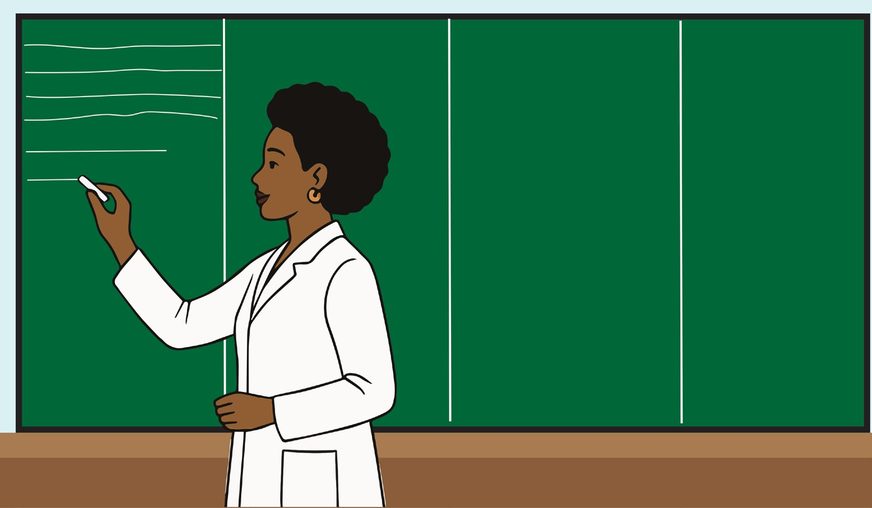

The chalkboard/whiteboard is a visual teaching aid. It is a medium of interaction between the teacher and the learner.

- Erase the chalkboard/ whiteboard completely at the start of the lesson and after the lesson so that the following teacher will find the board clean.
- Divide the chalkboard/ whiteboard into sections depending on its breadth, and use different sections of the board for different purposes:
      - Left edge of the board for the outline of the class plan
      - Middle zones for developing the lesson content
      - Right edge for lesson conclusion
- Write from the left to the right. When beginning a lesson, write the date at the top left corner of the chalkboard. Write the subject, the unit, the topic of the lesson and the lesson objectives at the appropriate time. This will help both you and the students to stay on track.
- Keep your writing clean and organized so the students can see connections. Don’t write too much. A cluttered chalkboard/whiteboard may confuse your students. Make sure your writing is large enough to be seen by students in the back of the room. Avoid writing too small or squished together.
- Don’t just write things down silently, explain what you’re writing as you go. This helps reinforce concepts and allows students to follow along with your reasoning. Do not write irrelevant information, focus on the key points. Do not stand in front of the material you write.
- Don’t erase the topic of the lesson and instructional objectives. Don’t erase the zone if you will need the material in that zone again later. Don’t erase the material on the board too soon after you wrote it.
- Use different colors of chalk to emphasize important points, formulas, or keywords: green and yellow colors are better for headings while white chalks are good for all other material.
- Do not use more than three colors. Provide your students with opportunities to write on the chalkboard. Many students enjoy the chance to display what they know and even to play the role of the teacher. Allow students sufficient time to copy what you wrote before you erase it.
- If you’re teaching a subject that involves diagrams (e.g., math, science, geography), draw them as you explain. This helps students visualize the material.
- While writing on the board, ask students questions to keep them engaged. This can also provide immediate feedback on whether they understand the material.
- Give students opportunities to come to the board to solve problems, share or write their ideas. This can create a more interactive and engaging classroom environment. Students like to play the role of the teacher in class.
- While writing on the board, avoid turning your back on the class for extended periods.
- Engage with students as you write and talk to them to maintain eye contact.
- Don’t be afraid to make mistakes on the board, correcting them in front of the class can be a valuable learning experience.
- Write key ideas, a summary or key takeaways on the board as the lesson goes on (Arends, 2015; Woolfolk, 2019).

Activity:
- Select a lesson topic from one of the subjects you will teach in secondary schools.
- Identify the generic competences and crosscutting issues relevant to your lesson objectives, content and activities that you can develop and integrate in each step of your lesson.
- Develop the lesson plan
- Share it with your colleagues for feedback.
- Reflect on the feedback received and how they can improve your lesson delivery.

- Classroom management

Activity:
Using the mid map, identify four key words that come to mind when you think about classroom management.

F.1 Meaning of classroom management
Classroom management refers to the strategies, practices, and techniques that teachers use to maintain an organized, productive, and respectful learning environment. It encompasses everything from setting clear expectations and maintaining discipline or managing student behaviour, organizing classroom activities to fostering student engagement and managing classroom resources. The goal of classroom management is to minimize disruptions and maximize learning time, creating a space where all students feel safe, respected, and engaged (Arends, 2015).

Effective strategies for classroom management

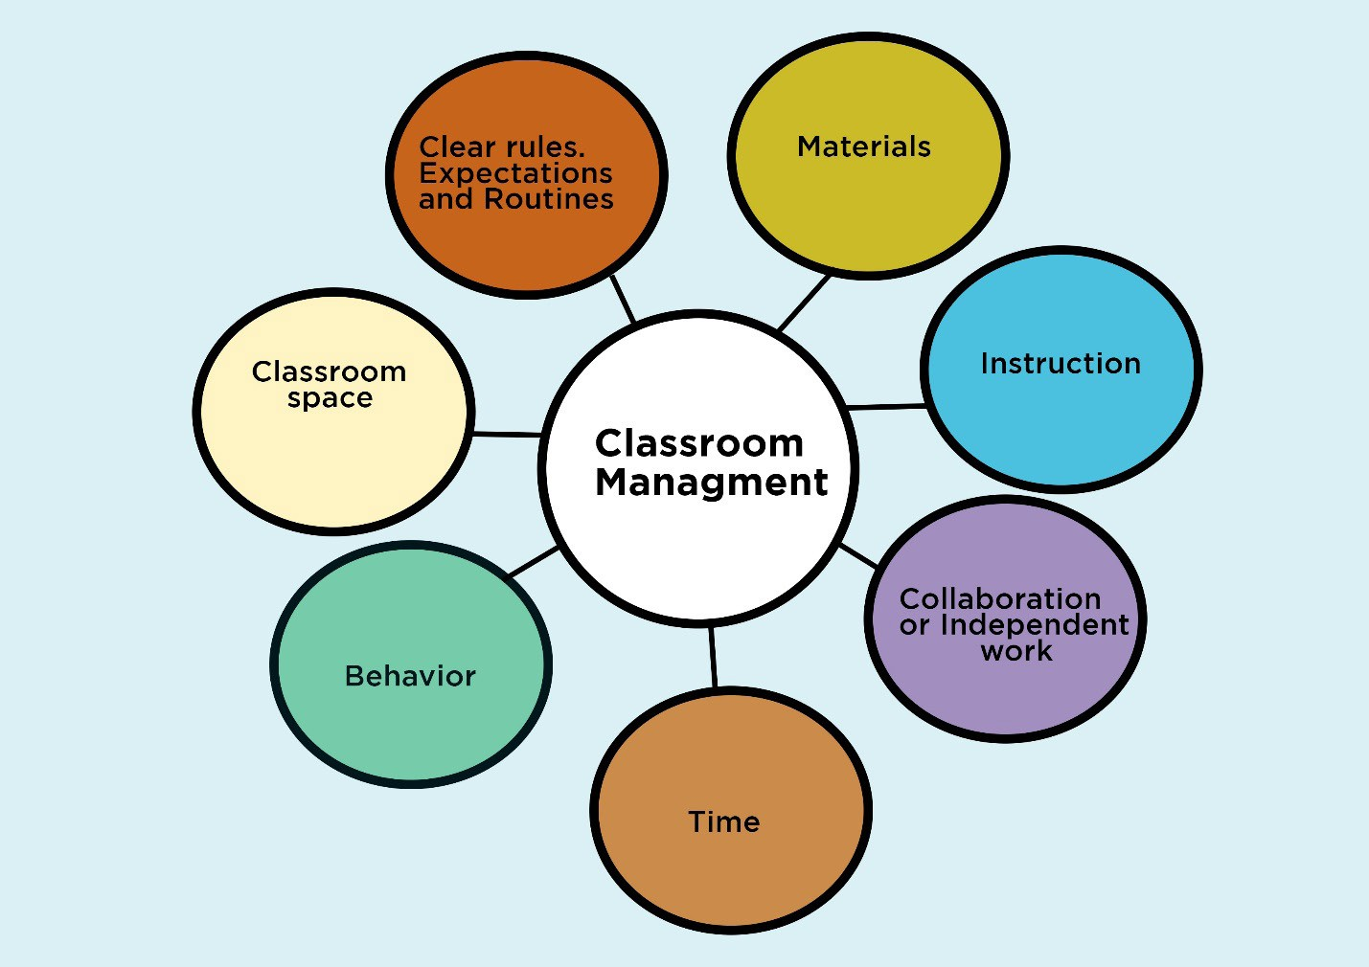
Strategies for classroom management
There are different classroom management strategies that a teacher can use (Simonsen et al., 2016; Emmer & Sabornie, 2023).

Establishing clear rules, expectations and routines:
Clearly define and communicate rules at the beginning of school year, term or lesson. Involve students in developing classroom norms to foster ownership and responsibility. Clearly define what behaviors are acceptable and unacceptable during lessons, transitions, and free time and make sure students understand them. Apply the rules consistently to ensure fairness. If students know what to expect, they’ll be more likely to follow the rules. Create routines for common classroom activities (e.g., entering the classroom, handing in assignments, transitions between activities). When routines are established, students will know what to do without constant reminders. Set time limits for activities and use visual or auditory signals (e.g., bells, timers) to help students transition smoothly between tasks.

Creating a positive learning environment:
Build respectful and supportive teacher-student relationships where students feel valued, respected, and part of a community. When students feel respected and valued, they’re more likely to engage and behave well. Promote a culture of inclusion, fairness, and encouragement. Encouraging positive behaviors through rewards, praise, and encouragement. Keep lessons engaging and interactive. When students are interested and actively involved, they’re less likely to misbehave.

Creating an environment that encourages collaboration or independent work, depending on the lesson:
Designing lessons that are engaging, interactive, and appropriately challenging for students. Celebrate successes and provide constructive feedback. Using a variety of teaching strategies and tools (e.g., group work, hands-on activities, multimedia) to keep students engaged and focused. If a lesson isn’t going well or students are disengaging, be flexible and adjust your approach. Sometimes, shifting activities or teaching strategies can re- engage students.

Organizing the physical space or classroom set up:
Arrange desks, chairs and materials in a way that supports interaction, accessibility, smooth transitions and minimizes distractions; and in a way that encourages cooperation and focus. Ensure the room is clean, well-lit, and free of unnecessary distractions. Avoid distractions by minimizing disorder and keeping learning materials within reach.

Time management:
Start and end lessons on time. Planning and managing the flow of the lesson to ensure that time is used effectively for instruction and student participation. Creating routines for transitions between activities to avoid wasted time. Use timers or visual schedules if needed to support pacing.

Behavior management:
Address misbehavior or disruptions calmly and quickly (as soon as they occur) to prevent escalation. A quick and calm response helps maintain control without disrupting the class. Provide immediate, specific feedback to reinforce good behavior and correct issues. Using preventive strategies such as proximity control (simply moving closer to a student who is off task can help redirect their attention), non-verbal cues (eye contact, hand gestures, or other non-verbal cues to let students know you’re paying attention and want them to stay on track) or redirecting. Keep students engaged in the lesson to prevent behavioral issues. Use strategies like positive reinforcement, and consequences- that are transparent and age appropriate- to guide student behavior. For instance, when students break the rules, follow through with the consequences you’ve established. Be consistent with how you apply consequences to prevent confusion. Use restorative approaches (e.g., conflict resolution or mediation) when appropriate. Involve parents, school leaders if behavior challenges persist.

Engaging students in learning:
Use varied teaching methods and strategies (e.g., discussions, demonstrations, group work, discussions, hands-on activities) to maintain interest. Differentiate instruction to meet diverse learning needs and abilities. Give learners opportunities to take responsibility (e.g., classroom roles, peer mentoring).

Maintain professionalism and take care of yourself:
Stay calm, even in challenging situations. Keeping your emotions in check, models emotional regulation for students. How to do it?
- Manage stress: Classroom management can be challenging, and stress can impact your effectiveness. Take breaks when you need to and ensure you’re maintaining your own well-being.
- Reflect and improve: After each lesson, reflect on what went well and what could be improved. This will help you continue to grow as a teacher and develop better management strategies over time.

Unit 6: Assessment in the teaching and learning process

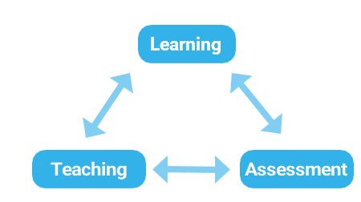Assessment is an integral part of the teaching and learning process and constitutes one of the most demanding tasks of the teacher. Until the assessment is complete, the teaching activity is not complete. This unit differentiates the concepts of assessment and evaluation, discuss types, strategies, approaches and principles of assessment. It clarifies the importance of assessment in the teaching and learning process, types of assessment questions, their advantages and disadvantages. By the end, you will be prepared to design and implement inclusive, goal-oriented, and reflective assessments.

Unit learning outcomes

By the end of the unit, you will be able to:
- Differentiate assessment and evaluation, assessment types, approaches, and strategies to develop a clear understanding of assessment in education.
- Explain principles of competence-based assessment and CBC assessment levels in Rwanda to apply them in improving teaching and learning quality.
- Discuss the importance of assessment, advantages and disadvantages of types of assessment questions to value its relevance in the teaching and learning process.
- Design valid and reliable assessment questions aligned with instructional objectives and learning activities.

6.1 Assessment and Evaluation
Activity: Read the following classroom situations and indicate whether each situation
represents assessment or evaluation.
- Learners complete a quiz and immediately discuss corrections with the teacher.
- End-of-term examination results are used to decide promotion to the next class.
- A teacher compares learners’ final project scores to determine the best performer.
- A school ranks students according to their final examination scores.
- During a class session, the teacher marks students’ presentations
- Learners complete classroom exercises and discuss corrections with the teacher

Assessment and evaluation are integral parts of the teaching and learning process, helping to measure and improve student learning while guiding teaching strategies. Though they are often used interchangeably, the two terms are different.
- Assessment
Assessment is a broader process of gathering information about students’ learning through various means (tests, observations, projects, portfolios, class participation, assignments, presentations, etc.). Assessment focuses on collecting evidence of learning (both quantitative and quantitative). For instance, a teacher assessing reading comprehension may give a reading test (quantitative) but also listen to students read aloud and check their book reviews (qualitative). This makes assessment more holistic. Assessment is used to measure learning progress, provide feedback, and improve teaching and learning. It must be aligned with the instructional objectives or learning outcomes and teaching/learning activities.

B. Evaluation

Evaluation is the process of making judgments or value decisions about the quality, effectiveness, or worth of a learner’s performance, an instructional program, or an educational system, often based on the information gathered through measurement and assessment. It answers the question “How good is it?” or “What does it mean?” Example: After assessing students in a history course through tests, projects, and participation, the teacher concludes that a student has mastered the subject at an “excellent” level (grading A), while another is “below average” (grading D). Here, judgment is made about the quality of learning, that is evaluation.

Relationship between Evaluation and Assessment

- Evaluation comes after assessment. It uses the evidence collected from assessments to make judgments about learning or program effectiveness. Assessment provides the raw information; evaluation interprets it to reach conclusions and decisions. Example: After assessing a student through tests, essays, and class discussions, the teacher evaluates whether the student deserves an A, B, or C grade or whether teaching strategies need to be adjusted.
- Assessment is more student-centered, focusing on individual learning progress, while evaluation is broader and often involves judgment about the entire teaching and learning process.
- Assessment informs evaluation by providing data about student learning, while evaluation helps improve future assessments and instructional practices.
- Both are used to identify areas of improvement for students and adjust teaching strategies accordingly.
- Teachers can modify instruction based on assessment data, and they can evaluate the overall effectiveness of their approach through regular evaluations.
- Both assessment and evaluation are key to ensuring that education is responsive, effective, and aligned with students’ needs and goals.

Some examples that differentiate assessment from evaluation
Example 1: Assessment: A teacher gives a quiz after teaching a math lesson on fractions. This quiz checks the students’ understanding of the specific content taught in that lesson, such as adding and subtracting fractions. Evaluation: At the end of the term, the teacher evaluates the overall performance of the class by reviewing the results of all quizzes, exams, projects, and participation. The teacher evaluates whether the teaching methods used throughout the semester were effective in helping students achieve the course objectives.

Example 2: Assessment: During the semester, the teacher provides ongoing feedback on students’ essays. This feedback could include comments on writing style, argument clarity, grammar, etc. The feedback helps the students understand where they are improving and what areas need work. Evaluation: At the end of the subject delivery, the teacher evaluates the overall effectiveness of the lessons/Unit delivered on writing. Did students improve their writing skills from the beginning of the subject teaching to the end? Were the teaching strategies (e.g., group works, role playing, presentations, et.) effective in helping students develop their writing?

6.2 Types of assessment
There are three main types of assessment: Diagnostic, Formative, summative and diagnostic (REB, 2020).
Formative assessment: Ongoing and usually informal, takes place during the learning process. It helps to monitor student progress and guide teaching adjustments. Examples include quizzes, peer reviews, group activities, presentations or observations.
Summative assessment: Conducted at the end of a learning period, it measures the cumulative knowledge and skills a student has acquired. Examples include final exams, end-of- term projects, standardized tests,etc..
Diagnostic assessment: Given before instruction begins, it helps identify students’ prior knowledge and learning needs. This can guide the design of lessons and help teachers understand what students already know and what they need to learn.

Assessment approaches: Assessment of, as, and for learning
The terms assessment of learning, assessment as learning, and assessment for learning refer to different purposes and approaches to assessment in education. These distinctions help clarify how assessment can be used in various ways to support and evaluate student progress (ENABEL, 2025).

a. Assessment of Learning (Summative Assessment)
Assessment of learning measures and evaluates students’ learning at a specific point in time, typically at the end of a lesson, unit, or module. It is used to determine how much students have learned and the extent to which students have achieved the learning objectives or standards. It is often summative in nature, and provides final judgment on student performance, often in the form of grades, scores, or certificates and helps to determine achievement levels or mastery of a subject. Examples of assessment of learning:
- Final exams: Tests that cover a wide range of material from the subject.
- End-of-unit tests: Assessments given at the end of a unit to evaluate if students grasped the main concepts.
- Final projects or presentations: A culminating assessment that demonstrates a student’s overall understanding and skills.
- Standardized tests: Large-scale tests used to evaluate learning at a national or state level.

Assessment as Learning (Student self-Assessment)
Assessment as learning, part of formative assessment, involves students monitoring and gathering information about their own learning. They do this through self- and/or peer- assessments to help understand how they are progressing in their learning, and what they can do to improve. Students actively participate in the assessment process and become more aware of their strengths and areas for improvement. It involves students in the assessment process and helps them use the information to guide and improve their own learning. Examples of assessment as learning:
  - Reflection journals: Students write about what they’ve learned, what they found challenging, and where they need to improve.
  - Peer reviews: Students evaluate their classmates’ work and receive feedback, which helps them reflect on their own work.
  - Rubrics for self-assessment: Students assess their own assignments or projects using rubric to determine how well they met the criteria.
  - Learning logs: Ongoing records where students track their learning progress, challenges, and adjustments made throughout a unit or semester.

Assessment for Learning (Formative Assessment)
It is an ongoing process that takes place during learning, providing feedback to help students improve and enabling teachers to adjust instruction accordingly. The focus is on progress and growth rather than final outcomes. This type of assessment identifies students’ strengths and weaknesses, supporting real-time learning by informing instruction and guiding necessary adjustments to enhance understanding and performance. Examples of assessment for learning:
  - Quizzes: Short, low-stakes tests that provide feedback on students’ understanding of the material, allowing for adjustments in teaching.
  - Classroom observations: Teachers observe students’ participation, collaboration, or problem-solving, providing informal feedback.
  - Concept mapping: Students create diagrams that show the relationships between key concepts, helping both teachers and students see areas of misunderstanding.
  - Exit tickets: At the end of a lesson, students quickly write what they learned or any questions they still have, helping teachers adjust future lessons.
  - Peer feedback: Students provide feedback to each other during assignments or projects, helping one another improve before final submissions.

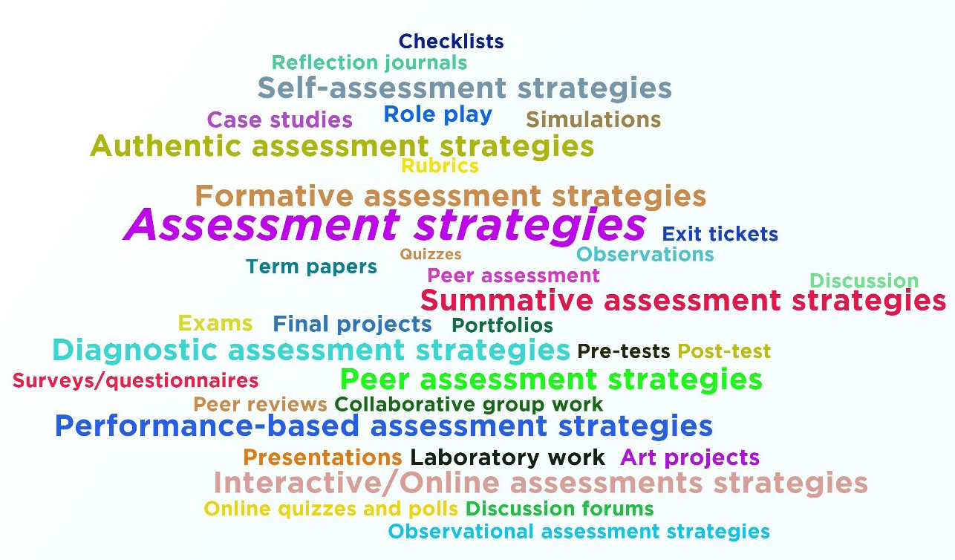
6.3 Assessment strategies
Assessment strategies refer to various methods and tools teachers use to gather information about students’ learning progress. These strategies help determine how well students understand the material and achieve instructional objectives. There are different approaches to assessment, and the best strategies often combine multiple methods to get a fuller picture of student learning. Some key assessment strategies commonly used in teaching and learning are the following:

Formative assessment strategies
Formative assessment is used during the learning process to monitor student progress and provide ongoing feedback. Examples of strategies:
- Quizzes: Short, frequent quizzes on the material can help both teachers and students identify areas where more focus is needed.
- Exit tickets: At the end of the lesson, students write a quick summary or answer a question on what they learned. This helps teachers gauge whether the students grasped the key concepts.
- Peer assessment: Students assess each other’s work based on given criteria, helping them think critically and engage with the learning material.
- Observations: Teachers can assess student behavior and performance in class through direct observation, noting participation, collaboration, and engagement.
- Discussion: Informal discussions or group work can serve as a form of assessment. Teachers can listen to students’ contributions to gauge understanding.

Summative assessment strategies
This type of assessment is conducted at the end of a learning unit or subject/ module to evaluate overall student performance. Examples of strategies:
- Exams: A traditional method that tests students’ knowledge on a wide range of topics covered during the subject or module.
- Final projects: Projects or presentations at the end of a unit or subject, module that showcase students’ understanding of a topic.
- Term papers: A written assignment requiring students to demonstrate comprehensive knowledge on a subject.
- Portfolios: A collection of students’ overtime work, which can include drafts, revisions, and final products, allowing for assessment of both the final outcome and the learning process.

Diagnostic assessment strategies
Used before teaching begins to identify students’ existing knowledge and skills, helping to tailor instruction to meet their needs. Examples of diagnostic assessment strategies:
- Pre-tests: A test administered before starting a unit to measure what students already know about the subject.
- Post-test: assess the gains in knowledge or skills that students have made as a result of the instruction. It helps determine if the students have understood and can apply the material taught during the learning period.
- Surveys/questionnaires: These can help identify students’ interests, learning preferences, and prior knowledge.

Authentic assessment strategies

They measure students’ ability to apply learned skills and knowledge in real- world situations. Examples:
- Case studies: Students analyze real-life scenarios, solving problems based on what they’ve learned.
- Role play: Students act out real-world situations that require the use of learned knowledge, like acting a historical event or practicing a job- related task.
- Simulations: These can be computer-based or real-world. In science, students could use a virtual lab to simulate chemical reactions that are too dangerous or costly to conduct in a real lab. In geography, learners might use GIS (Geographic Information System) software to simulate the impact of natural disasters on human settlements.

Self-assessment strategies
This allows students to reflect on their own learning and progress, encouraging
them to take ownership of their education. Examples of strategies:
- Reflection journals: Students regularly write in journals to reflect on their learning, set goals, and assess their progress.
- Checklists: Students use checklists to evaluate their own work based on set criteria.
- Rubrics: Students use rubrics to self-assess their projects or assignments, checking if they meet the specific criteria.

Peer assessment strategies
Peer assessment encourages students to evaluate each other’s work. It promotes collaborative learning and critical thinking. Examples:
  - Peer reviews: Students review each other’s essays, projects, or presentations, providing constructive feedback.
  - Collaborative group work: Peers assess each other’s contributions to a group project, often via peer evaluations.

Performance-based assessment strategies
Involves students demonstrating their learning through active performance, usually in the form of practical tasks or activities. Examples:
- Presentations: Students create and deliver a presentation to demonstrate understanding and mastery of a topic.
- Laboratory work: In science, students may perform experiments and be assessed on both the process and outcome.
- Art projects: In the arts, students may be tasked with creating something that showcases their skill, like a painting or a musical performance.

- Interactive/Online assessments strategies

With the advent of technology, many teachers use digital tools to assess students. Examples:
- Online quizzes and polls: Platforms like Kahoot, Quizlet, or Google Forms allow for instant feedback and easy tracking of student responses.
- Discussion forums: Students can engage in online discussions, which can be assessed for depth of analysis, engagement, and understanding of the topic.

- Observational assessment strategies
Teachers observe and assess students’ progress and behavior in real-time. Examples:
behavior checklists: teachers monitor students’ participation and engagement during class activities, noting progress and behavior.
anecdotal records: teachers jot down brief notes about students’ performance, learning behaviors, and any significant interactions during lessons.

6.5 Importance of assessment in the teaching and learning process

Assessment plays a crucial role in education, serving a variety of functions that help stakeholders (learners, parents, educational authorities, institutions, and employers) throughout the teaching and learning process.
Guiding instruction:
Assessment helps teachers understand where students are in their learning. It provides valuable information about what students know, what they don’t yet understand, and what areas need more focus. This helps teachers tailor their instruction to meet the specific needs of their students. For instance, formative assessments (like quizzes or group discussions) give teachers
real-time data that can guide adjustments in teaching strategies, content delivery, or pacing. Summative assessments (like exams or final projects) give teachers a clear picture of how well students have grasped the overall content.
Improving student learning:
Assessment provides students with feedback on their progress, helping them understand their strengths and areas for improvement. When feedback is timely and constructive, it can motivate students to improve and guide them toward better learning strategies. For example, self-assessment and peer- assessment encourage students to reflect on their own learning, recognize their achievements, and identify areas that need work.
Motivating students:
When assessments are used effectively, they can motivate students to work harder and take ownership of their learning. Knowing that they will be assessed helps students stay focused and committed to their studies. Assessment for learning (formative assessments) encourages students to engage in continuous improvement rather than focusing solely on final grades. Clear expectations through rubrics and assessments allow students to see the criteria for success, which can motivate them to meet or exceed those standards.
Providing evidence of achievement:
Assessment provides concrete evidence of student achievement. It allows teachers, parents, and administrators to track students’ progress and understand whether learning objectives are being met. For instance, summative assessments give a snapshot of what students have achieved after a lesson, unit, or module. This evidence can be used for academic records, reporting to parents, or even determining whether students are ready to move to the next grade or level of study.
Supporting decision-making:
Assessment helps in making important educational decisions, both for individual students and for groups of students. This can include decisions about teaching methods, grouping students for specific interventions, or even determining whether students are ready to advance. For instance, diagnostic assessments at the start of a unit or course help teachers make decisions about the best approach for teaching the material. Summative assessments can inform decisions about graduation, retention, or certification.
Identifying gaps in knowledge and skills:
Assessment helps identify gaps in students’ understanding or skills. This is particularly important for both individual and group learning. Formative assessment helps pinpoint specific areas where students are struggling, allowing teachers to provide additional support or adjust teaching strategies. It ensures that students don’t just passively memorize content but truly understand the material and are able to apply it effectively.
Promoting accountability:
Assessment holds students accountable for their learning. It helps students understand that they are responsible for mastering content and improving their skills. Regular assessments encourage students to stay on track and reflect on their learning progress. Teachers and schools can use assessment data to evaluate their own effectiveness and make necessary adjustments to better support student achievement.
Informing educational policy and planning:
At a larger scale, assessment data can inform educational policies and help plan curricula, allocate resources, and make decisions about teaching practices. For instance, standardized tests and national assessments help policymakers track overall educational performance and make decisions about funding, resources, or curriculum changes. Local assessments allow schools and educators to identify trends, strengths, and areas that need improvement in their own communities.
Facilitating communication with stakeholders:
Assessment provides a way to communicate student progress to various stakeholders—parents, administrators, and even the students themselves. For example, parent-teacher meetings often use assessment data to discuss a student’s progress, achievements, and areas needing attention. Report cards and other formal assessments provide parents with clear, measurable data on their child’s academic progress.

Building confidence:
When students do well on assessments, it boosts their confidence and self-esteem. Achieving good results on assessments shows students that they are capable and reinforces a growth mindset. For example, regular positive feedback and successful assessments can motivate students to engage more deeply with their learning and set higher goals for themselves. Assessment for learning encourages a focus on progress and improvement, helping students see their learning as an ongoing process rather than just a final outcome.

  - Assessment principles
Activity:
As a future teacher, what will you take into consideration while designing different types of assessments?

- Meaning of assessment principles
Assessment principles are the foundational guidelines or rules that govern how assessments should be designed, implemented, and interpreted to ensure fairness, effectiveness, and accuracy. These principles aim to improve both teaching and learning by ensuring that assessments are valid, reliable, and beneficial to all students.

Key principles of assessment:
They include among others (REB, 2020):
Validity: Validity refers to the extent to which an assessment measures what it is intended to measure. An assessment is valid only if it accurately reflects the learning objectives and content it is supposed to assess. Example of validity: A math test on algebra should not include questions unrelated to algebra, such as geometry or statistics.
Reliability: Reliability refers to the consistency of the assessment results over time and across different groups of students. Reliable assessments produce stable and consistent results, meaning that if the test was repeated under similar conditions, it would yield the same results. Example: If two teachers grade the same essay, their scores should be similar if the assessment is reliable.
Fairness: Fairness refers to the idea that assessments should be equitable and not favor any group or individual over another. Fair assessments provide all students, regardless of their background, with an equal opportunity to demonstrate their knowledge and skills. To be fair, a teacher has to avoid bias (cultural, gender, socioeconomic, etc.) in assessment design, providing accommodations for students with disabilities and ensuring that assessment methods are accessible to all learners. Example of fairness: A multiple-choice test should not include language that may be confusing or unfamiliar to students from diverse linguistic backgrounds.
Transparency: Transparency means that the assessment criteria, purpose, objectives and process are clear to students. When students understand what is expected of them, they are more likely to perform well and feel confident in their ability to succeed. Marking rubrics or marking criteria should be detailed so that students know how their work will be evaluated. Example of transparency: A teacher gives students rubric outlining the expectations for activity given, so students know exactly what aspects of their work will be assessed (e.g., creativity, accuracy, or presentation).
Inclusivity: Inclusivity refers to ensuring that assessments accommodate the diverse needs of all learners, including students with disabilities, different learning styles, and varied levels of preparedness. Inclusive assessments allow all students to demonstrate their learning, ensuring that no one is unfairly disadvantaged by the assessment process. The teacher can provide alternative assessment methods (e.g., oral presentations for students who struggle with written tasks) or adjusting time limits for students with specific learning needs. Example of inclusivity: A student with dyslexia may be given extra time on a reading comprehension test.
Feedback: Feedback is the information provided to students about their performance, indicating strengths and areas for improvement. Effective feedback helps students understand their progress and learn from their mistakes, guiding future learning. Effective feedback should be:
Timely: Provided soon after the assessment to allow for reflection and improvement.
Constructive: Focuses on specific actions students can take to improve.
Actionable: Provides clear suggestions for how students can address weaknesses.
Example of feedback: After a quiz, a teacher provides individual feedback pointing out common mistakes and offering resources for further study.
Authenticity: refers to the relevance of an assessment to real-world contexts, making the assessment tasks meaningful and applicable to students’ lives or future careers. The teacher can use real-life scenarios or practical tasks that require problem-solving and critical thinking and encourage the application of knowledge in relevant contexts. Authentic assessments motivate students by demonstrating how their learning applies outside of the classroom, thus fostering deeper engagement. Example of authenticity: In a science class, instead of just testing theoretical knowledge, a teacher might have students conduct experiments to solve a real-world problem (e.g., designing a water filtration system).
Purposefulness: Every assessment should have a clear purpose, whether it is to measure learning, inform instruction, or support accountability. The teacher decides whether the assessment is formative (providing feedback for improvement) or summative (measuring overall achievement) and aligns assessment design with the course’s learning outcomes or objectives. Example of purposefulness: A final exam in a history class should focus on evaluating the key historical concepts and events taught throughout the course, ensuring that the assessment matches the learning objectives.
Sustainability: refers to designing assessments that are practical and manageable for both students and teachers, without overloading them. An overburdened system of assessment can lead to fatigue, stress, or a diminished quality of learning. Assessments should be realistic in terms of time, resources, and expectations. The teacher has to balance the number of assessments with the available time for preparation and feedback and designing assessments that are feasible for both students and teachers. Teachers of sustainability: A teacher might choose to assign a series of smaller projects or quizzes rather than one large, high-stakes exam to allow students to pace their learning.

6.4 Types of assessment questions

Activity:
Read the following assessment questions and identify the type of question used in each case.
Question | Type of Assessment Question
1. Define democracy. | __________
2. Rwanda gained independence in: A. 1959 B. 1962 C. 1994 D. 2000 | __________
3. Match the leaders in Column A with their countries in Column B. | __________
4. Explain two causes of conflict in society. | __________
5. True or False: Assessment is the same as evaluation. | __________
6. Fill in the blank: The process of collecting information about learning is called __________. | __________

Assessment questions come in various types, each serving a specific purpose in evaluating students’ knowledge, skills, and values. These different types of questions help assess different levels of learning, from simple recall of facts to more complex types of information. Assessment questions are divided into two many categories: Closed- ended questions and open-ended questions and they may be oral or written (REB, 2020; Hyman & Sierra, 2016).

Closed-ended questions or objective assessment items
Closed-ended questions provide a limited set of possible answers, usually requiring a simple, direct response. They have predetermined or predefined answers for respondents to choose from the one that best fits. Types of closed-ended questions include the following:

Yes/No questions
Yes/No questions are framed as interrogative sentences that require the respondent to choose between “Yes” or “No”. They are useful for gathering simple facts or confirming information. Example: Answer by Yes or No. Is the capital of Italy Rome? Answer: Yes.

True/False questions
True/false questions are declarative statements that require learners to determine whether the statement is true or false. These questions test basic knowledge and understanding. They assess students’ ability to recognize correct information quickly. Example: Answer by True or False. Rwanda is a landlocked country. Answer: True.

Multiple-Choice Questions (MCQs)
A Multiple-Choice Question consists of a question or incomplete statement (called the stem) followed by several possible answers called options, typically including one correct answer and several distractors (incorrect or less appropriate options). Normally the suggested number of answers does not exceed five and not below four. The learner is requested to choose either the correct answer or the wrong one. They are useful for assessing knowledge, comprehension, and sometimes higher order thinking skills, depending on the quality of the questions.
Example: Which of the following is the largest planet in our solar system?
A. Earth B. Mars C. Jupiter D. Saturn Answer: C. Jupiter

Matching questions/items
Matching questions/ items require learners to pair items in one column with related items in another column based on a specific relationship (such as definitions, examples, causes, dates, or functions). Matching questions are structured in the following way:
- Instructions: A clear direction that tells students what the relationship is and how to match the items (e.g., Match the following terms with their correct definitions).
- Premises (Column A): A list of items such as terms, events, or questions.
- Responses (Column B): A list of possible matches, such as definitions, descriptions, or corresponding answers.
Matching questions/ items are efficient for assessing multiple pieces of information. They are efficient for testing a large amount of related information and are useful for assessing recall, association/relationships, and comprehension.

Example: Match the following countries (Column A) with their capitals (Column B).

Column A: Country | Column B: Capital
1. France | A.Tokyo
2. Japan | B. Paris
3. Canada | C. Nairobi
4. Australia | D. Ottawa
5. Kenya | E. Canberra
 | F. Kampala
Answers:
- → B. Paris
- → A. Tokyo
- → D. Ottawa
- → E. Canberra
- → C. Nairobi

Advantages of closed-ended questions

They are efficient: They are easier and faster to answer, making them suitable for surveys or quick assessments. Learners respond quickly because answers are already provided or limited.
Responses are simple to quantify and analyze statistically, which makes them ideal for large-scale data collection.
They guide and help the learner to remember
The teacher sets the marking scheme easily
They require little time to mark: Teachers can mark them objectively and quickly.
They are more objective because the number of answers is precise and limited, predefined, precise and limited, they reduce bias in both answering and grading
Suitable for large classes and examinations with many learners.
Ensures uniformity: All learners respond to the same options, making comparison easier.
Reliable for testing factual knowledge: Effective for checking recall, recognition, and understanding of facts.
Reduces ambiguity: Answers are specific and standardized.

Disadvantages of closed-ended questions

Limited depth: They do not allow for nuanced responses or explanations (answers that show careful thinking, detail, and a deep understanding), because they restrict the respondent to a set of options.
Limit creativity and expression: Learners cannot explain ideas in their own words.
Lack of detail: These questions do not allow the respondent to elaborate on their reasoning, feelings, or opinions.
They do not develop learners’ communication skills like speaking, listening and writing skills
They are difficult to set: Constructing good objective questions requires skill and time.
Encourage guessing: Learners may choose correct answers by chance. They favor random answers
Do not measure deep understanding well: Difficult to assess reasoning and critical thinking fully.
May encourage memorization: Learners may focus only on recalling facts.

Open-ended questions/ subjective assessment questions
Open-ended questions allow learners to answer in their own words, offering a broader and more detailed response rather than choosing from predetermined options. They require more elaborate answers, encouraging students to think critically, explain reasoning, express opinions, or demonstrate deeper understanding. The number of answers for an open-ended question is not limited because it varies from one learner to the other and it depends on the question asked. Open-ended questions are recommended:
- To carry out a quick assessment as teaching is going on.
- To assess complex and difficult learning which needs to be summarized.
- To assess a portion of a wide course which needs to be summarized.
- To assess the learning objectives with high taxonomic level.

Open-ended questions are essential for assessing higher thinking skills, allowing learners to demonstrate not only what they know but also how they think and communicate. There are two types of open-ended questions: short answers and long answers questions.

Short-answer questions
Short-answer questions require students to provide brief, concise responses, typically ranging from a word or phrase to a few sentences. These questions are designed to assess the recall of facts, understanding of key concepts, or ability to summarize ideas without the need for extended writing. Examples: What is photosynthesis? What is the capital city of Rwanda? Name two causes of environmental degradation.
Fill-in-the-blank questions are also a type of short answer question: Students complete a sentence or statement with the correct word or phrase. Example: The capital of Rwanda is ..

Long answer questions
They require long answers often formulated as follows: What do you think about...? Tell me about...? Discuss...; What is your opinion about...? etc.

Types of long answer questions:
- Essay questions: Students provide a detailed, structured written response to a question, typically involving analysis, interpretation, or argumentation. They test deep understanding, critical thinking, and the ability to communicate complex ideas. They allow for in-depth exploration of topics; evaluates higher-order thinking. Example: Discuss the impact of climate change on global agriculture and propose potential solutions. Answer: (Student’s detailed, well- organized response).
- Problem-solving questions: Students are asked to solve a practical problem or a scenario using knowledge, reasoning, calculation, etc. and ask the respondent to propose a solution. They test creativity, critical thinking, and problem-solving abilities. These questions assess the ability to apply concepts to real-world situations. They test application of knowledge in practical contexts. Example: If a car travels 60 km per hour for 3 hours, how far does it travel? (Answer: the student does calculations and provides the answer).
- Performance-based questions: Students demonstrate their knowledge and skills through a task or activity rather than through traditional written responses. The questions assess practical application, creativity, and skills in action. They are more authentic and reflective of real-world tasks. Example: Perform a science experiment to test the reaction between baking soda and vinegar and explain the results. Answer: (Student demonstrates and explains the experiment results).
- Case study questions: Students analyze a specific situation, problem, or case and provide a response based on their understanding of the material. These questions assess critical thinking, problem-solving, and application of knowledge. They encourage deep analysis and the application of concepts to real-world scenarios. Example: Given a case study on a business facing financial challenges, suggest strategies for improving its financial position. Answer: (Student provides a detailed response with analysis).
- Diagram or labeling questions: Students are given a diagram (e.g., body part, machine, or process) and asked to label parts or describe components. They assess recognition, recall, and understanding of visual concepts. They are useful for subjects like biology, engineering, or geography. Example: Label the parts of the plant in the diagram (Labels might include root, stem, leaf, etc.).

Advantages of open-ended questions

- Encourage critical thinking: Open-ended questions require students to analyze, evaluate, and synthesize information rather than simply recall facts, promoting deeper understanding and higher-order thinking.
- Allow for creativity and expression: These questions give learners the freedom to express their ideas in their own words, encouraging originality and personal interpretation.
- Provide insight into student understanding: Teachers can gauge not only what a student knows but also how they think and structure their responses, offering a clearer picture of conceptual understanding.
- Personalized responses: They allow for diverse answers that reflect individual perspectives and experiences.
- Develop communication skills: Answering open-ended questions helps students improve their written and verbal communication skills, especially in articulating and defending their viewpoints.
- Reveal misconceptions: Because students explain their thinking, open-ended questions can uncover misunderstandings that may not be evident in closed questions.
- Build confidence: Learners may feel more empowered when they realize there isn’t just one correct answer, reducing anxiety associated with right/wrong responses.
- They are easy to set because they do not require the teacher or examiner to provide a fixed set of alternatives or predetermined answers
- Allow for written feedback: Teachers can make comments on learners’ progress, on the quality of their thinking, the depth of their understanding and the difficulties they encounter from time to time.
- Motivate students: Research has shown that students are more motivated when they prepare for the examinations which require long answers than when they prepare the examinations with multiple-choice questions.

Disadvantages of open-ended questions
- Time-consuming to answer: Open-ended questions often require lengthy, detailed responses, which can be challenging for students under time constraints during tests or exams.
- Difficult to mark objectively: Scoring open-ended responses can be subjective and inconsistent, especially if clear rubrics are not used. This may lead to bias or variation in grading.
- They are not always easy to mark, since student responses may vary widely in depth, organization, and interpretation. This requires the teacher to develop clear marking criteria or rubrics to ensure fairness and consistency in evaluation
- Require strong language skills: Students with limited writing or language proficiency may struggle to express their understanding effectively, even if they know the content well.
- Increased teacher workload: Evaluating open-ended answers takes significantly more time and effort compared to marking closed-ended or multiple-choice questions.
- Risk of off-topic responses: Without clear guidance, students may misinterpret the question or provide responses that stray from the intended focus, making it harder to assess learning accurately.
- May discourage some learners: Some students may feel overwhelmed or anxious when faced with open-ended tasks, particularly if they lack confidence in their ability to structure responses.
- Limited use in large-scale testing: In standardized or large-scale assessments, open-ended questions are less practical due to the time and resources required for grading.
- It is not easy to set the marking scheme
- The validity of the contents can be neglected since the number of questions is very limited.

Oral assessments
An oral assessment is a type of open-ended question in which a student is asked to verbally respond to questions or present information. It is often used to assess a student’s knowledge, communication skills, critical thinking, and ability to articulate their understanding of a subject in real time.

Types of oral assessments
Question-and-answer sessions: The examiner asks the student a series of questions, and the student responds verbally. These sessions test the student’s recall, understanding, and ability to explain concepts in their own words. Example: A student might be asked about key concepts in a history exam, such as Can you explain the significance of the Industrial Revolution?
Presentations: The student is asked to present a specific topic, which could be related to course content or a research project, to an examiner or panel. This type of oral exam assesses the student’s ability to organize and present information clearly and coherently. Example: A student may present on a scientific discovery, explaining its background, findings, and implications.
Viva voce (or oral defence): This is often used in higher education, where students defend their thesis or research findings in front of an examiner or a panel. Oral defence tests the depth of a student’s research, understanding of their topic, and ability to engage in critical discussion. Example: In a PhD defence, the candidate might be asked detailed questions about their research methodology, data analysis, and conclusions.
Role-play or simulation: The student is given a hypothetical situation (often related to their field of study) and asked to respond or act as though they are in that scenario. Role plays test a student’s ability to apply knowledge in real-world or practical situations. Example: A medical student might simulate a patient consultation, where they explain a diagnosis and treatment options to a patient.

Advantages of oral examinations
Assesses communication skills: Oral exams allow teachers to assess not only students’ knowledge but also their ability to communicate clearly, and express ideas effectively (verbal expression, clarity of thought, and ability to articulate ideas) which are important skills beyond written knowledge.
Immediate interaction: The examiner can engage in dialogue with the student, ask follow-up questions and clarify answers in real time, providing a deeper understanding of the student’s knowledge and deeper exploration of topics.
Immediate feedback: Students often receive immediate feedback from the examiner, which can be constructive and guide their learning.
Adaptability: Examiners can adjust the difficulty or direction of questions based on the student’s responses, tailoring the assessment to individual ability levels.
Reduce memorization: Unlike written exams, which may focus on rote memorization, oral exams allow students to demonstrate their understanding and reasoning processes.
Test Higher-Order Thinking: Oral exams encourage students to think critically and respond in real-time, making them suitable for testing analysis, synthesis, and application of knowledge.
Encourage critical thinking: Students must think on their feet and demonstrate understanding rather than just recalling memorized answers.
Reduce cheating: Since the interaction is direct and spontaneous, it’s harder for students to cheat compared to written exams.

Disadvantages of oral examinations
Subjectivity in grading: Scoring may vary depending on the examiner’s judgment, potentially leading to inconsistent or biased results. It depends on the examiner’s interpretation of the student’s responses. Besides, Examiners might unintentionally favor students with better verbal communication skills, which may not always correlate with their actual understanding of the content (potential for bias).
Anxiety and nervousness: Some students may perform poorly due to stress or fear of speaking, which may not accurately reflect their knowledge.
Time-consuming: Oral exams take more time per student compared to written tests, making them less practical for large groups.
Limited scope: It may be difficult to cover a wide range of content within the limited time of an oral exam.
Resource intensive: Requires a quiet, private setting and skilled examiners, which may be challenging to organize regularly.

Unit 7: Gender responsive and inclusive pedagogy

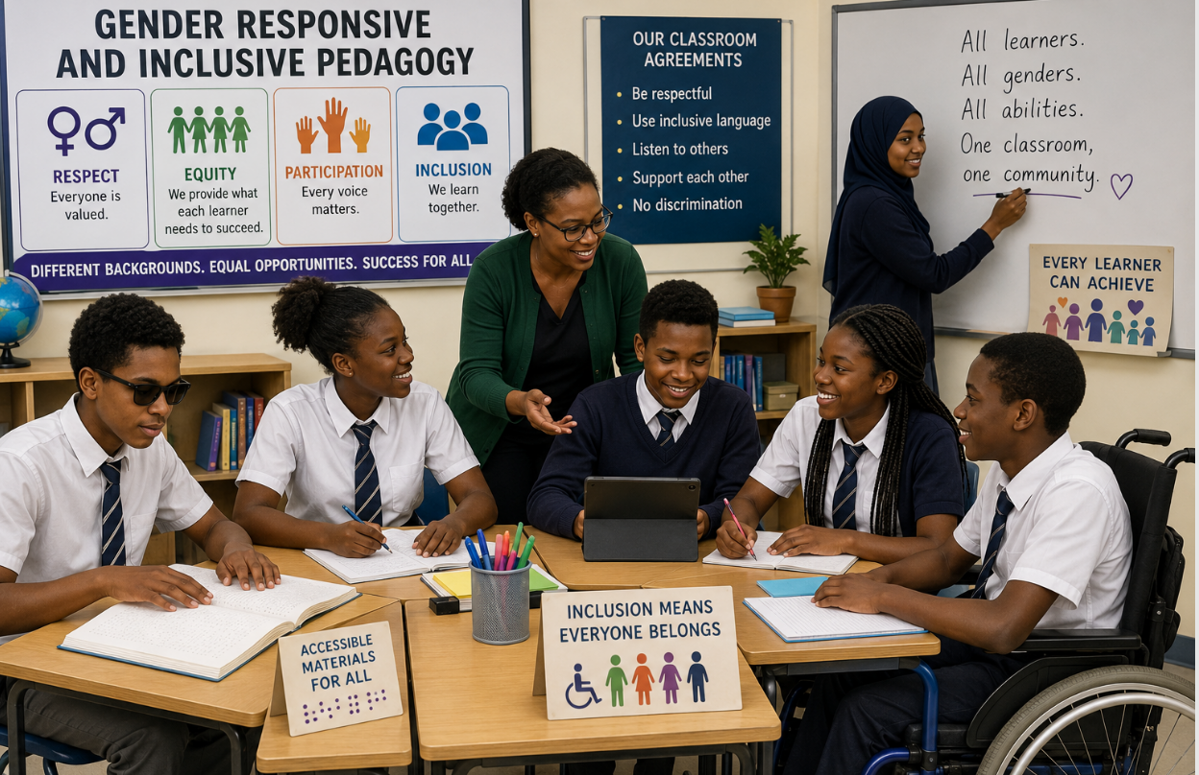 Introduction
Gender responsive and inclusive pedagogy refers to teaching approaches that ensure all learners, regardless of gender, ability, background, or social status, are treated fairly and given equal opportunities to participate and succeed in learning. This unit helps you understand how you can create a safe, equitable, supportive, and non-discriminatory learning environment that meets the needs of every student. It introduces key gender-related concepts and how they can be applied in schools to address bias and promote equality. It also explores the principles of inclusive pedagogy, the characteristics and support of learners with special educational needs, the principles, strategies, and barriers to gender responsive and inclusive pedagogy with a focus to the case of Rwanda.

Unit learning outcomes

- Explain the concepts of gender-responsive and inclusive pedagogy in education contexts to address gender biases and foster inclusive in your teaching practices.
- Categorize learners with special educational needs for building foundational understanding of inclusive education.
- Analyze challenges and achievements of gender-responsive and inclusive education in Rwanda for improving implementation of inclusive practices.
- Discuss effective teaching strategies for promoting gender responsiveness and inclusion in the teaching and learning process.

  - Gender responsive pedagogy

  - Key concepts related to gender
Activity: Understanding gender concepts in school
Instructions
Read each school situation carefully and identify the gender concept it represents from the list below.
Concepts
- Gender equity
- Gender stereotype
- Gender awareness
- Gender blindness
- Gender sensitivity
- Gender equality
- Gender balance
Situations
- A teacher ensures that both boys and girls are equally represented in the student leadership committee.
- During class discussions, the teacher notices that girls are quieter and intentionally encourages them to participate more.
- The school assumes that all learners have the same needs and ignores challenges faced by girls during menstruation.
- Boys are always chosen to carry equipment because people believe girls are weak.
- A school provides additional support to pregnant learners so they can continue their studies successfully.
- In a science club, the number of boys and girls participating is nearly equal.
- Teachers receive training on how to avoid discrimination and use inclusive language in class.
Follow-up questions
- Which situations promote fairness and inclusion in schools?
- Which situations may negatively affect learners? Explain briefly.
- Why is it important for teachers to understand gender-related concepts?

A. Gender

Gender refers to the socially and culturally constructed roles, responsibilities, behaviors, norms, expectations, and stereotypes that are believed to belong to women and men in a given society. These expectations and roles are learned and can change over time and vary within and between cultures. Some examples of gender characteristics, in most of the world, women do more housework than men. In education, more girls study social sciences than science subjects.

Gender Stereotype
Gender Awareness

B. Gender equality

Gender equality refers to the state in which people of all genders (women, men, boys, and girls, everyone, regardless of their gender identity) have equal rights, responsibilities, opportunities, and access to resources. It focuses on treating everyone the same, regardless of their gender, to ensure that they can enjoy the same benefits and opportunities in areas such as education, employment, health care, political participation, etc.

Gender equality is a state where all individuals have equal conditions for realizing their full human rights and for contributing to, and benefiting from, economic, social, cultural, and political development. It is based on women and men being full partners in their home, their community, and their society. Equality does not mean that women and men will become the same but that women’s and men’s rights, responsibilities and opportunities will not depend on whether they are born male or female and implies that the interests, needs and priorities of both women and men are taken into consideration, recognizing the diversity of different groups of women and men.

Gender equality in schools

Gender equality in schools refers to ensuring that all students, regardless of their gender, have the same opportunities to succeed, participate, and access resources in the educational environment. It involves creating a school culture where both boys and girls, as well as non-binary students, are treated equally and are not subjected to discrimination, stereotypes, or bias based on their gender.
This includes:
- Equal access to education: Every student should have the same opportunities to learn, whether in terms of subjects, extracurricular activities, or resources.
- Fair treatment: Gender equality in schools means challenging gender stereotypes and biases in teaching practices, classroom interactions, and school policies, ensuring that no student is disadvantaged because of their gender.
- Supportive environment: Schools should offer a safe space where all students feel respected and valued, free from gender-based bullying, harassment, or violence.
- Encouraging participation: Encouraging both boys and girls to participate in all academic fields, such as STEM (science, technology, engineering, and mathematics), and leadership roles, breaking down traditional gender roles.

C. Gender equity

Gender equity is the process of being fair to men and women (treating them in a way that is right or reasonable). It basically involves putting in place measures aimed at compensating for the historical and social disadvantages that prevent women and men from operating on the same level. A typical example of a gender equity measure can be found under article 10 of the Constitution of the Republic of Rwanda which provides as one of the fundamental principles of the Rwanda State, ensuring that women occupy of at least thirty percent (30%) of positions in decision-making organs.

Gender equity in schools

Gender equity in schools involves recognizing that different students may have different needs, experiences, and challenges based on their gender, and taking steps to provide tailored support to ensure fairness and equal opportunities for all students. In the context of schools, gender equity may involve:
- Targeted support for disadvantaged genders: For example, if girls are underrepresented in STEM subjects, schools may provide extra encouragement or mentorship programs to support their participation and success in these fields.
- Addressing gender-based barriers: Recognizing that some students may face specific obstacles based on their gender, such as unequal access to extracurricular activities, or gender-based bullying, and taking steps to reduce these barriers.
- Inclusive curricula and teaching practices: Ensuring that teaching materials, methods, and classroom activities do not perpetuate gender stereotypes and instead promote inclusivity and fairness for all genders.
- Safe and supportive environments: Creating a school culture where students feel free to express their gender identity without fear of discrimination or harassment, such as providing gender-neutral bathrooms or supporting students with diverse gender identities.

Gender equity challenges in schools

Examples of gender equity challenges in schools:
- Young girls who drop out of school take care of their young siblings.
- Young girls who drop out of school become nannies.
- Young girls who are not allowed to participate in school clubs like their brothers because of being busy with domestic chores.
- Young girls who are absent from school because there are no hygienic facilities.
- Girls being involved in sweeping while boys are playing or reading story books.
- Boys who drop out from school and perform child labour such as making bricks, mining, keeping animals etc.
- Social norms that boys are better at maths and science than girls.
- Girls are viewed as temporary residents in the parental home so returns on education will be enjoyed by the husband’s family.

D. Gender awareness

Gender awareness refers to knowing that men, women, boys and girls have different roles, responsibilities and needs. It refers to the understanding and recognition of the social, cultural, and historical factors that influence gender roles and relationships. It involves being aware of how gender impacts individuals' experiences, behaviors, opportunities, and challenges.

Gender awareness in schools

Gender awareness in schools refers to understanding and acknowledging the diverse gender identities and roles students may have. It involves recognizing how gender impacts students’ experiences, interactions, and educational outcomes. Gender awareness in schools is characterized by the following:
- Equal participation in class: Teachers encourage both boys and girls to answer questions, lead discussions, and participate in activities equally.
- Gender-inclusive teaching materials: Textbooks and examples show both men and women in different professions and leadership roles.
- Avoiding gender stereotypes: Teachers avoid statements like “boys are better at science” or “girls are better at cooking.”
- Equal access to subjects and activities: All learners are encouraged to study science, technology, sports, arts, and leadership regardless of gender.
- Fair distribution of responsibilities: Classroom duties such as cleaning, carrying materials, or leading groups are shared fairly among learners.
- Preventing gender-based bullying and discrimination: Schools create rules and awareness programs to stop teasing, harassment, or unfair treatment based on gender.
- Providing safe and supportive facilities: Schools ensure separate and safe toilets, menstrual hygiene support, and accessibility for all learners.
- Training teachers on gender sensitivity: Teachers receive training on how to use inclusive language and treat all learners fairly.
- Encouraging leadership opportunities: Both girls and boys are given equal chances to become class leaders, prefects, or club presidents.
- Including discussions on gender equality: Lessons and school clubs discuss respect, equality, human rights, and shared responsibilities between genders.

E. Gender blindness

Gender blindness refers to the inability to perceive that there are different gender roles, need, responsibilities of men, women, boys and girls, and as a result failure to realize that policies, programmes and projects can have different impact on men, women, boys and girls. Gender blindness is the lack of recognition or acknowledgment of the differences between genders, often leading to the assumption that treating everyone the same will result in equality. Gender blindness can overlook the unique challenges and needs of individuals based on their gender, leading to unintended disparities. It is essentially failure to consider the impact of gender on people's lives, which can perpetuate existing inequalities.

Gender blindness in schools

It refers to ignoring or being unaware of the different needs and challenges that students face based on their gender. In a gender-blind environment, students may be treated identically, regardless of the unique barriers they may face due to their gender identity. For example, this could result in overlooking the fact that girls might face obstacles in participating in STEM (science, technology, engineering, and math) activities, or that boys might be discouraged from pursuing traditionally feminine interests like the arts.

Examples of gender blindness in schools include situations where gender differences, needs, or inequalities are ignored, leading to unfair treatment or unequal opportunities. For example:
- Using teaching examples that favor one gender: Textbooks showing only men as scientists or leaders and women only as caregivers.
- Ignoring participation imbalance: Teachers allowing boys to dominate discussions while not encouraging girls to speak.
- Giving the same responsibilities based on stereotypes: Asking girls to clean classrooms while boys carry heavy items without questioning the practice.
- Lack of support for menstrual hygiene: Schools not providing facilities or understanding for girls during menstruation.
- Discouraging certain subjects by gender: like saying boys should take science and girls should take arts or home economics.
- Ignoring gender-based bullying or harassment: Treating teasing or discrimination as “normal behavior” instead of addressing it.
- Unequal access to sports and leadership: Providing more sports opportunities or leadership roles to one gender.
- Using non-inclusive language: Referring to all learners as “boys” or assuming only males can hold certain roles.
- Failure to consider safety needs: Not addressing safety concerns that may affect girls or boys differently.
- Assuming all learners have the same experiences: Teaching without recognizing that social expectations and challenges may differ by gender.

F. Gender sensitivity

It is the opposite of gender blindness. Gender sensitivity is the awareness and understanding of the different needs, roles, and experiences of people based on their gender. It involves recognizing gender disparities and responding to them thoughtfully in ways that promote fairness and respect. Gender-sensitive practices in education, the workplace, or other environments seek to avoid reinforcing stereotypes and create a more inclusive, equitable atmosphere for all genders. It is considering the impact of policies, projects and programmes on men, women, boys and girls and trying to mitigate the negative consequences thereof. It is about recognizing different needs of women, men, boys and girls and acknowledges gender power dynamics but does not necessarily address these other than to try and integrate an understanding of these dynamics within programme design.

Gender sensitivity in schools

It is the recognition and understanding of gender-based differences and the effort to address these disparities with care. It involves being aware of how gender inequality can manifest in schools and actively working to create fair and respectful environments. Gender-sensitive schools create policies and practices that support all genders and are mindful of issues like sexual harassment, gender bias in teaching, and unequal access to resources.

G. Gender balance

Gender balance refers to the equal representation or participation of different genders in a particular context, such as in a classroom, workforce, or leadership roles. Achieving gender balance means ensuring that both men and women (and people of all gender identities) have an equal presence and opportunity to contribute, without domination or exclusion of one gender.

Gender balance in schools

Gender balance in schools refers to the fair and equal representation of all genders in various aspects of the educational environment, including participation in academic subjects, extracurricular activities, leadership roles, and classroom dynamics. It is about ensuring that every student, no matter what their gender, has the opportunity to participate fully in all aspects of school life, breaking down gender barriers and promoting fairness and equity in education. Achieving gender balance means ensuring that no gender dominates or is excluded from opportunities, and that all students, whether male, female, non-binary, or gender-diverse, are equally supported in their academic, social, and personal development. For instance,
- Ensuring that students of all genders have equal opportunities to pursue and excel in subjects that are traditionally gendered, like encouraging girls to take STEM (science, technology, engineering, and mathematics) courses and supporting boys in pursuing the arts, humanities, and social sciences.
- Providing equal opportunities for students of all genders to take on leadership roles in the classroom, school government, clubs, and sports teams. Gender balance in leadership ensures that no gender is systematically underrepresented in decision-making processes.
- Promoting equal access to extracurricular activities, such as sports, drama, debate clubs, and student councils.
- Encouraging all genders to participate in a wide variety of activities helps to break down gender stereotypes and ensures diverse involvement.
- Inclusive teaching and learning practices: being aware of and actively preventing gender biases in their classroom interactions and teaching methods. Gender-balanced classrooms ensure that all students feel equally encouraged, supported, and valued, regardless of their gender.
- Confronting and challenging harmful stereotypes that may influence how students perceive their abilities or interests. For example, if a classroom only encourages boys to take leadership roles, or girls are always expected to assist with caregiving roles, these practices should be restructured to promote more equitable involvement from all genders.
- Fostering an inclusive school environment where all students, regardless of gender, feel safe, respected, and free from discrimination or harassment. Schools need to be spaces where students can express their gender identity without fear of judgment.

H. Gender stereotypes

Gender stereotypes are preconceived ideas or generalized beliefs about the characteristics, behaviors, roles, and attributes that are considered appropriate for individuals based on their gender. These stereotypes are often rooted in traditional and cultural norms and can limit the way individuals express themselves or pursue opportunities.
For example:
- Boys might be stereotyped as being strong, aggressive, or interested in activities like sports and technology.
- Girls might be stereotyped as being nurturing, emotional, or interested in activities like arts and caregiving.
These stereotypes can influence how people view themselves and others, affecting their choices, behaviors, and opportunities.

Gender stereotypes in schools

Gender stereotypes in schools are preconceived expectations about how boys and girls should behave, look, or think based on their gender. In schools, gender stereotypes can manifest in a variety of ways, such as:
- Academic stereotypes: The belief that boys are naturally better at math or science, while girls are better at subjects like literature or languages. This stereotype can lead to gender biases in classroom interactions and discourage students from pursuing subjects they are interested in or capable of excelling in.
- Behavioral expectations: Boys may be expected to be assertive, competitive, and outgoing, while girls might be expected to be quiet, nurturing, and cooperative. These expectations can restrict students' behavior, stifle self-expression, and lead to gender-based bullying or exclusion.
- Career stereotypes: Certain professions or careers are often seen as “appropriate” for specific genders. For instance, boys may be encouraged to pursue engineering or technology careers, while girls might be steered toward healthcare, teaching, or caregiving roles. These stereotypes limit the scope of career aspirations and opportunities for students, perpetuating gender inequality in various fields.
- Social and cultural roles: Girls might be expected to take on more domestic or caregiving roles, such as cleaning, cooking, or looking after younger siblings, while boys may be pushed toward more public or leadership roles. These roles can reinforce traditional family dynamics and restrict the personal growth of both boys and girls.

Teachers and school leaders can reinforce gender stereotypes in other ways during teaching and learning:

  - Asking more difficult questions to boys.
  - Asking more questions to boys.
  - Have higher expectations for boys than for girls
  - Giving more opportunities to boys to solve problems at the blackboard
  - Believing that boys are more able to do math and science than girls.
  - Using examples that are more appealing to boys than to girls

Impact of gender stereotypes on learners:

- Limited opportunities: Students may be less likely to pursue their interests and talents if they believe they are not "supposed" to do something because of their gender. For example, a boy who loves dance might avoid pursuing it because he fears it’s “not masculine.”
- Low self-esteem: Constant exposure to gender stereotypes can lead students to feel inadequate or insecure if they do not meet societal expectations of their gender. This may result in anxiety, stress, or a lack of confidence in certain areas.
- Perpetuation of inequality: Gender stereotypes often contribute to the ongoing societal inequality between men, women, and non-binary individuals. For example, the stereotype that women are not suited for leadership positions leads to a lack of female representation in political or corporate leadership roles.
- Reinforcement of traditional gender roles: These stereotypes promote the idea that certain behaviors, careers, or activities are "appropriate" for one gender and "inappropriate" for another, leading to an ongoing cycle of traditional gender roles.

Overcoming gender stereotypes in schools

- Promote equal opportunities: Schools can ensure that all students have equal access to subjects, extracurricular activities, and leadership opportunities, regardless of their gender.
- Encourage diverse role models: Expose students to diverse role models of all genders who break traditional stereotypes, such as female scientists, male nurses, or non-binary athletes.
- Use inclusive language: Teachers and staff should be mindful of the language they use, avoiding gendered phrases that perpetuate stereotypes (e.g., "boys will be boys" or "girls are always so sensitive").
- Create an inclusive curriculum: Teaching materials should reflect diverse gender experiences and challenge traditional stereotypes by including diverse perspectives, stories, and examples.
- Foster critical thinking: Encourage students to question stereotypes and explore their own identities, interests, and aspirations without being confined by societal expectations.

- Gender responsive
Gender responsive is about considering the specific needs and challenges faced by different genders and taking intentional steps to address them. In education, being gender-responsive means developing strategies, practices, and solutions that account for gender-related disparities. It involves creating environments, curricula, and initiatives that support gender equality and equity by adapting to the unique requirements of different genders.

7.2 Gender-responsive pedagogy

Activity: Write down:
- Two challenges faced by boys at school or in class.
- Two challenges faced by girls at school or in class.
- How will you address those challenges?

- Meaning of gender inclusive pedagogy

Gender responsive pedagogy means teaching in ways that ensure every learner has equal opportunities to learn, participate, and succeed regardless of gender. It aims to remove barriers that may disadvantage certain learners because of gender. It focuses on how teaching practices can be adapted to address and challenge gender inequalities in the classroom. It seeks to create learning environments that are sensitive to students' gender identities and experiences, ensuring equal access to educational opportunities for all students regardless of gender.

Gender responsive pedagogy recognizes and addresses different learning needs, interests, experiences, and challenges of learners of all genders in order to promote equal participation, inclusion, and achievement in education. It involves creating a classroom environment where boys and girls are treated fairly, gender stereotypes are avoided, teaching methods and materials are inclusive, and all learners are encouraged to participate confidently.

Gender inclusive pedagogy calls for teachers to take an integrated gender approach in the processes of lesson planning, teaching, class management and performance evaluation. The goal is to break down gender stereotypes, challenge societal norms, and foster an environment where both male and female students (and students of all gender identities) can thrive academically and socially.

Teaching strategies for gender responsive pedagogy

Teachers can use different teaching strategies for gender responsive pedagogy to ensure all learners, regardless of gender, participate equally, feel valued, and achieve their learning potential.
      - Use of inclusive and gender sensitive language: Teachers should avoid using gendered language (e.g., “he” or “she” as generic pronouns), and stereotypes in examples. Instead use gender- neutral language. For example, referring to students as “they” or “students” instead of “boys” or “girls” helps to ensure that no one feels excluded based on gender (Petkova, 2024)
      - Representation in learning materials: Ensure that teaching materials (books, images, videos, etc.) include diverse representations of all genders, roles, and identities. For instance, including stories or biographies of women in history, or showcasing male nurses and female scientists, can help students see beyond traditional gender roles. Use learning materials that show both men and women in diverse roles such as leaders, scientists, caregivers, and technicians. This helps learners develop fair perceptions of gender roles.
      - Encourage critical thinking: Encourage students to critically analyze societal norms, stereotypes, and biases around gender and other social categories.
      - Support gender diversity in collaborative learning: Group work is an opportunity for students to collaborate across gender lines. Teachers should ensure that all students are included and encouraged to contribute equally during group activities. When learners work in mixed-gender groups, they learn to respect each other, share responsibilities, and value different perspectives. The teacher ensures that roles within groups are fairly distributed rather than assigned based on gender assumptions.
      - Provide safe channels for expression: In a gender-responsive classroom, students should feel comfortable sharing their experiences and perspectives. Offering anonymous feedback channels or opportunities for private conversations can give students the chance to express concerns about gender issues or harassment.
      - Promote inclusive participation: teachers deliberately encourage both boys and girls to contribute during lessons by asking balanced questions and giving equal opportunities to speak. This helps reduce dominance by one gender and builds confidence for all learners.
      - Teachers should also apply fair classroom management practices, such as distributing tasks, leadership roles, and responsibilities equally among boys and girls. This prevents gender bias in participation and leadership development.
      - Creating a safe and supportive classroom environment. Teachers should actively prevent gender-based bullying, challenge discriminatory remarks, and support learners who may face gender-related barriers, such as girls during menstruation or boys discouraged from certain subjects.
      - Continuous reflection and assessment are also essential. Teachers should regularly review their own teaching practices to identify and correct any unconscious gender bias, ensuring that their methods remain inclusive and responsive.
These strategies ensure that teaching promotes equity, respect, and equal learning opportunities for all genders.

Activity: Discuss the following classroom scenarios and answer the corresponding question
        - Scenario A: Boys in the class are often restless and disengaged during reading lessons.
        - Scenario B: Girls rarely participate in science experiments and hesitate to answer questions.
        - Scenario C: Some students feel excluded because certain classroom activities favor one gender’s interests.

Question:
Using your knowledge of gender responsive pedagogy, propose at least three strategies you could use to address these challenges and create a more inclusive classroom

  - Inclusive pedagogy

7.2.1 Key concepts of Inclusion

Activity: Carefully read the situation below and answer the questions individually.
Situation
In a classroom, the teacher is teaching a lesson on climate. The class has:
- a learner who learns best through pictures and diagrams,
- a learner who understands better when concepts are explained orally,
- a learner who is shy and rarely speaks in class,
- a learner who has difficulty reading fast,
- and a learner who is very active and prefers group activities.
The teacher uses only one method: reading from the textbook and asking written questions.
Questions
- Do you think all learners in this class are able to learn effectively? Explain your answer.
- Which learners might face difficulties in this lesson? Why?
- If you were the teacher, what different methods would you use to help all learners understand the lesson?
- Why it is important for teachers to use different teaching methods in one class.
- What you think “inclusive pedagogy” means based on this activity.

  - Inclusive pedagogy
Students have different learning needs, and effective teaching must include strategies that help every learner succeed, which is the core idea of inclusive pedagogy. Inclusive pedagogy means teaching in a way that includes every learner and ensures no one is left behind. Inclusive pedagogy ensures all learners, regardless of their differences, have equal opportunities to participate, learn, and succeed in education.

It focuses on meeting the diverse needs of learners in one classroom, including differences in ability and disability, gender, language, learning pace, socio-economic background, and cultural identity. Inclusive pedagogy is based on the belief that every learner can learn, but they may need different forms of support.

Inclusive pedagogy involves designing and using teaching and learning methods, strategies and practices that accommodate the diverse needs of all students, including those from marginalized groups, regardless of their gender, ethnicity, ability, socio-economic status, or any other characteristics. It seeks to create learning environments where every student feels valued, respected, supported, and has equal opportunities to participate and succeed. Inclusive pedagogy focuses on removing barriers to learning and fostering an environment where every student can succeed. The main goal is to ensure that all students, regardless of their gender, ability, cultural background, or other factors, have equitable access to education and can engage fully with the curriculum and have equal opportunities to succeed academically by tailoring teaching to meet their diverse needs, strengths, and learning styles.

Inclusive pedagogy is more specific to what happens in the classroom. It refers to the teaching methods and strategies that teachers use to ensure that all learners are actively engaged, supported, and able to learn effectively within that inclusive system. It focuses on how teaching is adapted to meet diverse learning needs. Inclusive pedagogy is the classroom practice (teaching and learning level). For example, a teacher who uses group work, differentiated tasks, and varied teaching methods to support all learners is practicing inclusive pedagogy.

In inclusive pedagogy:
- Teachers adapt their teaching strategies to accommodate different learning styles and abilities. This could involve varying the content, process, or product of learning activities to meet individual needs (Differentiated instruction).
- Teachers design lessons that provide multiple means of representation (e.g., visuals, text, videos), engagement (e.g., hands-on activities, group work), and expression (e.g., oral presentations, written work) so that all students can participate and demonstrate their learning. Teachers makes sure, in their teaching approaches, methods, and strategies, that learning is accessible, and relevant, and engaging for all students. (Universal Design for Learning (UDL).
- Teachers create a classroom environment where students feel emotionally and socially supported. This involves building a culture of respect, addressing bullying, and providing opportunities for students to work together and learn from each other (Supportive learning environment).
- Teachers use strategies that encourage all students to actively engage in the learning process, including group discussions, hands-on activities, and problem-solving tasks. Teachers ensure that all students, regardless of their learning differences or personal characteristics, are actively engaged in learning (Active participation).

  - Inclusive education

Inclusive education is a broader educational policy and system approach that seeks to provide all students, regardless of their background, abilities, gender, or any other characteristic, with equal access to learning opportunities and resources. that seeks to provide all students, regardless of their background, abilities, gender, or any other characteristic, with equal access to learning opportunities and resources. It refers to the overall practice of ensuring that all learners, including those with different abilities, genders, languages, and backgrounds, are educated together in the same learning environment without discrimination. It focuses on access, participation, and removal of barriers within the entire education system, including school policies, infrastructure, curriculum, and support services.

Inclusive education aims to create an environment where all students, including those with disabilities, students from diverse cultural backgrounds, and students who face other barriers to learning, can fully participate in the academic, social, and extracurricular aspects of school life.
Inclusive education is about creating an educational system where every student has access to the same opportunities and can succeed according to their individual needs. It challenges traditional educational practices that often marginalize students who are different and instead focuses on creating a welcoming, supportive, and equitable environment for all learners. It benefits not just those who might traditionally be excluded from education but also enriches the educational experience for all students by promoting diversity, understanding, and mutual respect.

Inclusive education is the big picture (system and policy level), For example, a school that provides ramps, special needs support, and equal admission policies is practicing inclusive education.

Components of Inclusive Education

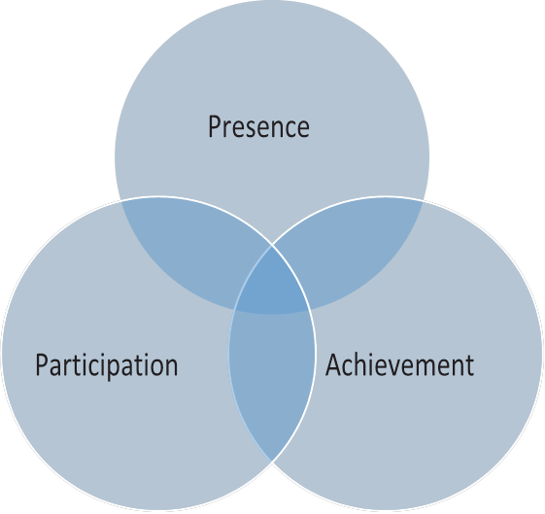

- Equal presence: making sure all learners are present in school. Teachers should be instructed to do daily attendance of the children disaggregated by sex. If there is an attendance issue specific to boys or girls, talk with individual parents or through SGA meetings
- Equal participation: Teachers should ensure that both girls and boys are participating actively and given chances to lead in classroom activities, classroom discussions, and different clubs.
- Equal achievement/ Performance: Parents, teachers and school leaders should ensure both boys and girls have equal opportunity to access learning materials and that there are not any achievement gaps. You may think it is too difficult to address the needs of a diverse range of children, as there are so many challenges.

Inclusive education is about treating all learners as individuals. It is about making sure that all learners can learn. When we think about inclusive education, often we just think about getting children into school, i.e. making sure they are present in school. However, we also need to ensure that children are participating in lessons and school life, and that they are achieving academically and socially because of coming to school.

Key differences between Inclusive Education and Inclusive Pedagogy

Criteria | Inclusive education | Inclusive pedagogy
Scope | Is the overarching system or framework that ensures all students have access to educational opportunities, support, and an inclusive environment.  Is the broad goal of making education accessible and equitable for all students, fostering an inclusive school culture. | refers specifically to the teaching practices and strategies used by teachers within that system to ensure that all students can learn effectively.  Is the specific set of teaching strategies used to create inclusive learning experiences for all students within that system.
Focus | focuses on the policies, structures, and systems that create an inclusive learning environment. It includes physical access to the school, learning resources, support systems, and inclusive school culture. | is about the practical classroom teaching methods and strategies that teachers use to create inclusive, engaging, and supportive learning experiences for all students.
Implementation | involves school-wide efforts to ensure all students, including those with disabilities, diverse backgrounds, and different needs, are included in the educational process. | is implemented by individual teachers who design and deliver lessons that meet the needs of a diverse group of learners within the classroom.

  - Special Education
Special Education refers to educational programs and services designed specifically to meet the needs of students with disabilities, learning difficulties, or exceptional abilities. This approach recognizes that some students require a different teaching method, environment, or support to access the curriculum effectively.
Key features of special education:
- Individualized instruction: Special education focuses on individualized instruction, tailoring teaching methods, strategies, and assessments to suit each student's unique learning needs. This often involves creating an Individualized Education Plan (IEP) that outlines specific educational goals and accommodations for the student.
- Specialized teachers and support: Special education teachers are trained to work with students who have a variety of disabilities, including physical disabilities, learning disabilities, emotional and behavioral disorders, autism, and intellectual disabilities. These teachers use specialized teaching strategies and materials.
- Separate classes or settings: Students receiving special education services may be placed in a separate classroom or educational setting that is designed to accommodate their learning needs. This allows for more focused support and a quieter, less distracting environment for students who struggle in a regular classroom.
- Support services: In addition to specialized teaching, students may receive therapies (speech, occupational, physical), counseling, or behavior support services depending on their needs.

  - Integrated Education
Integrated Education refers to an approach where students with disabilities are educated alongside their peers in general education classrooms. The goal of integrated education is to provide students with disabilities equal access to the same educational opportunities as other students, in an inclusive environment that promotes diversity and understanding.
Key features of integrated education:
- Inclusive classrooms: In integrated education, students with disabilities are placed in general education classrooms, with necessary modifications or accommodations. This allows students to interact with their peers and be part of the broader school community.
- Collaboration between teachers: Teachers in integrated education often work together, with general education teachers collaborating with special education teachers or support staff. This collaboration allows for tailored support within the mainstream classroom.
- Support services: Students in integrated education may still receive additional support services, such as specialized instruction, speech therapy, or counselling, but these services are delivered within the general education setting or through a pull-out system for specific support.
- Diverse learning strategies: Teachers in integrated classrooms use various teaching methods, such as differentiated instruction, to meet the diverse needs of students. This includes using visual aids, technology, hands-on activities, or alternative assessments to support learning.
Comparison of Special Education vs. Integrated Education
Aspect | Special Education | Integrated Education
Classroom Environment | Separate or specialized classrooms for students with disabilities | General education classrooms with some modifications or support
Social Interaction | Limited interaction with peers without disabilities | Promotes interaction with peers without disabilities
Support Services | Provides specialized support, therapies, and individualized plans | Support is provided within the general education setting, sometimes through co-teaching or pull-out services
Teaching Approach | Focuses on individualized instruction and tailored curriculum | Emphasizes differentiated instruction, collaboration between general and special education teachers
Philosophy | Aimed at meeting the needs of students with disabilities in a more structured and focused environment | Aimed at promoting inclusion, diversity, and equal access to education for all students
Stigma | May reinforce stigma or labeling of students with disabilities | Aims to reduce stigma and promote acceptance of diversity
Challenges | Potential isolation, lack of social interaction, and limited access to general curriculum | Requires adequate resources, teacher training, and peer acceptance to be effective

The shift towards Integrated Education or Inclusive education?
In recent years, there has been a global shift towards inclusive education that focuses on integrating students with disabilities into general education classrooms rather than segregating them into special education settings. The UN Convention on the Rights of Persons with Disabilities (CRPD), ratified by many countries, including Rwanda, stresses the importance of inclusive education for all children, regardless of their physical, intellectual, or emotional challenges.
In Rwanda, as part of its vision for inclusive education, the government has made strides in integrating students with disabilities into mainstream schools, including the development of accessible facilities and promoting inclusive teaching practices. This aligns with the country’s Education Sector Strategic Plan (ESSP), which emphasizes equity and inclusion.
Integrated and inclusive education

The terms integrated education and inclusive education are often used interchangeably, but they have distinct meanings and approaches when it comes to educating students, particularly those with disabilities. While both aim to provide equal educational opportunities, they differ in the extent to which they embrace diversity and provide support.

Integrated education involves placing students with disabilities or special needs into general education classrooms alongside their peers without disabilities. Students with disabilities may still receive additional support in separate settings (e.g., pull-out programs) for specialized instruction or therapy. Students with disabilities may have to adjust to a curriculum that doesn't fully accommodate their needs. It’s about bringing students with disabilities into mainstream education but doesn’t necessarily address full participation and equality. Example: A student with a disability may attend a regular school, but they might still be sent to a special education class for specific lessons, therapy, or individualized instruction outside of the general classroom.
Inclusive education, on the other hand, goes beyond simply integrating students with disabilities into general education settings. It focuses on creating an environment that fully supports and adapts to the diversity of all students, whether they have disabilities or not. Inclusion is about ensuring that all students, regardless of ability, background, or identity, are treated equally and participate fully in all aspects of the school community.

Key differences between integrated and inclusive education
Aspect | Integrated Education | Inclusive Education
Philosophy | Students with disabilities are placed in general education classrooms, but the system may still be segregated. | All students, regardless of ability, are seen as equally capable of learning together in an adapted system.
Focus | Physical placement of students with disabilities in regular classrooms. | Full participation of all students in all aspects of school life.
Curriculum | The general curriculum is typically not modified; students may receive support separately. | The curriculum is adapted to meet the diverse needs of all learners, ensuring everyone can succeed.
Support | Support is often provided outside the general classroom (e.g., pull-out programs, separate lessons). | Support is embedded within the classroom, with teachers working together to support all students.
Teacher Collaboration | General and special education teachers may work separately, with special educators providing support outside the classroom. | Teachers collaborate actively to ensure every student’s needs are met in the same classroom environment.
Social Inclusion | Students with disabilities may not be fully included in social activities and school culture. | Students with disabilities participate fully in academic, extracurricular, and social activities.
Goal | Integration of students with disabilities, but with the potential for continued separation. | A systemic approach to make schools accessible and welcoming to all students, fostering true inclusion.

Both inclusive education and inclusive pedagogy work together to ensure that all students, whether they have disabilities, come from diverse cultural backgrounds, or have different learning styles, are given the support and opportunities they need to succeed. Example: Imagine a school with an inclusive education policy that provides students with different learning abilities access to the same classroom, learning materials, and extracurricular activities. The teachers in this school would then use inclusive pedagogy, such as differentiated instruction, collaborative learning, and Universal Design for Learning, to make sure that every student can engage with the material and participate fully, regardless of their abilities or backgrounds.

7.2.2 Categories of learners with special educational needs

Activity: GS Murambi has over 1,000 learners. Among them, some use wheelchairs, some wear glasses, some communicate through sign language, and others struggle to afford learning materials.
Based on this scenario:
- Identify the possible categories and characteristics of each category among the learners at GS Tindo.
- What types of support can you provide to these learners,
considering their specific disabilities and needs?

  - Meaning of Special Educational Needs (SEN)

Special Educational Needs (SEN) refers to the learning difficulties or disabilities that require special support, adaptations, or educational services to help a learner achieve their full potential in school and society. A learner is considered to have special educational needs when they experience difficulties in learning, communication, behavior, physical functioning, sensory functioning, or social participation that make it harder for them to benefit from regular educational programs without additional support.

According to UNESCO, special educational needs refer to educational needs arising from disabilities or learning difficulties that make it necessary for learners to receive additional educational support to access and benefit from education effectively.

The concept of special educational needs emphasizes that education systems should adapt to meet the diverse needs of learners rather than expecting all learners to fit into a single teaching approach. This may involve providing specialized teaching methods, assistive technologies, modified curricula, individualized educational plans, additional learning resources, or support from special education professionals.

  - Categories of learners with SEN
Learners with special educational needs can be categorized into several areas, each encompassing a range of specific conditions (Hafsat Sani Chindo, 2022). The categories include:

B.1 Learners with visual difficulties
Visual difficulties or visual impairment refers to the loss of vision, whether total (blindness) or partial (low vision). Visual difficulty can be any problem in vision that can cause one to see less, inability of the eye or brain or both to visualize things in the normal way. Visual impairment may affect a learner's ability to access information, move independently, communicate, and participate fully in educational activities.

B.1.1 Characteristics of learners with visual difficulties
The characteristics of learners with visual impairment vary depending on the degree of vision loss, age of onset, and availability of support services. Generally, learners with visual difficulties are characterized by different behaviors including: Problems reading the notes, charts, maps from the chalkboard or scanning information quickly; discomfort and fatigue; avoiding tasks and activities that require good vision; tendency to seat next to the teacher at the front; reading by putting books close to the eyes; sitting too close to the TV or holding toys and books too close to the face (Korir, 2015). These learners often depend more on hearing, touch, and movement to gather information and understand concepts. Learners often rely heavily on verbal explanations and auditory cues to understand their environment and lessons. Many learners with visual impairment develop strong listening skills and auditory memory. Challenges in observing social behaviors may affect peer relationships and participation in social activities.

B.1.2 Strategies for teaching learners with visual difficulties
Learners with visual impairment have the same intellectual capacity as their sighted peers but access information differently. Their learning depends heavily on auditory, tactile, and experiential methods. Effective teaching requires accessible learning materials, clear verbal instruction, tactile resources, assistive technologies, mobility support, and inclusive classroom practices. By creating a supportive and accessible learning environment, teachers can enable learners with visual impairment to participate fully and achieve academic success. Teachers can do the following to help learners with visual difficulties:
- Use verbal explanations effectively: Describe everything that is written on the board, explain visual materials verbally, use precise and descriptive language, read aloud important information. Example: Instead of saying, "Look at this diagram," explain each part of the diagram verbally.
- Effective communication: Teachers should speak to the class when they enter and leave the room so that learners with visual impairment know what is happening.
- Provide learning materials in accessible formats: Braille textbooks and notes, large-print materials, audio recordings, digital documents compatible with screen readers. Example: Provide lesson notes in braille or electronic format before class.
- Use tactile teaching materials: Raised maps and diagrams, three-dimensional models, real objects and specimens and tactile graphics. Example: When teaching geography, use raised-relief maps that learners can explore by touch.
- Adapt classroom organization: Keep furniture in fixed positions, remove obstacles from walkways, ensure safe movement around the classroom, inform learners about changes in classroom arrangements. Example: Notify learners whenever desks or materials are relocated.
- Make sitting arrangements: For learners with some visual difficulties, it is important that they sit in a position in the classroom where they can see the board as clearly as possible.
- Provide orientation and mobility support: Familiarize learners with classroom layouts, teach routes within the school environment, encourage independent navigation where possible. When a learner with visual impairment starts in a new school orients them to where the main facilities and obstacles are, and where to find the learning materials. Example: Guide learners through the classroom and school before the start of the term.
- Use assistive technology: Integrate tools like screen readers, braille displays, braille note-takers, text-to- speech software, magnification software, audio books, talking calculators and tactile graphics to support learning. Example: Allow learners to use screen-reading software during computer lessons.
- Allow additional time: Provide extra time for reading and writing tasks, extend examination time where necessary, reduce unnecessary time pressure. Example: Permit additional time for braille reading during assessments.
- Promote peer support and inclusion: Encourage cooperative learning, pair learners with supportive classmates, facilitate inclusive group activities. Example: Assign peers to assist with locating materials during practical activities.
- Teach through multiple senses: Combine auditory, tactile, verbal, and kinesthetic methods; use songs, discussions, role plays, and physical demonstrations. Example: When teaching shapes, allow learners to feel physical models while discussing their properties.
- Scaffold learning: Provide support and guidance as needed, gradually reducing assistance as students become more independent.
- Always use names when addressing students: because students with visual impairment cannot rely on visual cues to know who the teacher is speaking to. When a teacher says, for example, “John, answer question one,” instead of simply saying “Answer question one,” the learner immediately knows that the instruction is directed to them. This reduces confusion, prevents unnecessary waiting or anxiety, and ensures active participation in learning activities. By consistently using names, the teacher ensures that learners with visual impairment are fully part of classroom interactions in the same way as their peers, rather than being unintentionally overlooked. This practice supports independence, confidence, and equal participation in learning.
- Foster a respectful and understanding environment: Create a classroom culture where students with visual impairments feel safe and included.
- Encourage independence: Allow learners to perform tasks independently whenever possible, teach self-advocacy skills, avoid excessive assistance. Example: Encourage learners to organize their own materials and navigate familiar environments independently.
- Adapt assessment methods: Use oral examinations when appropriate, provide braille or large-print test papers, allow the use of assistive devices during assessments. Example: Administer assessments in accessible formats that measure knowledge rather than visual ability.

B.2 Learners with hearing impairment
Hearing impairment refers to a partial or complete inability to hear sounds. It ranges from mild hearing loss to profound deafness and can affect a learner's communication, language development, academic performance, and social interactions.

B.2.1 Characteristics of learners with hearing impairment

The characteristics vary depending on the degree of hearing loss, age of onset, and availability of support services. Learners with hearing impairment have the following characteristics: Difficulty in hearing high pitched speech sounds such as /s/, /f/, /z/, /t/, /k/, /t/; difficulty in following verbal instructions and participating in group discussions; inappropriate rhythm in speech and poor articulation that limit participation in useful conversation with others; asking many repetitions of what has been said and a feeling of inferiority and may withdraw from the hearing community if misunderstood; May become aggressive or impulsive if not given appropriate support by the hearing learners; cupping the ear in the direction of sounds (Hove, 2014). Difficulty learning subjects that heavily depend on language, such as reading and writing; challenges in understanding complex instructions and classroom discussions, slower acquisition of literacy skills due to limited exposure to spoken language, possible difficulties with spelling, grammar, and sentence construction. Performance may be lower than potential when appropriate accommodations are not provided. May experience difficulties interacting with hearing peers, feelings of isolation or exclusion may occur in inclusive classrooms, challenges in participating in group discussions and social activities, may prefer interacting with peers who use similar communication methods. May experience frustration when communication is difficult. Reduced self-confidence due to repeated communication failures. Feelings of loneliness, anxiety, or dependence on others. Can develop positive self-esteem when supported appropriately. May appear inattentive because they cannot hear instructions clearly. Frequently watch speakers' faces to gather information. May respond inappropriately when messages are misunderstood. Sometimes demonstrate withdrawal from classroom participation. Strong reliance on visual learning. Enhanced observation skills and attention to visual details. Learn effectively through demonstrations, pictures, videos, diagrams, and practical activities.

B.2.2 Strategies to teach learners with hearing difficulties

Learners with hearing impairment possess the same intellectual potential as their hearing peers but often face challenges related to communication and language access. Effective teaching requires the use of visual methods, clear communication, assistive technologies, written instructions, peer support, and inclusive classroom practices. By removing communication barriers and providing appropriate accommodations, teachers can help learners with hearing impairment achieve their full academic and social potential.

- Use visual teaching methods: Employ pictures, charts, diagrams, maps, and graphic organizers. Use demonstrations and practical activities. Present information through videos with captions. Write key points on the board. Example: When teaching geography, use maps, photographs, and diagrams instead of relying solely on verbal explanations.
- Ensure clear communication: Face learners while speaking. Maintain eye contact. Speak clearly at a moderate pace. Avoid covering your mouth when talking. Use simple and understandable language. Example: Stand where learners can clearly see your face during instruction.
- Use sign language where appropriate: Learn basic sign language signs. Work with sign language interpreters when available. Encourage classmates to learn simple signs to facilitate interaction. Example: Use signs alongside spoken language when introducing new concepts.
- Provide written instructions: Write assignments and instructions on the board. Distribute handouts containing lesson summaries. Provide written directions for classroom activities. Example: Instead of giving only oral instructions, provide a written checklist of tasks.
- Arrange appropriate seating: Seat learners near the teacher. Ensure good lighting for lip-reading and sign language visibility. Minimize visual and auditory distractions. Example: Place the learner in the front row with a clear view of the teacher and instructional materials. You can also organize the classroom so that all learners are sitting in a U-shape to make hearing easy; use sign
- Check understanding frequently: Ask learners to explain instructions in their own words. Use short quizzes and feedback activities. Observe learners' responses during lessons. Example: After explaining a task, ask the learner to demonstrate what is expected.
- Encourage peer support: Pair learners with supportive classmates, promote cooperative learning activities, encourage inclusive participation in group work. Example: Assign a peer buddy to assist with notetaking and classroom communication.
- Utilize assistive technologies: Because the grammar of sign languages is very different from written languages, use assistive technologies including hearing aids, cochlear implants, FM systems and sound-field systems, speech-to-text applications, captioned multimedia resources. Example: Use captioned educational videos during lessons. Work together with an audiologist for proper support.
- Adapt teaching materials: Simplify complex language where necessary, highlight key vocabulary, use visual glossaries and illustrated materials. Example: Introduce new terms using pictures and definitions.
- Adapt assessment methods: focus more on content than on grammar when assessing the writing of learners who primarily use sign language for communication.
- Create a conducive and inclusive classroom environment: Classroom to be far from extraneous noise like noise from busy roads, airports, etc. Foster respect for diversity, prevent teasing and discrimination, encourage equal participation in classroom activities, celebrate achievements and strengths. Example: Conduct awareness activities that help all learners understand hearing impairment.

B.3 Learners with physical disabilities

Physical disability is the long-term loss or impairment of part of the body’s physical function. It refers to a condition that limits a person's physical functioning, mobility, dexterity, stamina, or motor skills. It may result from congenital conditions, diseases, injuries, or neurological disorders that affect movement and physical coordination. Examples include Cerebral Palsy, Spina Bifida, muscular dystrophy, limb loss, and paralysis.
Physical disability affects individuals differently. Some learners may require mobility aids such as wheelchairs, crutches, walkers, or prosthetic devices, while others may need assistance with writing, communication, or daily school activities.

B.3.1 Characteristics of learners with physical disabilities

- Limited mobility: Learners may have difficulty walking, standing, climbing stairs, or moving around the classroom and school environment.
- Poor motor coordination: Some learners experience difficulties with balance, coordination, and controlled body movements.
- Dependence on mobility aids: They may use wheelchairs, crutches, walkers, braces, or prosthetic limbs for movement.
- Difficulty writing: Learners may struggle to hold pencils, write legibly, draw diagrams, or complete written tasks.
- Slow task completion: Activities requiring precise hand movements may take longer.
- Challenges handling learning materials: Manipulating books, rulers, scissors, laboratory equipment, or technological devices may be difficult.
- Fatigue and reduced stamina during learning activities: Physical exertion may lead to tiredness more quickly than in other learners, concentration and task completion.
- Normal intellectual ability: Most learners with physical impairments have average or above-average intelligence. Their physical condition does not necessarily affect cognitive ability.
- Communication difficulties: Some physical impairments, particularly neurological conditions, may affect speech production and communication: Slow or unclear speech, difficulty controlling facial muscles, challenges expressing ideas verbally, need for augmentative and alternative communication (AAC) devices.
- Low self-esteem: Repeated experiences of dependency or exclusion may affect self-confidence.
- Frustration: Learners may become frustrated when unable to complete tasks independently.
- Anxiety and stress: Concerns about acceptance, accessibility, and academic performance may affect emotional well-being.
- Pain or discomfort: Certain conditions may cause chronic pain or discomfort that affects learning.

B.3.2 Strategies for teaching learners with physical disabilities

Learners with physical impairments often face challenges related to mobility, motor coordination, communication, and participation in school activities. However, most possess the same intellectual potential as their peers. Effective teaching requires accessible environments, assistive technologies, flexible instructional methods, adapted assessments, emotional support, and opportunities for independence. By removing physical and attitudinal barriers, teachers can ensure that learners with physical impairments participate fully and achieve their educational goals.

- Create an accessible learning environment: Ensure ramps, wide doorways, handles easy to operate and positioned at a low height and accessible toilets are available; arrange desks to allow free wheelchair movement, remove obstacles from pathways, position learning materials within easy reach. Address accessibility challenges both inside and outside the classroom.
- Adapt writing and note-taking activities: Allow the use of computers, tablets, or speech-to-text software, provide printed notes and handouts, permit audio recording of lessons, use scribes when necessary. Example: Allow a learner with limited hand movement to type assignments instead of handwriting them.
- Provide additional time: Extend time for assignments, tests, and examinations, allow rest breaks during lengthy activities, reduce unnecessary time pressure. Provide specific accommodations during examinations, such as separate venues, extended time or a scribe for those unable to write their answers. Example: Grant extra examination time for learners who write slowly.
- Use assistive technology including adaptive keyboards and mice, speech-recognition software, communication devices, electronic note-taking tools. Example: Use speech-to-text applications for learners who experience difficulty writing.
- Differentiate Instruction: Present information through multiple methods, use visual, auditory, and practical learning experiences, offer alternative ways of demonstrating learning. Example: Permit oral presentations instead of written reports when appropriate.
- Encourage cooperative learning: Organize group work that promotes participation, assign meaningful roles in group activities, foster peer support and collaboration. Example: Ensure the learner contributes ideas and decision-making during group projects.
- Adapt physical education and recreational activities: Modify sports and games to accommodate physical abilities, emphasize participation rather than competition, use adaptive equipment when available. Example: Adjust game rules to allow wheelchair users to participate actively.
- Promote independence: Encourage learners to perform tasks they can manage independently, teach self-advocacy skills, avoid excessive assistance. Example: Allow learners to organize their own materials whenever possible.
- Provide emotional and social support: Encourage positive peer relationships, address bullying and discrimination promptly, recognize achievements and strengths, foster a supportive classroom climate. Encourage learners to share any accessibility concerns they may have. Incorporate into lessons or classroom displays examples of role models who have physical disabilities. Avoid interfering with the learner’s movement in any way. Example: Celebrate academic accomplishments and leadership skills rather than focusing on limitations.
- Collaborate with families and specialists: Communicate regularly with parents or guardians, work with therapists, medical professionals, and special educators, implement recommendations from individualized support plans. Example: Coordinate classroom accommodations with advice from occupational therapists.
- Adapt assessment methods: Allow oral, practical, or computer-based assessments, provide assistive devices during examinations, focus assessment on learning outcomes rather than physical limitations. Where appropriate, offer complete oral tests or written tests, whichever best meets the learner’s needs. Example: Use oral questioning instead of extensive written responses when appropriate.
- Manage fatigue and health needs: Schedule demanding tasks when learners are most alert, allow short breaks during lessons, be flexible when health conditions affect attendance or participation. Example: Permit rest periods for learners who experience muscle fatigue.

B.4 Learners with specific learning difficulties
Learning disability is a general term describing specific kinds of learning problems. It is a condition that affects how a person receives, processes, understands, remembers, or uses information. It can cause a person to have difficulty learning and using certain skills. Learners with learning difficulties or disabilities are individuals who experience significant and persistent difficulties in acquiring and using skills such as reading, writing, mathematics, listening, reasoning, and problem-solving. These difficulties are caused by differences in the way the brain processes information and are not due to low intelligence, lack of effort, poor teaching, or sensory impairments. Learners with learning difficulties are intelligent enough to learn but face unexpected challenges in processing and expressing information in specific academic areas. Learning disabilities are neurologically based and may affect one or more areas of academic learning. A learner may be strong in some subjects while struggling greatly in others.

B.4.1 Characteristics of learners with learning disabilities

Although learning disabilities vary from one learner to another, the following are common learning difficulty types, characteristics and strategies that teachers can use to teach them. Learners with learning difficulties often struggle with reading, writing, and mathematics, as well as with memory, attention, and social skills (Imran Khan et al., 2024).

Learners with Dyslexia
Dyslexia is a specific learning disability that primarily affects reading, spelling, writing, and language processing skills. It is neurological in origin and affects the way the brain processes written and spoken language. Dyslexia is not related to intelligence, vision problems, or lack of educational opportunities. Learners with dyslexia often experience difficulties in acquiring literacy skills. Despite having normal intelligence and access to education, dyslexia impairs a person’s ability to read, write, and spell.

A.1 Characteristics of learners with Dyslexia

The characteristics of dyslexia vary from one learner to another and may range from mild to severe. Learners with dyslexia may display:
1. Reading difficulties characteristics
- Slow and inaccurate reading: Learners with dyslexia often read more slowly than their peers and may make frequent mistakes when reading words.
- Difficulty decoding words: They may struggle to connect letters and letter combinations with their corresponding sounds.
- Problems recognizing familiar words: Even common words may not be recognized automatically, requiring extra effort to read.
- Frequent reading errors: Learners may omit letters or words, add extra letters or words, reverse letters or words, mispronounce unfamiliar words.
2. Spelling difficulties characteristics: Frequent spelling mistakes, inconsistent spelling of the same word, difficulty remembering spelling rules, letter reversals and omissions. Examples: A learner may write "freind" instead of: “friend”, "becos" instead of "because."
3. Writing difficulties characteristics: Poor handwriting, difficulty organizing ideas in writing, slow written work, problems with punctuation and grammar, difficulty copying from the board.
4. Phonological processing difficulties: inability to recognize and manipulate sounds in spoken language such as difficulty identifying rhyming words, problems breaking words into syllables, difficulty identifying beginning and ending sounds, challenges blending sounds to form words.
5. Memory difficulties
- Short-term memory challenges: Learners may have difficulty remembering instructions, sequences, and information presented verbally.
- Working memory difficulties: They may struggle to hold and manipulate information while performing tasks. Examples: Forgetting multi-step instructions, difficulty recalling spellings and vocabulary.
6. Language difficulties characteristics: Difficulty retrieving words during conversations, challenges learning new vocabulary, problems understanding complex language structures, difficulty following lengthy verbal explanations.
7. Organizational difficulties characteristics: Difficulty managing time, problems organizing books and materials, challenges planning assignments and projects, forgetfulness regarding homework and deadlines.
8. Emotional and social characteristics
- Frustration and anxiety: Repeated academic difficulties may cause stress and frustration.
- Low self-esteem: Learners may feel less capable than their peers despite having normal intelligence.
- Avoidance behaviors: Some learners may avoid reading and writing tasks.
- Reduced confidence: Fear of making mistakes may limit classroom participation.
9.Strengths often associated with dyslexia: Many learners with dyslexia demonstrate strengths in creativity, problem-solving, critical thinking, visual-spatial reasoning, practical and hands-on learning, oral communication.

A.2 Characteristics of learners with Dyslexia

- Use structured literacy instruction: Structured literacy involves systematic and explicit teaching of phonemic awareness, phonics, vocabulary, fluency, reading comprehension. Example: Teach letter-sound relationships directly and sequentially.
- Provide multisensory learning experiences: Multisensory learning strengthens memory and understanding. Engage multiple senses simultaneously seeing, hearing, touching, moving. Example: Provide activities such as tracing letters in sand, using letter tiles, clapping syllables, writing words while saying sounds aloud.
- Teach phonological awareness skills: Help learners identify sounds in words, blend sounds into words, segment words into sounds, recognize rhyming patterns. Example: Ask learners to identify the first sound in a word before reading it.
- Use assistive technology: Useful tools include text-to-speech software, audiobooks, speech-to-text applications, electronic dictionaries, word prediction software. Example: Allow learners to listen to digital versions of textbooks.
- Provide additional time: Extend time for reading assignments, allow extra examination time, reduce pressure during timed activities. Example: Provide additional time to complete reading comprehension tests.
- Simplify and clarify instructions: Give one instruction at a time, use short and clear sentences, repeat important information, check understanding regularly. Example: Provide written and verbal instructions together.
- Use visual supports: Graphic organizers, mind maps, charts and diagrams, color coding. Example: Use a story map to organize reading comprehension activities.
- Adapt reading materials: Use larger fonts, increase spacing between lines, highlight key information, provide simplified texts when necessary.
- Support writing development: Use writing templates, provide sentence starters, allow typing instead of handwriting, focus on content before correcting spelling errors. Example: Permit learners to submit assignments using a computer.
- Teach vocabulary explicitly: Provide definitions and examples, use visual representations, review vocabulary frequently. Example: Create word walls for important concepts.
- Encourage peer support: Use cooperative learning activities, pair learners with supportive peers, promote collaborative reading and writing tasks.
- Build confidence and motivation: Praise effort and progress, celebrate strengths and achievements, set realistic goals, avoid public criticism of reading or spelling errors. Example: Recognize improvements in reading fluency rather than focusing only on mistakes.
- Adapt assessment methods: Allow oral responses, use project-based assessments, permit assistive technology during tests, focus on knowledge rather than spelling accuracy alone. Example: Assess understanding through oral presentations when appropriate.
- Maintain regular communication with parents and specialists: Share progress with families, collaborate with special education teachers, implement recommended interventions consistently. Example: Work together to reinforce reading strategies at home and school.

Learners with Dyscalculia
Dyscalculia is a specific learning disability that affects a learner's ability to understand, learn, and perform mathematical concepts and calculations. It involves difficulties with number sense, mathematical reasoning, arithmetic operations, and understanding numerical relationships. Dyscalculia is not caused by low intelligence, poor teaching, or lack of effort. Learners with dyscalculia often experience persistent challenges in mathematics.

B.1 Characteristics of learners with Dyscalculia
The characteristics of dyscalculia vary depending on the severity of the condition and the learner's age.
- Difficulties with number sense: Number sense refers to the ability to understand and work with numbers: difficulty recognizing and understanding numbers, problems identifying the value of numbers, difficulty comparing quantities (greater than, less than, equal to), poor understanding of numerical relationships. Examples: Difficulty understanding that 8 is larger than 5; confusion when arranging numbers in order.
- Difficulty learning basic arithmetic operations: difficulty understanding addition, subtraction, multiplication, and division, frequent errors in calculations, inability to remember arithmetic facts, reliance on counting fingers long after peers have mastered basic facts. Examples: Difficulty recalling that 5 + 3 = 8, confusing multiplication and division operations.
- Problems with mathematical reasoning: Difficulty solving word problems, challenges identifying appropriate mathematical operations, problems understanding mathematical concepts and procedures, difficulty applying mathematical knowledge to new situations. Examples: Inability to determine whether to add or subtract in a word problem, difficulty explaining mathematical reasoning.
- Difficulties understanding mathematical symbols: Confusion between symbols such as:
    - and ×; < and > ; ÷ and −; difficulty interpreting mathematical notation. Examples: Using the wrong operation sign when solving problems, misreading equations.
- Memory difficulties related to mathematics: difficulty remembering multiplication tables, problems recalling mathematical formulas, forgetting procedures used to solve problems, challenges retaining numerical information. Examples: forgetting steps in long division, difficulty remembering place value rules.
- Difficulties with sequencing and patterns: problems recognizing numerical patterns, difficulty counting forward and backward, challenges understanding sequences. Examples: difficulty continuing number patterns, problems counting by twos, fives, or tens.
- Difficulties with time, measurement, and money: Struggle with concepts related to time (days, weeks, months, seasons, quarters), difficulty reading clocks, problems understanding calendars and schedules, challenges estimating quantities and distances, difficulty handling money and making change. Examples: Confusion about elapsed time, difficulty calculating the total cost of purchases.
- Spatial and visual difficulties: difficulty aligning numbers correctly, problems interpreting graphs, charts, and tables, confusion with place value organization. Examples: Writing numbers in incorrect columns, difficulty understanding coordinate systems.
- Emotional and behavioral characteristics:
        - Mathematics anxiety: Learners often experience fear and stress when faced with mathematical tasks.
        - Low self-esteem: Repeated difficulties may reduce confidence in academic abilities.
        - Avoidance of mathematics: Learners may avoid participating in mathematical activities.
        - Frustration: Difficulty understanding mathematical concepts may lead to discouragement.
- Academic characteristics: Mathematics performance significantly below expected levels, strong performance in non-mathematical subjects, difficulty completing mathematical assignments independently.

B.2 Strategies for teaching learners with dyscalculia

Learners with dyscalculia experience significant difficulties in understanding numbers, mathematical operations, problem-solving, measurement, time, and numerical reasoning. Despite these challenges, they possess normal intellectual abilities and can succeed when provided with appropriate support. Effective teaching involves the use of concrete materials, multisensory instruction, visual supports, step-by-step guidance, assistive technology, individualized interventions, and positive encouragement. By addressing learners' specific needs and building their confidence, teachers can help them develop meaningful mathematical understanding and skills.

- Use concrete materials and manipulatives: Concrete materials help learners visualize mathematical concepts. Learners can physically manipulate objects to understand abstract concepts.
- Teach concepts step by step: Break tasks into smaller components, introduce one concept at a time, move gradually from simple to complex ideas. Example: Teach addition before introducing subtraction and more advanced operations.
- Use multisensory teaching methods: Engage multiple senses during instruction.
- Some activities may include touching and moving objects, speaking mathematical facts aloud, writing numbers while saying them, using visual aids and demonstrations.
- Multisensory learning improves understanding and retention.
- Strengthen number sense: Some activities include number recognition exercises, number ordering activities, estimation tasks, comparing quantities. Example: Use number lines to demonstrate numerical relationships.
- Use visual supports: Visual aids make mathematical relationships easier to understand. Examples: Number charts, place value charts, graphic organizers, diagrams and illustrations.
- Provide repeated practice and review: Review concepts frequently, practice skills regularly, reinforce previously learned material. For instance, begin each lesson with a brief review of earlier concepts.
- Teach problem-solving strategies explicitly? identify important information, underline key words, choose the appropriate operation, check answers for reasonableness. Example: Model how to solve a word problem step by step.
- Use assistive technology: Use tools like talking calculators, mathematics learning applications, interactive educational software, digital manipulatives. Example: Allow learners to use calculators for complex calculations while focusing on conceptual understanding.
- Relate mathematics to real-life situations: Give activities like shopping simulations, time management exercises, cooking measurements, classroom budgeting activities. Real-life applications increase understanding and motivation.
- Adapt assessments: Provide accommodations such as extra time during tests, oral explanations of questions, use of calculators where appropriate, reduced emphasis on speed. Example: Assess understanding through practical demonstrations rather than only written tests.
- Provide individualized support: Offer additional instruction when needed, monitor progress regularly, adjust teaching approaches based on learner needs. Example: Provide small-group or one-on-one mathematics support sessions.
- Encourage peer learning: Pair learners with supportive classmates, use cooperative learning groups, promote discussion of mathematical ideas. Example: Allow learners to solve problems collaboratively before working independently.
- Reduce mathematics anxiety: Create a supportive classroom atmosphere, celebrate small successes, focus on progress rather than mistakes, avoid embarrassing learners for incorrect answers. Example: Praise effort and problem-solving attempts even when answers are not completely correct.
- Collaborate with parents and specialists: Communicate regularly about progress, share effective strategies for home practice, work with special educators and psychologists when appropriate. Example: Provide parents with practical activities to reinforce number concepts at home.

Learners with dysgraphia
Dysgraphia is a specific learning disability that affects a learner's ability to write effectively. It impacts handwriting, spelling, written expression, and the organization of ideas on paper, despite having adequate intelligence and learning opportunities.

C.1 Characteristics of learners with Dysgraphia
Learners with dysgraphia may demonstrate the following characteristics:
- Poor handwriting: Handwriting may be illegible, messy, or difficult to read, letters may vary in size, shape, and spacing; learners may mix uppercase and lowercase letters inappropriately, writing may appear inconsistent and untidy.
- Slow writing speed: They often take much longer than their peers to complete written tasks, copying notes from the board can be particularly challenging, they may struggle to keep pace during classroom activities requiring extensive writing.
- Difficulty with fine motor skills: Problems holding and controlling a pen/pencil correctly, excessive pressure or very light pressure when writing, hand fatigue, discomfort, or pain during writing activities.
- Spelling difficulties: Frequent spelling errors, even with familiar words, inconsistent spelling of the same word within a single piece of writing, difficulty remembering spelling patterns and rules.
- Problems organizing written work: Difficulty arranging thoughts logically on paper, written work may lack structure, coherence, or sequence, challenges in planning, drafting, and revising written assignments.
- Difficulty copying text: Struggles to accurately copy words, sentences, or notes, may omit words, letters, or punctuation marks; frequently loses place while copying.
- Avoidance of writing tasks: May become frustrated or anxious when asked to write, often avoids assignments requiring extensive handwriting, may appear unmotivated when the real difficulty is writing itself.
- Better oral than written expression: Can explain ideas clearly when speaking but struggles to express the same ideas in writing, written work often does not reflect their actual knowledge or understanding.
- Difficulty with grammar and punctuation: Frequent errors in sentence construction, omits punctuation marks or uses them incorrectly, difficulty applying grammatical rules while writing.
- Reduced academic performance: Written assignments, examinations, and note-taking activities may be negatively affected, performance may be lower than expected given their intellectual ability.

C.2 Strategies for teaching learners with dysgraphia
Learners with dysgraphia experience significant difficulties with handwriting, spelling, and written expression, but these challenges do not reflect their intelligence or potential. Through explicit instruction, assistive technology, multisensory teaching approaches, accommodations, and positive support, teachers can help learners participate successfully in classroom activities and achieve their academic goals. Effective teaching strategies should focus on reducing writing barriers while helping learners develop writing skills and confidence.

- Provide alternative methods of expression: Allow learners to answer questions orally, use presentations, discussions, or recorded responses as alternatives to written assignments; permit the use of computers or tablets for completing tasks.
- Teach handwriting explicitly: Provide direct instruction in letter formation and spacing, use guided practice and modelling, break handwriting skills into small, manageable steps.
- Strengthen fine motor skills: Incorporate activities such as:
  - Tracing letters
  - Drawing and coloring
  - Manipulating clay or playdough
  - Cutting with scissors
  - Bead threading
These activities improve hand strength and coordination.
- Use assistive technology: Word processors with spell-check features, speech-to-text software, typing programs to improve keyboarding skills, audio recording tools for capturing ideas.
- Provide writing supports: Offer graphic organizers for planning ideas, use writing templates and sentence starters, provide checklists for editing and revising work.
- Reduce the amount of copying required: Provide printed notes, handouts, or digital copies, allow learners to photograph board notes, use peer note-sharing when appropriate.
- Allow extra time: Give additional time for written assignments and examinations, reduce pressure associated with writing speed, permit work to be completed in stages.
- Break writing tasks into smaller steps: Separate the writing process into: brainstorming, planning, drafting, revising, editing. Provide feedback at each stage.
- Focus on content before handwriting quality: Assess understanding and ideas separately from handwriting. Avoid penalizing learners excessively for handwriting difficulties. Encourage creativity and knowledge expression.
- Use multisensory teaching approaches: Teach letters and spelling through visual, auditory, and kinesthetic methods. Use sand trays, finger writing, letter tiles, and tactile materials. Engage multiple senses to strengthen learning.
- Provide positive reinforcement: Recognize effort and progress rather than focusing solely on errors. Celebrate small improvements in handwriting and written expression. Build learners' confidence and motivation.
- Create an inclusive learning environment: Encourage peer support and cooperation. Avoid embarrassing learners about handwriting difficulties. Foster a classroom culture that values different learning styles and abilities.

Learners with Dyspraxia

Dyspraxia, also known as Developmental Coordination Disorder (DCD), is a neurological condition that affects the planning, organization, and coordination of movement. Learners with dyspraxia often have difficulty performing motor tasks, coordinating physical movements, organizing activities, and sometimes processing information efficiently. Their intelligence is usually within the average range or above, but they may struggle to demonstrate their abilities due to coordination and organizational difficulties.

D.1 Characteristics of learners with dyspraxia

- Poor gross motor coordination: Learners may experience difficulties with large body movements and physical activities. Examples: Frequently bumping into objects or people, difficulty running, jumping, catching, or throwing a ball, poor balance and coordination, appearing clumsy during physical activities.
- Poor fine motor skills: They often struggle with tasks requiring precise hand and finger movements. Examples: Difficulty holding pencils, scissors, or rulers, poor handwriting quality, slow completion of written work, difficulty buttoning clothes, tying shoelaces, or manipulating small objects.
- Difficulty planning and organizing tasks: Learners may have trouble sequencing actions and organizing activities. Examples: Difficulty following multi-step instructions, challenges organizing school materials, problems completing tasks in the correct order, frequently forgetting required materials.
- Delayed development of motor skills: Motor milestones may develop later than expected. Examples: Delayed crawling, walking, or riding a bicycle. Difficulty learning new physical skills.
- Problems with Spatial Awareness: They may struggle to judge distances and positions accurately. Examples: Difficulty navigating crowded spaces, problems arranging work neatly on a page, frequently knocking over objects.
- Difficulty with handwriting: Handwriting often presents significant challenges.
- Examples: Slow, untidy, or illegible handwriting. Inconsistent letter formation and spacing. Fatigue during writing tasks.
- Challenges with time management: Learners may struggle to estimate or manage time effectively. Examples: Taking longer than expected to complete tasks. Difficulty transitioning between activities. Frequently arriving late to activities or lessons.
- Difficulties with concentration and memory: Some learners experience challenges with attention and working memory: Forgetting instructions quickly, difficulty remembering sequences of tasks, losing track of activities during lessons.
- Emotional and social difficulties: Repeated struggles may affect self-confidence and social participation. Examples: Low self-esteem, frustration when performing motor tasks, avoidance of sports and group activities, anxiety about participating in classroom tasks.
- Sensory processing difficulties: Some learners may be overly sensitive or under-responsive to sensory information. Examples: Sensitivity to noise, touch, or textures, difficulty processing sensory input efficiently. becoming overwhelmed in busy environments.

D.2 Strategies for teaching learners with dyspraxia

Learners with dyspraxia often experience difficulties with coordination, movement, organization, handwriting, and task planning. However, with appropriate accommodations, structured instruction, assistive technology, multisensory teaching approaches, and a supportive learning environment, they can successfully participate in learning activities and achieve their academic and personal potential.

- Provide clear and step-by-step instructions: Break tasks into smaller, manageable steps. For example: Give one instruction at a time, use simple and clear language. demonstrate tasks before expecting independent performance.
- Use visual supports: Visual aids help learners understand and remember instructions. Examples: Pictures and diagrams, visual schedules, flowcharts and checklists, demonstration videos.
- Allow extra time: Learners with dyspraxia often need more time to process information and complete tasks. Teachers should: Extend deadlines when appropriate, allow additional examination time, avoid rushing learners.
- Use assistive technology: Technology can reduce the impact of motor difficulties. Examples: Computers and tablets for writing, speech-to-text software, audio recording devices, electronic organizers and calendars.
- Support handwriting development: Provide alternatives and support for written tasks. Examples: Use pencil grips, provide lined or graph paper, teach keyboarding skills, reduce the amount of copying from the board.
- Adapt classroom materials: Modify learning materials to make them easier to use. Examples: Large-print worksheets, pre-highlighted notes, simplified layouts, worksheets with adequate spacing.
- Develop organizational skills: Teach strategies for planning and organization. Examples: Color-coded folders and notebooks, daily planners and timetables, checklists for assignments, clearly labeled storage spaces.
- Encourage multisensory learning: Engage multiple senses during instruction. Examples: Hands-on activities, manipulatives and models., role-playing and demonstrations, visual, auditory, and tactile teaching methods.
- Create a supportive physical environment: Arrange the classroom to reduce unnecessary obstacles and distractions. Examples: Ensure clear walking paths, seat learners where they can easily see demonstrations, provide stable and comfortable seating.
- Promote participation in physical activities: Encourage involvement in physical activities while adapting tasks as necessary. Examples: Modify sports activities, focus on participation rather than competition, allow practice opportunities before group activities.
- Provide positive reinforcement: Recognize effort and improvement rather than focusing solely on performance. Teachers should praise persistence and progress, celebrate small achievements, encourage self-confidence and resilience.
- Foster social inclusion: Support positive peer relationships and classroom participation. Examples: Use cooperative learning groups, encourage peer support, prevent teasing or exclusion, promote respect for individual differences.

Learners with Dysphasia, or Aphasia

Dysphasia is a language disorder that affects the ability to produce and understand spoken language. Learners with dysphasia or aphasia experience difficulties in understanding and using language, which may affect speaking, listening, reading, and writing. While aphasia generally refers to a severe language impairment (complete loss of language abilities), dysphasia often refers to a partial impairment. However, the terms are frequently used interchangeably.

Dysphasia (Aphasia) occurs when areas of the brain responsible for language production and comprehension are damaged or do not function properly. It is commonly caused by brain damage resulting from conditions like stroke, traumatic brain injury, or neurological diseases such as dementia. Dysphasia can impair speech production, understanding spoken language, reading, and writing. Learners with dysphasia may have difficulty expressing their thoughts (Speech production), understanding spoken language, reading, writing, finding the right words, or processing language effectively. Learners with dysphasia or aphasia may have normal intelligence, but their language difficulties can significantly affect communication and academic performance.

E.1 Characteristics of learners with Dysphasia, or Aphasia
- Difficulty expressing thoughts verbally: Learners may know what they want to say but struggle to express it clearly. They may experience:
- Limited vocabulary during conversation.
- Difficulty forming complete sentences.
- Frequent pauses while speaking.
- Use of incorrect or substitute words.
- Speaking in short or fragmented phrases.
- Difficulty understanding spoken language: Some learners may struggle to comprehend verbal instructions and conversations. They may experience:
- Difficulty following directions.
- Problems understanding questions.
- Misinterpretation of spoken information.
- Requiring repetition of instructions.
- Word-finding difficulties: Learners often have trouble retrieving the correct words, substituting one word for another, long pauses when searching for words, frustration during communication.
- Reading difficulties: Difficulty recognizing words, problems understanding written text, slow reading speed, difficulty answering questions about reading passages.
- Writing difficulties: Problems spelling words correctly, difficulty organizing ideas in writing, incomplete sentences, errors in grammar and punctuation.
- Difficulty following conversations: Learners may find it challenging to keep track of discussions, losing the thread of conversations, difficulty understanding complex discussions limited participation in group activities.
- Reduced communication confidence: Communication difficulties may affect self-esteem. They may show reluctance to speak in class, anxiety during oral presentations, withdrawal from social interactions, fear of making mistakes.
- Slow language processing: such as delayed responses to questions, difficulty keeping up with classroom discussions, need for extra time to understand information.
- Frustration and emotional challenges: Communication barriers can create emotional difficulties such as frustration when misunderstood, anger or sadness related to communication problems, reduced motivation to participate in language-based activities.
- Academic difficulties: Language difficulties can affect learning across subjects such as poor performance on language-based tasks, difficulty understanding test questions, challenges in completing written assignments, problems learning new vocabulary.

E.2 Strategies for teaching learners with Dysphasia, or Aphasia
Learners with Dysphasia, or Aphasia often struggle with communication, vocabulary, language processing, and academic tasks that depend heavily on language. Effective teaching involves using clear language, visual supports, multisensory methods, adapted instruction, positive reinforcement, and collaboration with families and specialists. Through these supportive strategies, learners with dysphasia can participate meaningfully in learning and achieve their educational potential.

- Use simple and clear language: Teachers should communicate in a way that is easy to understand. Use short, clear sentences, avoid complex vocabulary, when possible, speak slowly and clearly. Emphasize key information.
- Give instructions in small steps: Present one instruction at a time, check understanding after each step, repeat instructions, when necessary, use sequential teaching methods. Breaking tasks into manageable parts improves understanding.
- Use visual supports: Use pictures, diagrams, charts, and illustrations; provide visual schedules, demonstrate tasks whenever possible, use graphic organizers. Visual information helps reinforce understanding.
- Allow extra processing time: Wait patiently after asking questions, avoid rushing responses, provide extended time for assignments and tests, allow pauses during conversations. Learners need sufficient time to understand and respond.
- Encourage alternative communication methods: Learners should be allowed to communicate in various ways. For instance, use gestures and facial expressions, encourage drawing or pointing, allow the use of communication boards or technology, accept non-verbal responses when appropriate.
- Support vocabulary development: Examples: Pre-teach important vocabulary, use word walls and picture dictionaries, review new words frequently, teach vocabulary in meaningful contexts. Systematic vocabulary instruction can improve communication.
- Adapt reading and writing activities: Modify language demands to suit learners' needs. For instance: provide simplified texts, use guided reading activities, offer sentence starters and writing frames, allow oral responses instead of written responses when appropriate.
- Promote active participation: Learners should be encouraged to engage in classroom activities. For instance, ask questions that require short responses initially, use small-group discussions, provide opportunities for success, encourage participation without forcing communication.
- Use multisensory teaching approaches: Combine visual, auditory, tactile, and kinesthetic activities, use real objects and demonstrations, incorporate hands-on learning experiences. Engaging multiple senses enhances learning
- Provide positive reinforcement: Praise communication efforts, focus on successful communication rather than mistakes, recognize improvements and achievements, create a supportive classroom atmosphere. Encouragement builds confidence and motivation.
- Foster peer support and inclusion: Pair learners with supportive peers, use cooperative learning activities, promote respect and understanding among classmate, encourage inclusive participation, positive social interactions support language development.
- Collaborate with specialists and families: Work closely with speech and language therapists, communicate regularly with parents or caregivers, implement recommended intervention strategies consistently, monitor progress collaboratively. A team approach enhances learner support.

Learners with Autism Spectrum Disorder
Autism Spectrum Disorder (ASD) is a neurodevelopmental condition that affects how individuals communicate, interact socially, process information, and respond to their environment. The term spectrum reflects the wide variation in strengths, challenges, and support needs among individuals with autism (the wide range of symptoms, skills, and levels of support that individuals with autism may require (WHO, 2023). Some learners may require substantial support, while others may function independently and perform exceptionally well in certain areas.

F.1 Characteristics of learners with Autism Spectrum Disorder
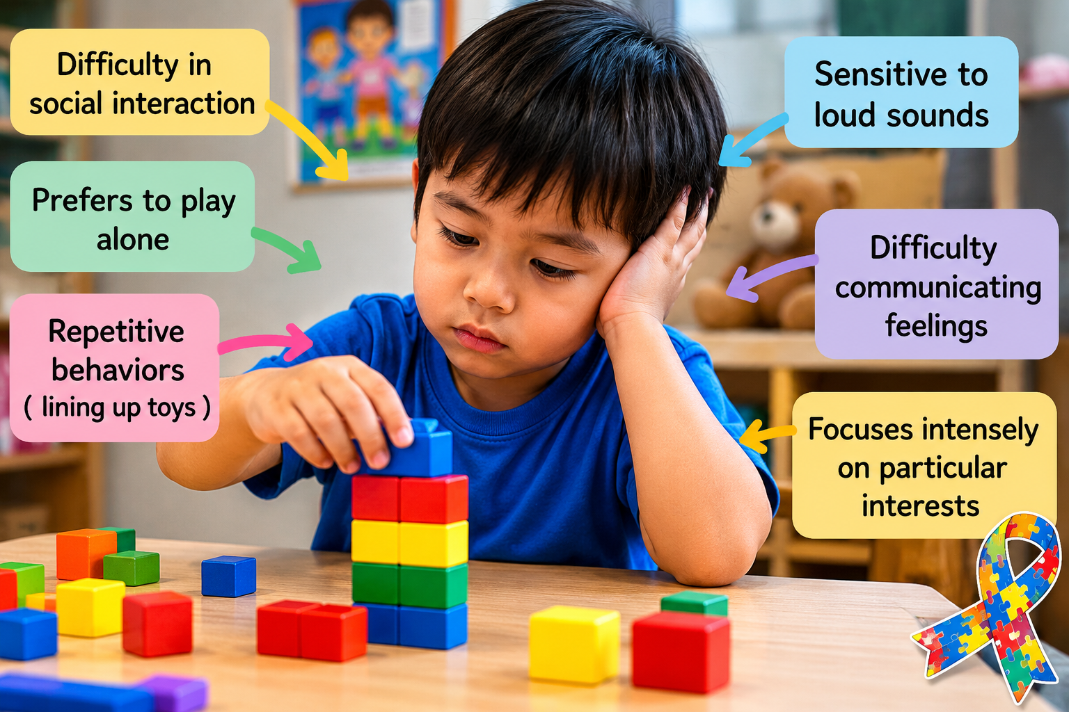
Characteristics of Autism Spectrum Disorder (ASD) vary from person to person, in severity and presentation but they often appear in three main domains: social communication, behavioral patterns, and sensory processing.

- Difficulties in social interaction: Learners with ASD often experience challenges in understanding and participating in social relationships. They present limited interest in social interactions, difficulty making and maintaining friendships, challenges understanding social rules and expectations, may prefer solitary activities, difficulty interpreting facial expressions, gestures, and body language.
- Communication difficulties: Communication challenges may affect both verbal and non-verbal communication. They present delayed speech and language development, difficulty initiating or maintaining conversations, literal interpretation of language, challenges understanding jokes, sarcasm, idioms, or figurative language, limited use of gestures and eye contact, repetition of words or phrases (echolalia).
- Repetitive behaviors and restricted interests: Many learners with ASD display repetitive patterns of behavior and intense interests: Repetitive movements such as hand-flapping, rocking, or spinning, strong attachment to routines and predictability, intense focus on specific topics or activities, repeatedly talking about preferred interests, distress when routines are changed.
- Sensory processing differences: Learners may respond differently to sensory information. Examples: Over-sensitivity or under-sensitivity to sounds, lights, smells, textures, or touch, discomfort in noisy or crowded environments, strong reactions to certain clothing materials or food textures, seeking sensory stimulation through movement or touch.
- Difficulty with change and transitions: Changes in routine can be particularly challenging. Examples: Anxiety when schedules change unexpectedly, resistance to new activities or environments, difficulty moving from one task to another, preference for familiar routines.
- Challenges with executive functioning: Executive functioning involves planning, organizing, and managing tasks. Examples: Difficulty organizing materials and activities, problems with time management, challenges prioritizing tasks, difficulty following multiple-step instructions.
- Uneven development of skills: Learners may demonstrate strengths in some areas and challenges in others. Examples: Exceptional abilities in areas such as mathematics, music, memory, art, or technology; advanced knowledge in specific subjects of interest, academic performance that varies significantly across subjects.
- Attention and concentration difficulties: Some learners may experience difficulties maintaining attention. Examples: Becoming distracted by sensory stimuli, focusing intensely on preferred interests while ignoring other tasks, difficulty shifting attention between activities.
- Emotional regulation difficulties: Learners may find it difficult to manage emotions such as anxiety in unfamiliar situations, frustration when communication breaks down, emotional outbursts or meltdowns when overwhelmed, difficulty expressing feelings appropriately.
- Strong preference for predictability: Many learners with ASD thrive in structured environments. Examples: Preference for clear expectations and routines, comfort in familiar settings, anxiety when faced with uncertainty.

F.2 Strategies for teaching learners with Autism

Teaching learners with Autism requires patience, structure, and strategies tailored to their social, communication, behavioral, and sensory needs. Effective teaching requires structured routines, visual supports, clear communication, sensory accommodations, explicit social skills instruction, and positive reinforcement. Through inclusive and individualized teaching practices, teachers can help learners with ASD participate successfully in academic, social, and personal development activities.

- Establish clear and predictable routines: Maintain regular classroom schedules, inform learners in advance of any changes, use visual timetables and schedules, create predictable lesson structures, consistency helps learners feel secure and understand expectations.
- Use visual supports: Many learners with ASD process visual information more effectively than verbal information. Use pictures, charts, diagrams, and graphic organizers, provide visual instructions, display classroom rules visually, use visual schedules for daily activities to reinforce verbal communication. Many learners with autism spectrum disorder (ASD) process visual information more effectively than spoken instructions.
- Give clear and concrete instructions: Communication should be direct and easy to understand. Use simple language, avoid unnecessary figurative expressions, break instructions into small steps, check for understanding.
- Support communication development: Teachers should encourage effective communication in multiple forms. For instance, allow additional time for responses, use communication boards or assistive communication devices, when necessary, encourage peer interaction in structured settings, model appropriate communication skills.
- Create a sensory-friendly environment: Reduce excessive noise and distractions, provide quiet areas for breaks, allow the use of sensory tools when appropriate, consider lighting and seating arrangements carefully. Minimizing sensory overload can improve learning.
- Use structured teaching approaches: Organize materials clearly, use step-by-step task sequences, provide clear beginnings and endings for activities, establish consistent classroom procedures. Well-organized learning experiences help learners understand expectations.
- Teach social skills explicitly: Social skills often need direct instruction. Teach turn-taking and conversation skills, use role-playing activities, social stories, to teach social norms and relationship-building, model appropriate social behaviors, practice social interactions in real-life situations, Structured opportunities for group work with clearly assigned roles can further support learners’ social interaction.
- Incorporate learners' interests: Connect lessons to learners' preferred topics, use interests as rewards or engagement tools, integrate favorite subjects into academic tasks. Special interests can be powerful learning motivators.
- Provide positive reinforcement: Praise specific positive behaviors, recognize effort and achievement, use reward systems when appropriate, focus on strengths as well as areas of need. Positive reinforcement encourages desirable behaviors and learning. Clear consequences for inappropriate behaviors should be provided, with emphasis on guidance rather than punishment.
- Break tasks into manageable steps: Large tasks may feel overwhelming. Divide assignments into smaller components, provide checklists, monitor progress regularly, offer support at each stage.
- Support emotional regulation: Teach self-calming techniques, identify triggers for stress or anxiety, provide opportunities for breaks, develop individualized coping strategies, learners benefit from strategies that help them manage emotions.
- Promote inclusion and peer support: Encourage cooperative learning activities, promote acceptance and understanding among peers, pair learners with supportive classmates, address bullying or exclusion immediately. Inclusive classrooms foster belonging and participation.
- Teachers should support communication needs by using augmentative and alternative communication (AAC) tools where necessary, including Picture Exchange Communication Systems (PECS), sign language, or speech-generating devices. Learners should be encouraged to interact, but teachers should avoid forcing eye contact or social behaviors that may cause distress.
- Teachers should manage sensory sensitivities by identifying and minimizing triggers such as noise, bright lights, or crowded spaces. They should provide sensory breaks or calming corners where learners can self-regulate.
- Teachers should allow flexibility in assessment by offering alternative ways for learners to demonstrate their understanding, such as oral responses, projects, or visual presentations instead of strictly timed written tests.
- Collaborate with families and specialists: Maintain regular communication with parents or caregivers, consult special education professionals, therapists, and other support staff, to ensure consistency between school and home strategies. Effective support often involves teamwork.

  - Gifted and talented learners
Gifted and talented learners are children and young who demonstrate exceptionally high levels of aptitude, intelligence, creativity, leadership, artistic ability, or academic performance compared to their peers of the same age, experience, or environment. These learners often show advanced abilities in one or more domains and require educational experiences that go beyond the regular curriculum to fully develop their potential.
Giftedness generally refers to exceptional intellectual or academic ability, while talent often refers to outstanding performance in specific areas such as music, art, sports, leadership, or creative thinking. Gifted learners’ strengths are usually in areas like logical reasoning, problem-solving, abstract thinking, and understanding complex concepts quickly. Intellectual and academic ability (cognitive) of gifted learners are often innate. Talented learners display skills or abilities in specific domains such as music, art, sports, drama, or leadership. Their excellence is often more visible in practical, creative, or performance-based areas rather than purely academic subjects. These abilities are usually developed and strengthened through continuous practice, training, and experience.

G.1 Characteristics of gifted, genius and talented learners
Gifted and talented learners display a wide range of characteristics. Not all gifted and talented learners exhibit every characteristic, and their abilities may vary across different domains.
- Advanced intellectual ability: Learn new concepts quickly, understand complex ideas at an early age, demonstrate exceptional reasoning and problem-solving skills, grasp abstract concepts more easily than peers, require less repetition to master new content. Examples: Solving advanced mathematical problems beyond grade level, understanding complex scientific concepts at an early age.
- Exceptional memory: Retain information for long periods, recall facts, events, and details accurately, learn rapidly from limited exposure. Examples: Remembering information from lessons after a single explanation. Recalling detailed information from books and discussions.
- Advanced language development: Advanced language skills including extensive or large vocabulary for their age, early reading ability, ability to communicate ideas clearly, sophisticated use of language, strong verbal reasoning skills. Examples: Reading books intended for older learners. Using complex sentence structures during discussions.
- Curiosity and love of learning: Ask many questions, show intense interest in specific topics, seek additional information independently, enjoy exploring new ideas. Examples: Conducting independent research, asking deep questions about how things work.
- Creativity and imagination: Generate original ideas, think creatively and divergently, approach problems from multiple perspectives, demonstrate innovation and imagination. Examples: Developing unique solutions to problems. Creating original stories, artworks, or inventions, display original thinking, develop alternative solutions, and think beyond conventional boundaries.
- Strong problem-solving skills: Analyze situations effectively, identify patterns and relationships, develop multiple solutions to problems, apply knowledge in new situations. Examples: Solving complex puzzles, proposing innovative solutions to real-world issues.
- High levels of concentration: Focus intensely on areas of interest, persist with challenging tasks, demonstrate sustained attention when motivated. Examples: Spending extended periods researching a topic, completing complex projects independently.
- Leadership characteristics: Influence peers positively, take initiative in group activities, demonstrate responsibility and confidence, show organizational skills. Examples: Leading group discussions, organizing class projects.
- Emotional characteristics:
- Sensitivity: emotionally sensitive showing heightened empathy, strong awareness, and highly aware of social and ethical issues.
- Perfectionism: They may set very high standards for themselves and become frustrated when expectations are not met. They may be self-critical, easily affected by mistakes, and continuously strive for excellence.
- Strong sense of justice: They often show concern for fairness and moral issues.
- Intensity: They may experience emotions deeply and react strongly to situations (intense emotional reactions).
- Social characteristics: Prefer interacting with older learners or adults, enjoy intellectual discussions, may feel different from peers, sometimes experience social isolation. Examples: seeking friendships based on shared interests rather than age, feeling misunderstood by classmates.
- Academic characteristics: Consistently high academic achievement, advanced reading and writing skills, rapid mastery of curriculum content, ability to work independently. Examples: Completing assignments quickly and accurately, performing above grade level in multiple subjects.

- Asynchronous development where their intellectual abilities may be far ahead of their social, emotional, or physical development.

G.2 Strategies for teaching gifted and talented learners

Gifted and talented learners possess exceptional abilities in intellectual, academic, creative, artistic, leadership, or other domains. They often learn rapidly, think critically, solve complex problems, and demonstrate strong curiosity and creativity. However, they may also experience social, emotional, and motivational challenges. Effective teaching requires differentiated instruction, enrichment, acceleration, inquiry-based learning, leadership opportunities, and attention to social-emotional development. By providing challenging and supportive learning environments, teachers can help gifted and talented learners realize their full potential and contribute meaningfully to society. Teaching strategies for gifted and talented learners can focus on the following strategies (Imran Khan et al., 2024):

- Differentiate instruction: Adapt content, process, and learning outcomes, provide tasks of varying complexity, match instruction to learners' readiness levels. Example: Offer advanced assignments for learners who master concepts quickly.
- Curriculum enrichment: Provide activities that extend beyond the standard curriculum, introduce advanced topics, encourage independent investigations. Example: Assign research projects on topics not covered in the regular syllabus.
- Curriculum acceleration: Allow learners to move through content more quickly, permit advancement to higher-level courses when appropriate, compact already-mastered content. Example: Allow a learner who has mastered grade-level mathematics to study more advanced topics.
- Use inquiry-based learning: Encourage questioning, promote investigation and discovery, support problem-based learning. Example: Ask learners to design solutions to real-world environmental challenges.
- Encourage creative thinking: Use open-ended questions, promote brainstorming activities, encourage innovation and originality. Example: Ask learners to develop multiple solutions to a community problem.
- Provide independent learning opportunities: Independent study projects, research assignments, self-directed learning activities. Example: Allow learners to investigate a topic of personal interest and present findings.
- Promote Higher-Order Thinking Skills: Encourage analyzing, evaluating, creating, critical thinking. Example: Ask learners to compare different theories and justify their conclusions.
- Use flexible grouping: Group learners according to interests or abilities, use mixed-ability and ability-based groups when appropriate. Example: Create enrichment groups for advanced learners.
- Develop leadership skills: Assign leadership roles, encourage mentoring opportunities, involve learners in decision-making. Example: Allow learners to lead group projects or classroom activities.
- Address social and emotional needs: Help learners manage perfectionism, encourage resilience and risk-taking, provide counseling support when needed, foster positive peer relationships. Example: Discuss the value of learning from mistakes and setbacks.
- Integrate technology and advanced resources: Use digital learning platforms, provide access to advanced reading materials, encourage participation in online learning opportunities. Example: Allow learners to explore university-level educational resources appropriate to their interests.
- Encourage participation in enrichment programs: provide opportunities to apply knowledge rather than repeatedly reviewing mastered content such as academic competitions, science fairs, debate clubs, leadership programs, arts and music programs. Example: Support participation in mathematics competitions or innovation challenges.
- Use authentic and challenging assessments such as research projects, portfolios, presentations, problem-solving tasks. Example: Assess learners through real-world projects rather than relying solely on traditional tests.
- Collaborate with parents and specialists: Maintain communication with families, work with gifted education specialists, develop individualized learning plans when appropriate. Example: Coordinate enrichment opportunities between home and school.

7.2.3 Core principles of gender-responsive and inclusive pedagogy

- Challenging gender stereotypes: Teachers should actively challenge and dismantle stereotypes about gender roles in both the content and the delivery of lessons. For example, encouraging boys to engage with the humanities or girls to pursue STEM (Science, Technology, Engineering, and Mathematics) subjects helps to break traditional gender-based expectations.
- Valuing diverse gender identities: Gender-responsive pedagogy ensures that students who do not fit into binary gender categories (e.g., non-binary, gender fluid, transgender students) are respected and supported. Classroom materials, language, and activities should reflect and affirm diverse gender identities.
- Inclusive curriculum and teaching materials: The curriculum should include diverse perspectives and experiences, especially those of historically marginalized groups, including women, transgender individuals, and non-binary people. The curriculum should avoid reinforcing harmful gender biases or excluding the experiences of specific genders.
- Encouraging equal participation: Gender-responsive teaching strategies emphasize providing equal opportunities for all students to participate in class discussions, group work, and leadership roles. Teachers should be mindful of ensuring that all students, regardless of gender, feel comfortable expressing their ideas.
- Creating a safe and supportive environment: A gender-responsive and inclusive classroom creates a space where all students feel safe to be themselves. This includes developing policies to prevent bullying, harassment, and discrimination based on gender or any other factor. Teachers must promote respect and understanding among students.
- Differentiated instruction: Teachers should recognize the diverse learning styles, abilities, interests and needs of their students. This includes accommodating students with disabilities, students from various cultural backgrounds, and students with different levels of academic preparation. This can involve varying the content, teaching strategies, and assessments to meet students where they are and offer multiple pathways for learning. Differentiated instruction allows students to engage with content in a way that suits their individual needs.
- Bias-free assessment: Assessments should be designed to be free of gender biases. Teachers should be mindful of their own biases in grading and ensure that their assessments fairly measure the skills and knowledge of all students, regardless of gender.
- Collaborative learning: Students are encouraged to work together in diverse groups, learning from each other’s perspectives and strengths. Collaborative learning allows for peer support, fosters a sense of community, and helps students develop empathy and social skills.
- High expectations for all students: Inclusive pedagogy emphasizes the importance of setting high expectations for all students, regardless of their background or abilities. Teachers believe in the potential of each student and work to provide the necessary support to help them reach their goals.

7.2.3 Benefits of gender-responsive and inclusive pedagogy

- Promotes equality and equity: It ensures that all students, regardless of their differences, have equal opportunities to succeed in the classroom. It fosters an equitable learning environment where all students have the same opportunities to succeed.
- Empowers students: Gender-responsive pedagogy helps students feel validated, accepted, and empowered to pursue their academic and personal goals, regardless of gender. It empowers students by acknowledging their individual strengths, needs, and identities, allowing them to feel confident and engaged in their learning.
- Enhances social understanding: It encourages students to be more socially aware and respectful of the diverse identities and experiences of others.
- Promotes social and emotional development: Inclusive classrooms foster empathy, respect, and understanding, helping students develop important social and emotional skills.
- Reduces discrimination: By addressing and deconstructing gender biases, students learn to recognize and challenge discrimination, both in the classroom and beyond.
- Improves academic engagement and outcomes: When students see themselves reflected in the curriculum and teaching practices, they are more likely to engage with the content and feel a sense of belonging. By addressing the varied needs of all students, gender responsive and inclusive pedagogy has been shown to improve learning outcomes, especially for students who might otherwise be marginalized.
- Community building: A gender responsive and inclusive classroom promotes a sense of belonging, where students can appreciate diversity and work together toward common goals.

7.2.4 Challenges to implementing gender-responsive and inclusive pedagogy

- Resistance to change: Some teachers or students may resist the shift toward more inclusive teaching practices, particularly if they come from cultures or backgrounds where gender norms are rigid. There may be resistance to adopting gender-responsive pedagogy due to traditional views on gender roles or the belief that gender equality is not a priority in education.
- Limited resources: Teachers may face difficulties finding appropriate, gender-inclusive materials, especially in subjects that traditionally have been gender-segregated. Many educational resources, including textbooks and classroom materials, reflect outdated gender roles. For example, textbooks might depict men in leadership roles and women in passive or domestic roles. This can reinforce harmful stereotypes and limit students' perceptions of what they can achieve. Materials often fail to adequately represent women in a variety of fields, such as science, politics, or business, or do not reflect the experiences of gender-diverse individuals. Many schools lack sufficient resources to accommodate diverse learners, including students with disabilities, students from marginalized communities, or those with special educational needs. For example, schools may not have Braille textbooks, assistive technologies, or accessible facilities for students with physical disabilities.
- Insufficient funding: Implementing inclusive pedagogy often requires additional resources, such as specialized staff, training, and materials. Schools in resource-poor settings may struggle to secure the funding necessary to support inclusive practices.
- Overloaded curriculum: Teachers may already feel burdened by large class sizes and extensive curricula. In such cases, adding the responsibility of accommodating a diverse set of learners can lead to burnout or neglect of inclusive practices.
- Teacher bias: Teachers might have unconscious or implicit biases about students based on their gender, which can affect how they interact with students, assign tasks, or assess students’ abilities. For example, teachers may offer more opportunities to boys to speak in class or may praise girls for compliance rather than academic achievements. Teachers may have preconceived notions about students from marginalized groups, such as students with disabilities, students from different cultural or linguistic backgrounds, or LGBTQ+ students. These biases can lead to unequal treatment or low expectations for certain groups of students.
- Limited training on gender-awareness and inclusivity: Teachers may not be sufficiently trained or aware of the principles of gender-responsive pedagogy. Without proper understanding, they might not incorporate strategies that ensure both male and female students are treated equally and given the same opportunities for success. Effective gender-responsive teaching requires teachers to be aware of their own biases and to undergo training in inclusive practices, which may not always be readily available. Many teachers are not trained in how to deliver a gender-responsive curriculum. Without adequate professional development opportunities, teachers may not be equipped to challenge gender inequalities or adopt gender-sensitive teaching methods. Communities and families may not fully understand the importance of gender-responsive pedagogy or may not support efforts to challenge gender-based discrimination in schools. Teachers may not be trained in inclusive teaching strategies or how to effectively address the needs of students with diverse backgrounds or learning abilities. This gap in training can prevent teachers from creating an inclusive learning environment.
- Cultural barriers:
  - Cultural and social norms like traditional gender roles and stereotypes. In many societies, traditional gender norms are deeply ingrained, and these norms influence how students are expected to behave in the classroom. These expectations can lead to gender bias, where girls may be discouraged from pursuing certain subjects (e.g., STEM fields), or boys may face pressure to avoid subjects traditionally associated with femininity (e.g., arts and humanities). In addition, teachers and students may unconsciously perpetuate stereotypes about the capabilities of different genders. For example, the stereotype that women are less capable in subjects like mathematics or science may result in biased teaching practices and less encouragement for female students.
  - Cultural insensitivity: The curriculum or teaching practices may not reflect the diverse cultural backgrounds of the students. This can create feelings of alienation or disengagement among students from marginalized communities, especially if their language, traditions, or histories are not represented or valued in the classroom.
  - Language barriers: For students who speak languages other than the official language of instruction, the lack of appropriate language support can impede their participation and learning. In some cases, the teaching language itself might be a barrier to full inclusion.
  - Cultural expectations: Parents and communities may have strong views on gender roles, which can sometimes conflict with the goals of gender-responsive pedagogy. For instance, parents may believe that girls should focus on domestic skills rather than academic achievement, leading to resistance against girls' participation in certain subjects or extracurricular activities.
- Gender-based violence (GBV): including harassment or bullying, is a significant barrier to creating a gender-responsive environment. If students feel unsafe or uncomfortable in the classroom due to their gender identity or expression, it can hinder their ability to learn and participate.
- School social stigma and discriminatory attitudes: Prejudices and discrimination within the school environment can create a non-supportive atmosphere for students from diverse backgrounds. For instance, students who speak a different language or come from minority ethnic backgrounds might be marginalized or left out of classroom activities. Students with disabilities may face social exclusion or stigma from their peers, which can undermine their ability to participate fully in classroom activities. The lack of a supportive peer environment can be a significant barrier to inclusion. Some schools may unintentionally engage in exclusionary practices, such as segregating students with disabilities or not providing accommodations for students with special needs, which limits their access to a truly inclusive education.
- Curriculum rigidity (Standardized curriculum and lack of flexibility): In many education systems, curricula are rigid and standardized, which can make it difficult to adapt to the needs of diverse learners. For example, students with learning disabilities may find it challenging to keep up with the same materials and assessments as their peers. Inclusive pedagogy requires the flexibility to adapt teaching methods, assessment strategies, and classroom activities to accommodate the diverse needs of all students. The lack of flexibility in the curriculum or teaching approach can undermine efforts to be inclusive.
- Lack of supportive policies and legislation:
- Absence of inclusive and protective policies: Without clear policies supporting inclusive education, schools may not prioritize the creation of an inclusive environment. Policies may fail to address issues such as differentiated instruction, accessibility, and support for students with disabilities. Schools that do not have strong anti-bullying policies or mechanisms to address sexual harassment may struggle to create a safe and supportive learning environment for all students.
- Weak enforcement of inclusive practices: Even when policies exist, there may be a lack of enforcement or monitoring to ensure that inclusive education practices are being implemented effectively.

7.2.5 Strategies for implementing gender-responsive and inclusive pedagogy:
- Use of inclusive language: Teachers should avoid using gendered language (e.g., “he” or “she” as generic pronouns) and use gender-neutral language instead. For example, referring to students as "they" or "students" instead of "boys" or "girls" helps to ensure that no one feels excluded based on gender.
- Representation in learning materials: Ensure that teaching materials (books, images, videos, etc.) include diverse representations of all genders, roles, and identities. For instance, including stories or biographies of women in history, or showcasing male nurses and female scientists, can help students see beyond traditional gender roles.
- Encourage critical thinking: Encourage students to critically analyze societal norms, stereotypes, and biases around gender and other social categories. Providing space for discussions around issues like gender equality, sexual orientation, and identity can help students become more aware of these topics and their implications.
- Support gender diversity in group work: Group work is an opportunity for students to collaborate across gender lines. Teachers should ensure that all students are included and encouraged to contribute equally during group activities. Teachers should intervene if they notice that certain students (often girls or gender non-conforming students) are marginalized or not given equal opportunities.
- Support for diverse learners: Teachers provide appropriate accommodations for students with disabilities, language barriers, or other learning challenges to ensure they can fully participate in lessons. Discussions and classroom activities that include various viewpoints, ensuring that all students feel their experiences and ideas are valued.
- Provide safe channels for expression: In a gender-responsive classroom, students should feel comfortable sharing their experiences and perspectives. Offering anonymous feedback channels or opportunities for private conversations can give students the chance to express concerns about gender issues or harassment.
- Use of inclusive materials: Textbooks, reading materials, and digital resources reflect diverse voices, cultures, and experiences, ensuring that students can see themselves represented in what they are learning.

Conclusion

Both gender-responsive pedagogy and inclusive pedagogy have the potential to transform educational environments into more equitable, supportive, and inclusive spaces. However, significant barriers such as cultural norms, teacher biases, lack of resources, and inadequate training can hinder the full realization of these pedagogical approaches. Overcoming these barriers requires systemic changes in educational policies, continuous teacher professional development, and active engagement from all stakeholders to create inclusive, gender-responsive learning environments for all students.

7.2.6 Gender-Responsive and Inclusive Pedagogy in Rwanda

Rwanda has made significant strides in education, focusing on gender equality and inclusivity in its education system. Gender-responsive pedagogy (GRP) and inclusive pedagogy are essential strategies in ensuring that all students, regardless of their gender, background, or ability, can thrive in the classroom. In the Rwandan context, these approaches are integral to achieving Rwanda's broader development goals, particularly in promoting equality and creating a learning environment that supports all learners.

  - Key achievements in gender-responsive and inclusive pedagogy in Rwanda

- Rwanda signed the United Nations Convention on the Rights of the Child (UNCRC) on 26 January 1990. According to this Convention, disabled children have a right to education, and schools have a responsibility to educate all children. The UNCRC protects and promotes the rights of all children including disabled children. Key articles are: article 2: non-discrimination, article 23: disabled children’s rights and articles 28 and 29: right to education.
- Curriculum and content review: Rwanda has actively worked on eliminating gender stereotypes from its curriculum. The Rwandan National Curriculum (Competency-Based Curriculum - CBC) encourages gender-sensitive content by ensuring that teaching materials represent both men and women in a diverse range of roles, particularly in fields where one gender has historically been underrepresented, such as leadership, science, technology, and engineering. The 2015 Competence-Based Curriculum (CBC) was designed to be accessible to all learners, including those with disabilities and learning difficulties. Textbooks and learning materials are being reviewed to reflect gender-neutral language and provide balanced representation, avoiding reinforcing traditional gender roles.
- Teacher training and capacity building: Teacher education programs in Rwanda emphasize gender sensitivity, ensuring that teachers are equipped to foster an inclusive and supportive classroom environment. Professional development programs and workshops focus on raising awareness about gender bias and equipping educators with strategies to combat it. In-service teacher training continues to focus on gender-responsive pedagogy, ensuring teachers can identify and address gender-related challenges in the classroom. All schools have at least one trained professional in special needs education and inclusive education.
- Addressing Gender-Based Violence (GBV): Rwanda has enacted laws criminalizing GBV and implemented policies and strategies to address gender-based violence (GBV) in schools. The government has established safe schools’ initiatives, which aim to protect girls from harassment, sexual violence, and exploitation in educational settings. There are anti-bullying and gender-sensitive reporting mechanisms in place to ensure that girls and boys can attend school in a safe and supportive environment free from gender-based violence.
- Promoting Girls' Education: Rwanda approved the girls education policy in 2008 and has launched campaigns and programs aimed at promoting girls' education, particularly in STEM subjects (Science, Technology, Engineering, and Mathematics), where girls have been traditionally underrepresented. Programs like STEM Girls Empowerment focus on breaking down barriers and encouraging more girls to pursue careers in these fields. Additionally, the government supports female mentorship programs to guide girls in navigating their educational and career choices. Rwanda has built girls’ rooms in schools as part of a broader effort to promote gender equality and ensure that girls have access to a safe, supportive, and conducive environment for learning. These girls' rooms serve several important purposes, which align with the country’s commitment to advancing gender equality in education and addressing the specific challenges that girls face. One of the primary reasons for building girls' rooms is to provide a safe space where girls can access to private and clean sanitation facilities. Menstrual hygiene is an important issue that can impact girls’ school attendance and participation. Girls’ rooms are often equipped with private, clean, and hygienic spaces to manage menstruation. This provides a sanitary environment for girls to change their menstrual products, wash up, and maintain their dignity during menstruation. In many areas, menstruation is still considered a taboo subject, and girls may feel embarrassed or uncomfortable discussing it. Having dedicated girls’ rooms helps to reduce stigma and gives them a place to rest and recover if they experience any discomfort during their menstrual cycle. Girls’ rooms can serve as a confidential space where girls can report cases of sexual harassment, abuse, or other forms of GBV without fear of retaliation or stigma. This can help to address and reduce the incidents of GBV in schools by giving girls a voice and the confidence to speak up.

- Challenging gender stereotypes in classroom interactions: teachers in Rwanda are encouraged to create gender-balanced classroom environments. This includes ensuring equal participation of boys and girls in all classroom activities, promoting both genders’ contributions, and challenging any gender-biased behavior among students. For example, teachers are trained to give equal opportunities for girls and boys to answer questions, present ideas, and lead group activities.
- Special Education and Inclusive Education Policy 2018: a critical framework designed to ensure that all children, including those with disabilities, children from disadvantages, and those facing socio-economic challenges, can access and benefit from education. The policy encourages the integration of students with disabilities into regular schools, and special accommodations are made to support their learning. This includes providing accessible infrastructure, specialized learning materials, and training for teachers on how to work with students who have different learning needs. The policy has five goals including:
    - Improved access, enrolment, and retention rates in 9YBE & 12YBE levels.
    - To establish and support present schools of excellence for early SEN Identification, Assessment, and Rehabilitation.
    - Capacity development for SNIE services.
    - Improved quality in SNIE services.
    - Promote Inclusive/Child-Friendly school approaches.
- Differentiated instruction: Teachers are encouraged to use differentiated teaching methods to cater to the diverse needs of students. This involves adjusting content, processes, and products to accommodate various learning styles and abilities. For example, teachers may offer different levels of support or provide learning activities that cater to a range of abilities, ensuring that every student can participate fully. Group work and collaborative learning are also promoted as methods for supporting inclusive learning, as they allow students to learn from and support one another.
- Support for students with disabilities: Rwanda’s education system provides specialized support services for students with disabilities. This includes the provision of assistive devices, the training of special education teachers, and the creation of accessible school environments. Schools are being equipped with resources such as Braille textbooks, sign language interpreters, and ramps for wheelchair access.
- Special education units have been established within some mainstream schools to support students with significant disabilities, while others may require specialized institutions. At each school, there is a teacher in charge of special and inclusive education. The Special Needs and Inclusive Education Unit was formed in the Rwanda Basic Education Board (REB) in 2020 to strengthen system capacity on special needs education, gender, and inclusion for the full participation of all learners in schools.
- Community and parental engagement: In Rwanda, community involvement is seen as crucial in supporting inclusive education. Schools work closely with parents and local communities to create a supportive learning environment for children with diverse needs. Raising awareness about the importance of inclusive education helps parents and community members recognize their roles in fostering an inclusive mindset. Awareness campaigns are held to change attitudes about students with disabilities, ensuring they are not marginalized in the classroom.

  - Challenges to gender-responsive and inclusive pedagogy in Rwanda

In Rwanda, like in many other countries, gender-responsive and inclusive pedagogy faces several challenges, even though there has been notable progress toward achieving gender equality and inclusion in education. These challenges often arise from historical, cultural, social, and structural factors that can influence both the classroom environment and the broader education system. Below are some of the key challenges to gender-responsive and inclusive pedagogy in Rwanda:

    - Cultural norms and gender stereotypes:
- Traditional gender roles: Despite significant progress, cultural norms still influence perceptions of gender roles. In rural areas, traditional beliefs about girls' roles in the family still impact their participation and performance in school, especially in subjects perceived as more masculine. Girls are still expected to prioritize household responsibilities over education, while boys may be encouraged to pursue higher education and leadership roles. These stereotypes can limit girls’ participation in certain subjects (e.g., STEM) and activities.
- Cultural taboo on discussions of gender and sexuality: Conversations about gender-based violence, sexual harassment, and LGBTQ+ rights may be avoided or seen as taboo. This lack of open dialogue can make it harder to address such issues effectively within schools.
- Community influence on education: In some communities, gender biases and patriarchal norms may persist, influencing how children are raised and educated. These norms might encourage boys to dominate in the classroom, while girls may be expected to prioritize home responsibilities. Teachers and parents alike may hold these assumptions, which can shape educational outcomes.
- Social stigma: Students with disabilities or from disadvantaged backgrounds may still face social exclusion or stigma in some areas, which can affect their educational experience and participation in school activities.
- Rural-urban divide: In rural areas, traditional gender norms can be stronger, and girls may face more pressure to stay home and help with family chores or farming. This rural-urban divide can contribute to unequal access to quality education for girls.

- Inadequate training in gender-inclusive pedagogy: Many teachers in Rwanda may not have received specific training on gender-responsive teaching and inclusive pedagogy. Without professional development on gender equality, teachers might not fully understand how to address and dismantle biases or create inclusive learning environments for all students. many teachers still lack the specific skills and knowledge to effectively teach students with disabilities or other learning needs.

- Limited resources and infrastructure:
- Inadequate learning materials: While progress has been made in reviewing textbooks, more work is needed to ensure that all learning materials are free from gender bias and adequately represent women and girls in diverse roles. Textbooks and teaching materials in some schools may perpetuate gender stereotypes or fail to represent the contributions of women and marginalized groups. If girls’ achievements, historical figures, or perspectives are not adequately represented, it can affect their engagement and motivation. Besides, there is still a lack of adequate resources to fully implement inclusive education across the country. Some schools, especially in rural areas, lack basic infrastructure such as ramps, assistive devices, and trained personnel.
- Lack of accessibility for students with disabilities: Although there has been progress in improving access to education for children with disabilities, many schools still lack the necessary infrastructure (such as accessible classrooms, ramps, or specialized learning materials) to support these students effectively. This limits the inclusivity of the learning environment.
- Limited technological resources: In rural or underserved areas, there may be insufficient access to technology, which can impact students' ability to participate in inclusive, modern, or differentiated learning activities. This inequality further exacerbates gaps in educational access for marginalized students, including girls and students with disabilities.
- Economic barriers:
- Poverty and gendered economic expectations: In some areas, economic factors still disproportionately affect girls' education. Families may prioritize sending boys to school over girls, or girls may be expected to contribute to household income or work, limiting their ability to stay in school or pursue higher education. This economic pressure can hinder gender equality in education.
- School fees and costs: Despite the government's efforts to provide free education, hidden costs such as uniforms, supplies, and transportation may still disproportionately affect girls, particularly in rural areas, where families may be less able to afford these expenses.
- Gender-Based Violence (GBV) in schools are significant concerns. Girls are often more vulnerable to rape, sexual harassment, bullying, etc. which can result in school absenteeism, lower academic performance, and even early dropout. Such issues can create an unsafe learning environment, affecting students' ability to learn and engage.
- Curriculum and teaching practices:
- Gender-insensitive curriculum: Although there has been some progress, the curriculum in many schools may still contain gender biases, either in the way subjects are taught or in the materials used. For instance, girls may be underrepresented in subjects like technology, mathematics, and engineering, leading to a lack of encouragement for girls to pursue these fields.
- Gendered pedagogical approaches: Teaching practices may still reflect traditional gender roles. For example, girls may be assigned tasks like organizing materials or cleaning the classroom, reinforcing the idea that girls’ roles are primarily in caregiving and domestic tasks. This can influence their career aspirations and limit their academic potential.
- Gendered expectations in the classroom: Teachers may unknowingly reinforce gender stereotypes, such as expecting girls to be more passive or nurturing, while boys may be encouraged to be more vocal or assertive. This can affect how teachers interact with students and which students are given more attention or praise in class.
- Teacher bias: Teachers may unintentionally hold biases that affect how they treat male and female students. For example, they might call on boys more often in subjects like mathematics or science, or give girls more opportunities for nurturing roles, such as taking care of classroom materials or organizing events.
- Lack of gender-responsive school policies:
- Absence of clear gender-responsive strategies: While Rwanda has made significant progress toward gender equality in education, some schools may lack clear policies on gender inclusion, such as specific measures to address the underrepresentation of girls in certain subjects or ensure equal opportunities for both genders.
- Lack of support for disadvantaged groups: There may be limited support systems for students with diverse needs, such as those from disadvantaged backgrounds, girls who have been victims of GBV, or students with disabilities. Without tailored interventions, these students may face barriers to fully participating in educational activities.

  - Addressing the challenges

While Rwanda has made significant strides in promoting gender equality in education, there are still numerous challenges to achieving fully inclusive and gender-responsive pedagogy. Addressing these challenges requires a concerted effort from the government, educational institutions, communities, and families to create a more equitable and supportive educational environment for all students. To overcome these challenges, Rwanda can continue to focus on the following areas:
- Teacher training: Implementing more comprehensive professional development programs for teachers on gender-sensitive and inclusive teaching methods. This can help educators recognize and address biases, foster gender equality, and support diverse learners.
- Curriculum reform: Updating the curriculum to ensure that it is inclusive and free from gender bias, promoting equal opportunities for boys and girls in all subjects, and representing both genders equally in educational materials.
- Community engagement: Engaging communities in discussions about the importance of gender equality in education, especially in rural areas, and challenging traditional gender norms that limit girls' opportunities.
- Improving access to resources: Ensuring that schools, especially in rural areas, have the necessary resources to support inclusive education, such as accessible learning materials, technology, and infrastructure for students with disabilities.
- Policies and legal frameworks: Strengthening national policies on gender equality in education and ensuring that schools implement these policies effectively. This can include stronger responses to gender-based violence and clear strategies for promoting the participation of girls and marginalized groups in education.
- Addressing economic barriers: Providing support to low-income families, including scholarships, school supplies, and transport subsidies, to ensure that all children, regardless of gender, can attend school and thrive.

Conclusion
Rwanda’s commitment to gender-responsive pedagogy and inclusive pedagogy reflects the country’s broader goals of equality, social justice, and national development. Gender-responsive pedagogy ensures that both boys and girls have equal opportunities in education, while inclusive pedagogy seeks to accommodate all students, regardless of their backgrounds or abilities. While Rwanda has made significant progress, ongoing efforts are needed to address the challenges of resource limitations, teacher training, cultural norms, social stigma, etc. By continuing to implement gender-responsive and inclusive teaching methods, Rwanda can build a more equitable and inclusive education system that supports the success of all learners.

References

Bhopal, K. (2020). Intersectionality, Gender, and Inclusive Pedagogy: Implications for Educational Practice. Educational Studies, 46(3), 334-348. DOI: 10.1080/03055698.2020.1740398
Kumar, R., & Seth, A. (2022). Exploring the Impact of Gender Responsive Pedagogy on Classroom Dynamics and Learning Outcomes. International Journal of Educational Development, 87, 102479. DOI: 10.1016/j.ijedudev.2021.102479.
Shumba, A., & Tutu, S. (2020). Inclusive Education and Gender-Sensitive Pedagogy in Sub-Saharan Africa: A Critical Review. International Journal of Inclusive Education, 24(8), 869-883. DOI: 10.1080/13603116.2020.1794130.
The World Bank (2023). Inclusive Education Initiative in Rwanda. A final report of project activities. Accessed from: https://documents1.worldbank.org/curated/en/099052323105539110/pdf/P1733020a9504a05c0a73801245c164256d.pdf.

UNESCO. (2021). Gender Equality in Education: A Review of Policies and Practices in Sub-Saharan Africa.
UNICEF. (2022). Gender-Responsive Pedagogy for Teachers: Guidelines and Strategies.

